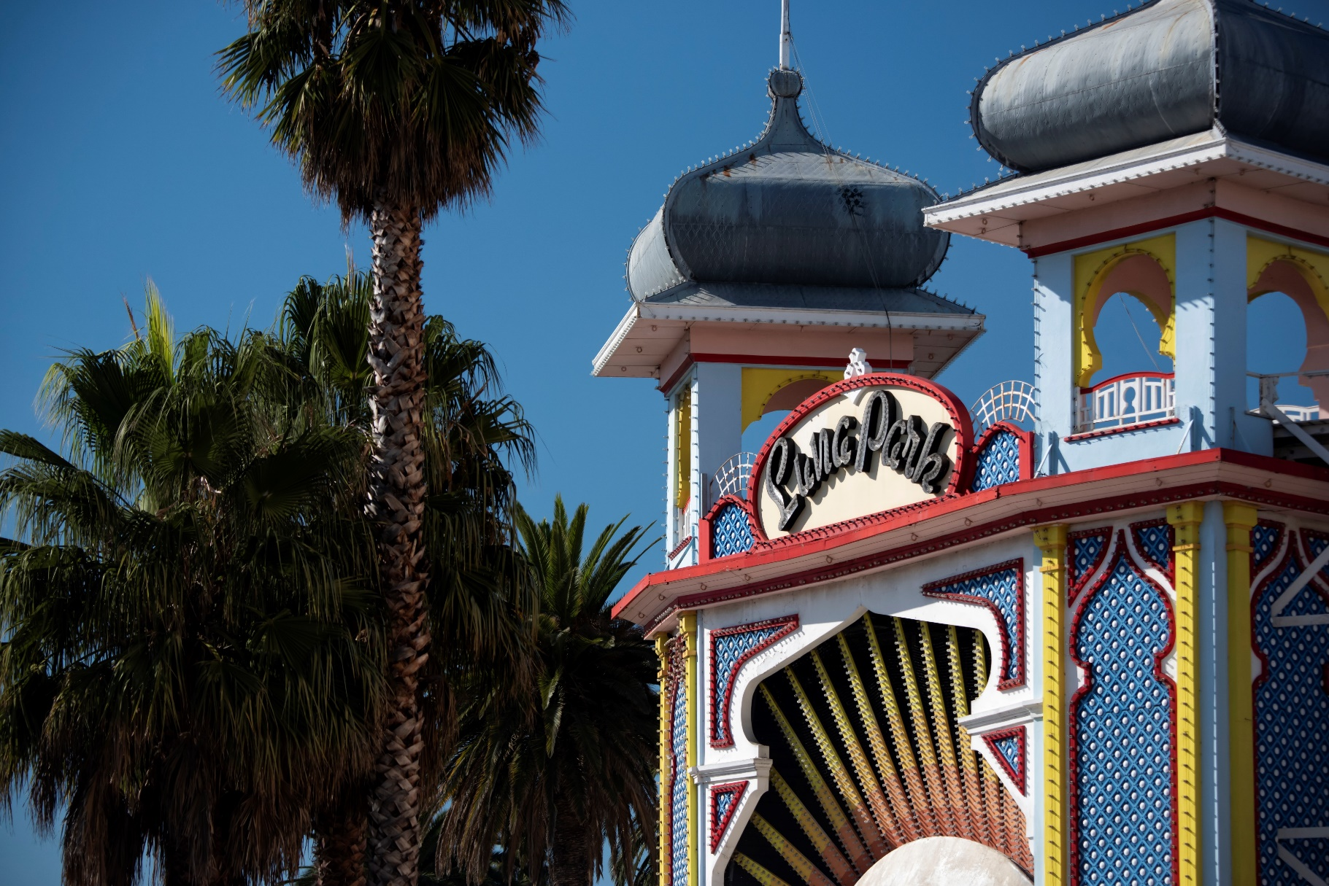
2023 Public survey –summary report
Future directions of the
Victorian Heritage Register
Acknowledgement of country
As a peak heritage body, we acknowledge the Traditional Owners of the Country that we call Victoria as the original custodians of Victoria’s land and waters, and acknowledge the importance and significance of Aboriginal cultural heritage across the state. We honour Elders past and present whose knowledge and wisdom has ensured the continuation of Aboriginal culture and traditional practices.

ACKNOWLEDGEMENTS
The Heritage Council of Victoria would like to acknowledge the work of Dr Marina Jansen of Heritage Victoria in developing the survey questions and categorising and summarising the survey results for this report.

Accessibility
If you would like to receive this publication in an alternative format, please telephone the Heritage Council Secretariat on 9651 5060, email heritage.council@delwp.vic.gov.au. This document is also available on the internet at www.heritagecouncil.vic.gov.au.
Cover Photograph: VHR H0938 Luna Park (© 2023 HIN LIM AIPP | Hin Lim Photography). Used with Permission.
© State of Victoria, Heritage Council of Victoria 2024
This work is licensed under a Creative Commons Attribution 4.0 International licence. You are free to re-use the work under that licence, on the condition that you credit the State of Victoria as author. The licence does not apply to any images, photographs or branding, including the Victorian Coat of Arms, the Victorian Government logo and the Heritage Council of Victoria logo.
To view a copy of this licence, visit
http://creativecommons.org/licenses/by/4.0/
ISBN 978-0-7311-9325-7 (pdf/online/MS word)

Disclaimer
This publication may be of assistance to you, but the State of Victoria and its employees do not guarantee that the publication is without flaw of any kind or is wholly appropriate for your particular purposes and therefore disclaims all liability for any error, loss or other consequence which may arise from you relying on any information in this publication.

Contents

1. Introduction 1
1.1 Background to the survey 1
1.2 The survey process 2
1.3 About this report 2
2. Survey results 3
3.1 Profile of participants 3
3.2 Participants’ views about heritage protection and the heritage they value 7
3.3 Participants’ views about representativeness in heritage listings in Victoria 10
3.4 Participants’ feedback on the Victorian Heritage Register 14
3.5 Participants’ suggestions for the future direction of the Victorian Heritage Register 20
3.6 Summary of written submissions 23
3. Next steps 25

1. Introduction

1.1 Background to the survey

The Heritage Council of Victoria
The Heritage Council of Victoria is an independent statutory authority established under the Heritage Act 2017 (previously the Heritage Act 1995). Two of its key functions include:
- determining the places and objects of state-level cultural heritage significance to be included in the Victorian Heritage Register
- promoting a public understanding of Victoria’s cultural heritage and the importance of its protection.
For more information about the Heritage Council, see its website: heritagecouncil.vic.gov.au

The Victorian Heritage Register
The Victorian Heritage Register is a statutory list that provides legal protection for cultural heritage places and objects that are significant to the history and development of the State of Victoria, under the Heritage Act 2017. It can be accessed online, alongside other statutory and non-statutory heritage listings, via the Victorian Heritage Database portal: vhd.heritagecouncil.vic.gov.au.
The places and objects in the Victorian Heritage Register are of ‘state-level’ cultural heritage significance. This means that they must be of importance to Victoria’s history, rather than to a single local area. They need to represent a key, outstanding or rare aspect of the state’s cultural heritage. The 2,400 listings include cultural heritage places and objects associated with important events, individuals and communities in Victoria’s history.

Aboriginal cultural heritage
The Victorian Heritage Register includes places and objects that are of cultural heritage significance to both Aboriginal and non-Aboriginal people, e.g. the Former Aboriginal Church of Christ, the William Cooper Residence (Southampton Street) and the Wombeetch Puyuun Monument and Dawson Family Grave. In these examples, Registered Aboriginal Parties supported inclusion in the Victorian Heritage Register. Given the history of the dispossession of Aboriginal people and taking of land, the inclusion of a place in the Victorian Heritage Register needs to be considered carefully.
It is important to note that the Victorian Heritage Register does not include cultural heritage places and objects associated solely with Aboriginal tradition, such as Aboriginal archaeological sites, scarred trees and rock art. This heritage is included in the Victorian Aboriginal Heritage Register. This is administered by First Peoples – State Relations who work with Traditional Owners to protect Aboriginal cultural heritage in Victoria, under the Aboriginal Heritage Act 2006.

Natural or environmental heritage
Places that are solely of natural heritage value are not within the scope of the Heritage Act 2017. However, there are some places in the Victorian Heritage Register that have high natural heritage values as well as state-level cultural heritage significance. These places, while seemingly natural places, have been registered under the Heritage Act 2017 for their cultural heritage values e.g. Bells Beach Recreational Surfing Reserve, registered for its social and historical significance to surfing and surfing culture.

Heritage Council’s Strategic Plan 2021–25
Strategy 2 of the Heritage Council’s Strategic Plan 2021–25 is an ‘Effective and representative Victorian Heritage Register’.
As part of delivering this strategy, the Heritage Council wanted to understand the cultural heritage most valued by the Victorian community today and whether this is reflected in the Victorian Heritage Register. It also wanted to gather feedback about potential gaps.
To do this it conducted a public online survey ‘Future directions of the Victorian Heritage Register’ through the Engage Victoria website.

1.2 The survey process
The survey was open on Engage Victoria from 1 November 2023 to 17 December 2023 (6.5 weeks).
Invitations to participate were circulated widely to: heritage professionals and related professional organisations; community history and heritage groups; Traditional Owner and Registered Aboriginal Party organisations; multicultural societies and community groups; tertiary educational organisations; and other individuals and community groups across Victoria. The survey was also publicised on ABC regional radio.
The survey consisted of 17 questions, none of which were mandatory. There were a mixture of closed questions (with multiple-choice response options) and open text questions (where respondents were free to write anything).
All responses were anonymous.
Respondents could also upload written submissions.

1.3 About this report
This report provides a summary of the feedback received from the public via the Engage Victoria survey ‘Future directions of the Victorian Heritage Register’.
The survey results are organised into the following topic areas:
- Profile of participants (see section 3.1)
- Participants’ views about heritage protection and the heritage they value (see section 3.2)
- Participants’ views about representativeness in heritage listings in Victoria (see section 3.3)
- Participants’ feedback on the Victorian Heritage Register (see section 3.4)
- Participants’ suggestions for the future direction of the Victorian Heritage Register (see section 3.5)
- Summary of written submissions (see section 3.6).
The responses have been summarised and categorised for ease of reporting.
It should be noted that the acknowledgement of a response or submission, including any direct quotation, does not imply support or weight given to that response or submission.
The Heritage Council would like to thank all survey participants for their time in completing the survey and their thoughtful and detailed comments.

2. Survey results

This section summarises the survey results.
There were 644 responses to the survey and 22 written submissions (from individuals and groups).
The survey contained 17 questions: six questions were multiple choice and the rest allowed free-text responses.

3.1 Profile of participants
At the end of the survey people were asked two questions to provide information about the survey’s reach.
One question asked participants to provide their postcode so that the Heritage Council could understand the geographical diversity of survey respondents. The other was a multiple-choice question to gain information about the background of survey participants and their general knowledge about heritage.

3.1.1 Geographical diversity of participants

Question 15: What is your postcode? We'd like to know the geographical diversity of survey respondents.
– Participants who answered this question: 580 (90% of total survey participants)
For ease of reporting the responses have been grouped into local council areas (see Figures 3 and 4). The number of local government areas with one or more survey participants is 74 (94%).
The majority of survey respondents (67%) live in metropolitan Melbourne, with approximately 45% of these from the ‘Metro Inner’ councils, 40% from ‘Metro Middle’ councils and 15% from ‘Metro Outer’ councils. While only 31% of respondents were from rural / regional Victoria, these participants were spread across most regions of the state. Nine interstate residents also responded to the survey.
Figure 1: Councils with more than 10 participants. |  |  | Figure 2: The top 17 postcodes
Council | Participants |  | Postcode | Locality | Participants
Melbourne | 34 |  | 3350 | Ballarat | 15
Merri-bek | 33 |  | 3058 | Coburg | 12
Glen Eira | 32 |  | 3000 | Melbourne | 11
Stonnington | 29 |  | 3121 | Richmond | 10
Boroondara | 28 |  | 3182 | St Kilda | 10
Yarra | 28 |  | 3056 | Brunswick | 8
Ballarat | 21 |  | 3068 | Clifton Hill | 8
Darebin | 21 |  | 3122 | Hawthorn | 8
Greater Geelong | 20 |  | 3163 | Carnegie | 8
Whitehorse | 18 |  | 3463 | Castlemaine | 7
Port Phillip | 16 |  | 3550 | Bendigo | 7
Moonee Valley | 15 |  | 3054 | Carlton North | 7
Banyule | 14 |  | 3070 | Northcote | 7
Greater Bendigo | 12 |  | 3071 | Thornbury | 7
Maroondah | 12 |  | 3144 | Malvern | 7
Mount Alexander | 12 |  | 3204 | Bentleigh | 7
Yarra Ranges | 12 |  | 3065 | Fitzroy | 6
Figure 3: Council groupings map (from the Heritage Council State of Heritage Review: Local Heritage 2020, p. 11).
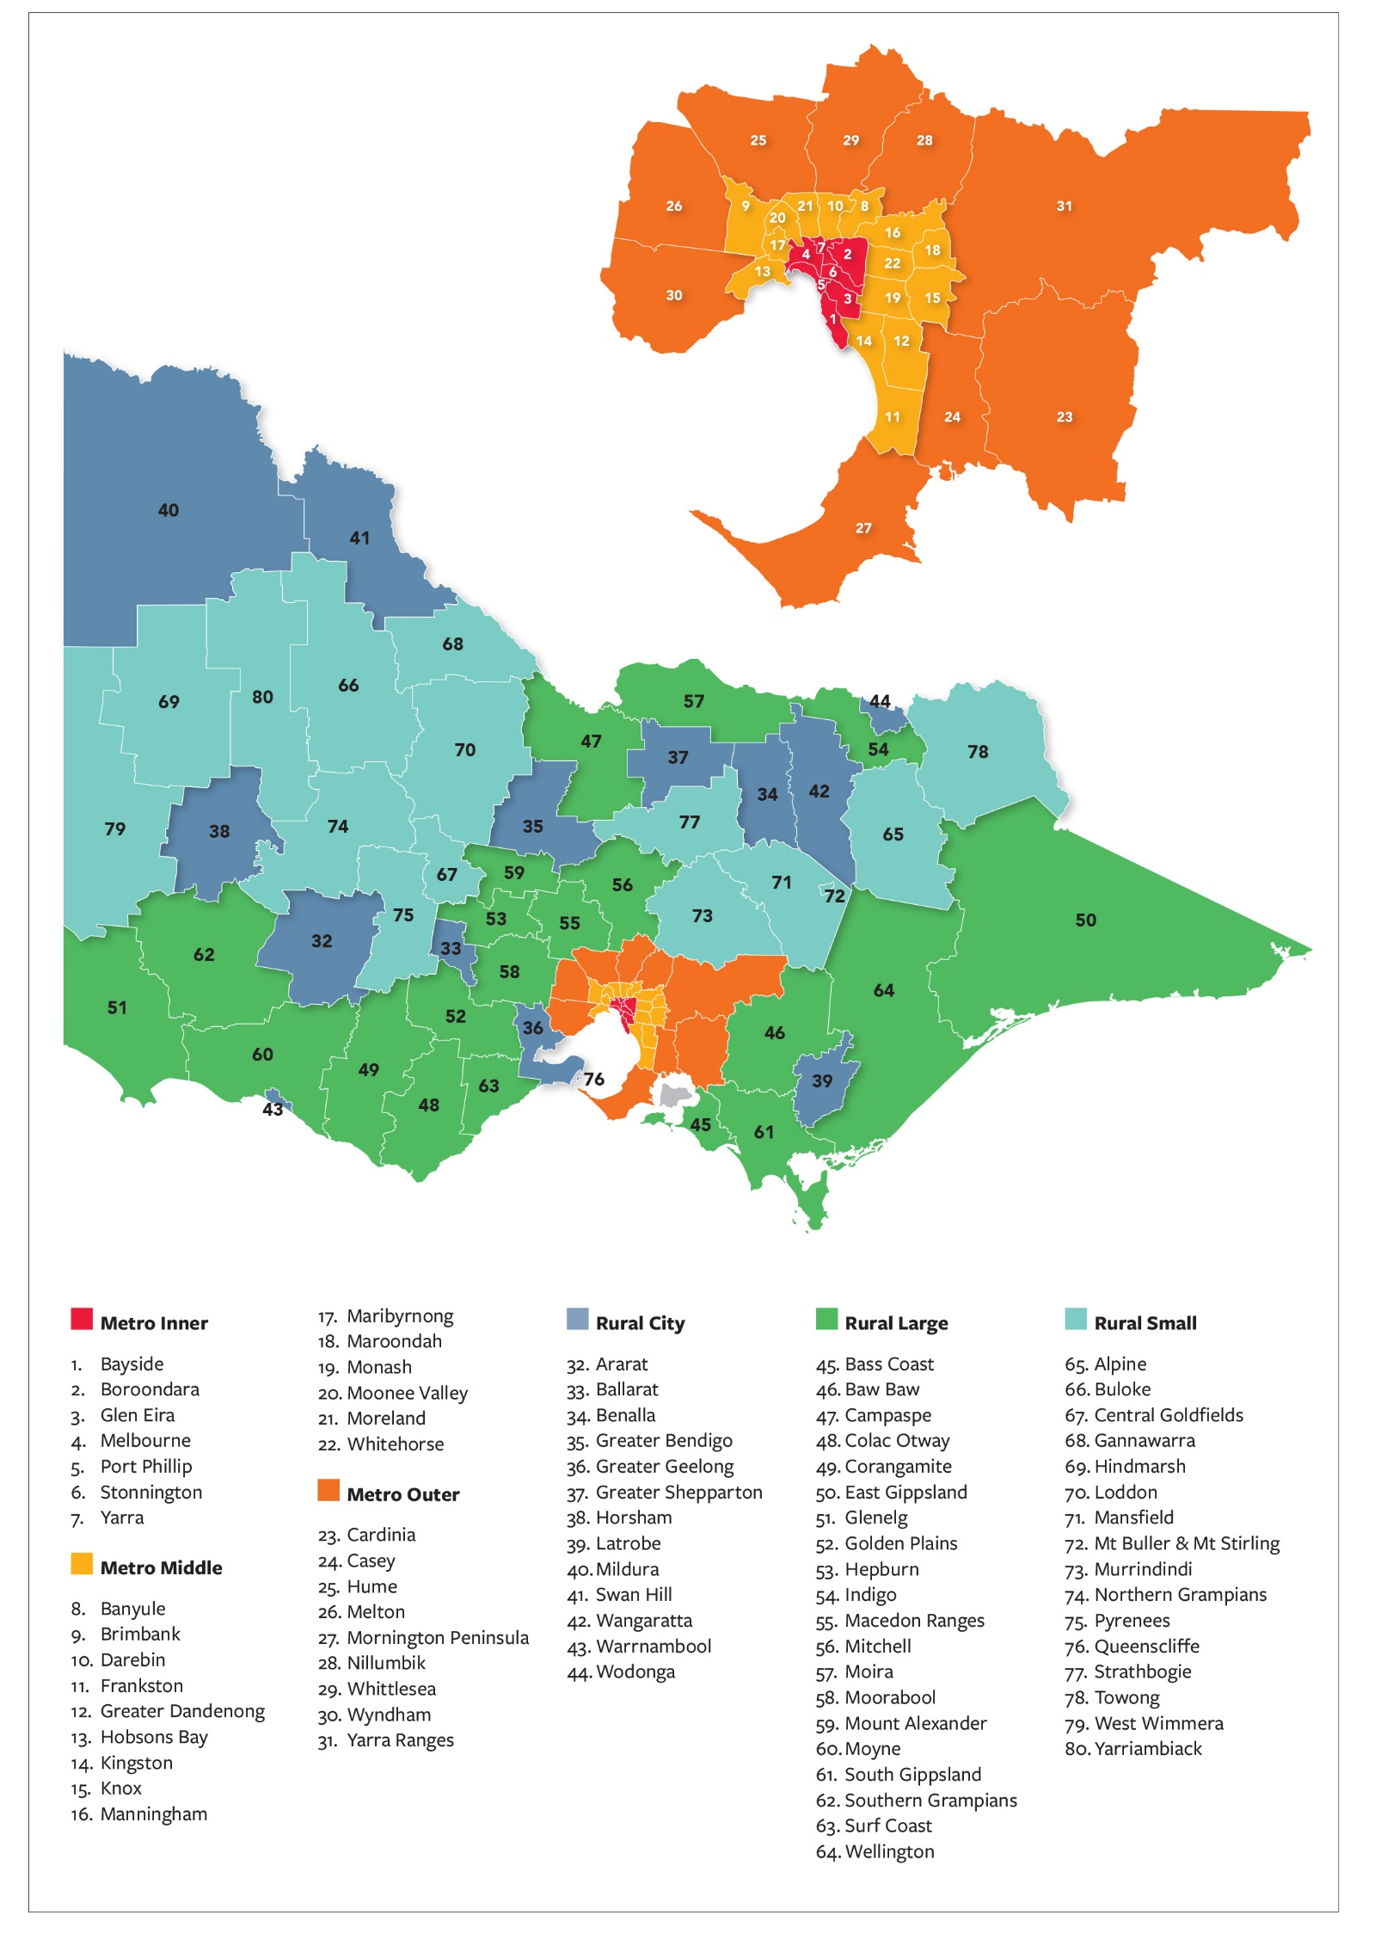
Figure 4: Survey participation – organised by Council groupings.

3.1.2 Primary interest in heritage

Question 14: My interest in heritage is connected to (choose one option).
– Participants who answered this question: 621 (96%)
- My work in the heritage or planning sector: 28%
- My desire to learn more about historical places and objects: 24%
- My activities at a historical society, community group or RSL: 17%
- My work at a museum, library or archive: 9%
- My family history research: 5%
- My work at a university: 2%
- My university studies: 2%
- Other: 13%
Participants who selected ‘Other’ had a short free-text field in which they could further specify their interest. Responses included:
- Owning/managing a heritage place or living in a heritage area, e.g.:
‘I am responsible for maintaining an iconic suburban church’
‘My property is located within a heritage overlay’
‘Living in a landscape heritage community’
- Activism and advocacy, e.g.:
‘Community activism in attempting to save buildings, parkland and coastal areas from destruction or alienation in unsympathetic development’
‘Helping to limit the impact that heritage has had on the ability to build appropriate houses for people to live in’
- Volunteering, e.g.:
‘I volunteer at a rural museum’
- Work as a historian, researcher or other related field, e.g.:
‘My work as a consulting historian’
‘My previous engineering roles involving heritage buildings’
‘My former PhD studies and ongoing research as an independent scholar in history and heritage’
- General passion and interest, e.g.:
‘I love to look around suburbs at the architecture’
‘Desire to protect and preserve what we were lucky enough to grow up with, so that subsequent generations can also understand what led to our society ending up where we are today’

3.2 Participants’ views about heritage protection and the heritage they value

3.2.1 Current recognition and protection

Question 1: I think the cultural heritage (historic places and objects) of importance to all Victorians is currently recognised and protected.
– Participants who answered this question: 640 (99%).
- Strongly Agree: 16%
- Agree: 35%
- Neither Agree Nor Disagree: 15%
- Disagree: 23%
- Strongly Disagree: 8%
- Don't Know: 2%
- No response: 1%
Figure 5: Chart showing responses to Q1, with ‘agree’ and ‘disagree’ and ‘don’t know’ responses totaled.

3.2.2 Valued heritage – from predefined list

Question 2: The cultural heritage that I value the most is (select up to five options).
Participants were asked to choose up to 5 selections from a predefined list of 22 common types of cultural heritage.
– Participants who answered this question: 644 (100%).
– Total responses: 2929 (participants provided more than one response)
See Figure 6 over the page for a graph depicting the results.
The top responses were:
- 19th century architectural heritage (14%)
- Aboriginal heritage (11%)
- Parks & gardens heritage (9%)
- 20th century architectural heritage (9%)
Figure 6: Graph showing responses to Question 2, ‘The cultural heritage that I value the most’.

3.2.3 Valued heritage – identified by participants

Question 3: In addition to the above, the following types of heritage are also important to me. Provide up to 3 answers.
When answering this question participants did not duplicate their responses in Question 2.
– Participants who answered this question: 484 (75%).
– Total responses: 1171 (participants provided more than one response)
For ease of reporting the answers have been grouped into categories.
See Figure 7 over the page for a graph depicting the results.
The top 5 categories were:
1. Natural & environmental heritage (102 responses)
2. Architectural heritage (102 responses)
3. Precincts & urban streetscapes (69 responses)
4. Parks & gardens (incl trees) heritage (65 responses)
5. Migrant & multicultural heritage (60 responses).

Figure 7: Graph showing number of responses to Question 3, ‘In addition to the above, the following types of heritage are also important to me. Provide up to 3 answers’. The results show the total number of responses in each category.

Things to note about the categories:
- As the question did not specify ‘cultural heritage’ a large number of participants listed answers that fit in the category of ‘natural and environmental’ heritage – as opposed to ‘cultural heritage’. This includes national parks, geological features (e.g. mountains, rocky outcrops, rivers, creeks), natural landscapes, coastlines, biodiversity, threatened ecosystems, extinct flora and fauna and endangered species. See page 1 for more information about places of natural heritage value and the Victorian Heritage Register.
- 59% of the ‘architectural heritage’ responses related to 20th century architectural heritage and 9% related to 19th century architectural heritage; 31% of the ‘architectural heritage’ responses related to architectural heritage in general.
- Where participants made general comments such as ‘all heritage’, ‘it is not a competition’, or provided feedback or comments not directly related to the question, e.g.:
  - Digitising and recording heritage places rather than attempting to preserve by order and failing to protect due to cost to owners or inability to meet contemporary needs hence becoming dilapidated
  - Evidence of the (unnecessary) shrinkage of Victoria into the metropolis of Melbourne
these responses have been grouped into ‘not related to question’ or ‘At risk & save heritage general comment’.
- There were a large number of singular responses or those with fewer than 5 similar answers. These included different place types (e.g. ‘memorials’, ‘cemeteries’, signs’), people (e.g. ‘Ned Kelly’, ‘significant Victorians’), themes (e.g. ‘Family heritage’, ‘significant Victorians’, ‘heritage that relates to identity’) or ideas (e.g. ‘help put context of Victoria’s place in world history’, ‘ideas, such as environment movements, education processes, art movements etc.’). This list is too extensive to include in this report, so these have been grouped into a general category: ‘Other: places, people, ideas and themes’.

3.3 Participants’ views about representativeness in heritage listings in Victoria

3.3.1 Under-represented heritage – common types

Question 4: The 2022 Australian Government State of the Environment Report noted that the following aspects are under-represented in heritage listings across Australia. Do you think any of the following aspects are under-represented in Victoria’s heritage listings? Select one or more of the following predefined list.
– Participants who answered this question: 644 (100%).
– Total responses: 2098 (participants provided more than one response)
- Aboriginal Victorians: 16%
- Victoria's rural history: 15%
- Women's history: 15%
- Twentieth century architecture: 13%
- Migrant communities: 11%
- Scientific heritage: 10%
- LGBTQIA+ communities: 8%
- Soldier settlement: 7%
- I don't know. I am not sufficiently familiar with Victoria's heritage listings to comment: 4%
- All of these aspects are well represented in Victoria's heritage listings: 1%

3.3.2 Under-represented heritage – identified by participants

Question 5: I think the following aspects – not listed in the previous question – are also under-represented in Victoria’s heritage listings. Provide up to 3 answers.
– Participants who answered this question: 330 (51%).
– Total responses: 660 (participants provided more than one response)
For ease of reporting the answers have been grouped into categories.
See Figure 8 over the page for a graph depicting the results.

Figure 8: Graph showing number of responses to Question 5, ‘I think the following aspects, not listed in the previous question – are also underrepresented in Victoria’s heritage listings. Provide up to 3 answers’. The results show the total number of responses in each category.

Things to note about the categories:
- As the question did not specify ‘cultural heritage’ a large number of participants listed answers that fit in the category of ‘natural and environmental’ heritage – as opposed to ‘cultural heritage’. This includes national parks, geological features (e.g. mountains, rocky outcrops, rivers, creeks), natural landscapes, coastlines, biodiversity, threatened ecosystems, extinct flora and fauna and endangered species. See page 1 for more information about places of natural heritage value and the Victorian Heritage Register.
- Where participants made general comments such as ‘all heritage’ or provided feedback or comments not directly related to the question, e.g.:
  - ‘We didn’t learn the lesson from the Whelan era’
  - ‘The National Trust is woefully underfunded and only has a small number of properties’
these responses have grouped into ‘not related to question’ or ‘At risk & save heritage general comment’.
- There were a large number of singular responses or those with fewer than 5 similar answers. As well as responses relating to ‘19th century architectural heritage’ and ‘LGBTQIA+ heritage’, these included answers such as ‘forgotten heritage’ (forgotten/abandoned towns & graves, ghost signs & advertising), ‘difficult histories’, ‘places associated with activism and protest’ (including social justice, climate change & environmental activism), ‘artificial intelligence heritage’ and ‘kitchenalia’/’domestic heritage’. This list is too extensive to include in this report, so these have been grouped into a general category: ‘Other: places, people, ideas & themes’.

3.3.3 Priority areas for Victoria’s heritage listings

Question 6. What should be prioritised for inclusion in Victoria’s heritage listings? Provide up to 3 suggestions.
– Participants who answered this question: 455 (70%).
– Total responses: 991 (participants provided more than one response)
For ease of reporting the answers have been grouped into categories.
See Figure 9 over the page for a summary of the results.
The top 10 priority categories identified in the survey responses are:
1. Aboriginal cultural heritage (116 responses)
2. Architectural heritage (20th century) (67 responses)
3. Women’s heritage (67 responses) (67 responses)
4. Migrant & multicultural heritage (65 responses)
5. Architectural heritage (general)* (50 responses)
6. Precincts & urban streetscapes (46 responses)
7. Rural, regional & agricultural heritage (45 responses)
8. Natural & environmental heritage (44 responses)
9. Parks & gardens (incl trees) heritage (43 responses)
10. At risk heritage (30 responses)
While the broad category ‘Architectural heritage’ had the highest number of results (139 responses), these were divided into the subcategories Architectural heritage (20th century), Architectural heritage (general) and Architectural heritage (19th century) for easier comparison with earlier and later questions.

Figure 9: Graph showing number of responses to Question 6, ‘What should be prioritised for inclusion in Victoria’s heritage listings? Provide up to 3 suggestions’. The results show the total number of responses in each category.

Things to note about the categories:
- The ‘At risk heritage’ category includes responses relating to vulnerable fabric (e.g. timber), demolition, climate change, development, inappropriate adaptation, ‘loss’, rarity and demolition by neglect. It also includes a suggestion for the creation of a ‘Heritage at Risk’ Register, like that of Historic England.
- The ’Migrant & multicultural heritage’ category is a large one, but it is not possible to break it down further as respondents rarely noted specific groups (there were three mentions of ‘Chinese heritage’, two of ‘Islamic heritage’ and one for ‘Asian heritage’ and ‘South Sea Islander activism’).
- As in previous questions, a large number of participants listed answers that fit in the category of ‘natural & environmental’ heritage (as opposed to ‘cultural heritage’).
- Although respondents were instructed not to name specific places or objects requiring protection in this survey, a large number of respondents did so in this question. These have been grouped under ‘Name of specific place’.
- A number of respondents also interpreted the question broadly, providing specific or general feedback about improvements to heritage recognition and management processes, and the information provided in listings, e.g.:
  - ‘Clear parameters /defensible criteria to inform status and value – is the building / place a no-go zone for change or will revisioning provide intergenerational value?’
  - ‘Adequate funding to identify potential listings, and to enforce protection of them’
  - ‘Height restrictions as new buildings overpower significant buildings such as Vic Market’
  - ‘Improved descriptions of the properties listed on the Victorian Heritage Register. Some do not have adequate descriptions and communicating their importance to local communities is paramount to increased appreciation of Victorian heritage.’
These have been grouped into ‘Management & information improvements’.

3.4 Participants’ feedback on the Victorian Heritage Register

3.4.1 Frequency of using the Victorian Heritage Register

Question 7: I consult the Victorian Heritage Register (select one option).
– Participants who answered this question: 644 (100%).
- Frequently (daily or weekly): 16%
- Less frequently (monthly): 24%
- Rarely (a couple of times a year): 40%
- I have never used the Victorian Heritage Register: 20%
Figure 10: Chart showing responses to Question 7, with ‘frequently/less frequently’ (252 responses) and ‘rarely/never’ (392 responses) responses totaled as percentages.

A note on Questions 8 to 12: Participants were informed that Questions 8 to 12 require experience using the Victorian Heritage Register and knowledge of its contents. Participants who selected ‘rarely’ or ‘never’ in their use of the Victorian Heritage Register were sent straight to Question 13.
For the purposes of Questions 8 to 12, the total number of ‘frequent users’ is 252.
Victorian Heritage Register vs the Victorian Heritage Database: Some of the responses to Questions 8 to 12 show that participants do not always distinguish between the Victorian Heritage Database and the Victorian Heritage Register in their feedback.
The Victorian Heritage Database is an online repository that provides public access to a number of statutory and non-statutory heritage lists.
The Victorian Heritage Register is one of the lists that is publicly accessible via the Victorian Heritage Database. It is a statutory list of the state's most significant ‘historical’ heritage places, objects and historic shipwrecks protected under the Heritage Act 2017.

3.4.2 Positive aspects of using the Victorian Heritage Register

Question 8: What do you most enjoy about using the Victorian Heritage Register online? Provide up to 3 reasons.
– Participants who answered this question: 211 (84% of ‘frequent users’).
– Total responses: 408 (participants provided more than one response)
For ease of reporting the answers have been grouped into 10 categories.
Figure 11: Graph showing responses to Question 8, ‘What do you most enjoy about using the Victorian Heritage Register online? Provide up to 3 reasons’. The results show the total number of responses in each category.

Things to note about the categories:
- There were 13 responses to what people didn’t like about using the Victorian Heritage Register. These have been grouped into a ‘Not relevant’ category.

3.4.3 Feedback on data quality in the Victorian Heritage Register

Question 9: Generally speaking, I think the data in the Victorian Heritage Register is of a high quality. (Select one option)
A definition of ‘data’ was provided in the question: ‘By data we mean the information in the 'fields' which are visible in the Victorian Heritage Register online. These fields include statements of significance, architectural styles, architects' names, Victorian historical themes, construction dates, extent diagrams, photos, histories etc.’
– Participants who answered this question: 246 (98% of ‘frequent’ users).
- Strongly agree: 9%
- Agree: 46%
- Neither agree nor disagree: 25%
- Disagree: 18%
- Strongly disagree: 2%
- Don't know: 0%
Figure 12: Chart showing responses to Question 9, ‘Generally speaking, I think the data in the Victorian Heritage Register is of a high quality’, with ‘agree’, ‘neither agree/disagree’ and ‘disagree’ responses totaled as percentages.

Question 10: Why do you think this? [i.e. that the data in the Victorian Heritage Register is or is not of a high quality – see previous question]
– Participants who answered this question: 200 (79% of ‘frequent users’).
– Total responses: 270 (participants provided more than one response)
For ease of reporting the answers have been grouped into 11 broad categories.
See Figure 13 over the page for a summary of the results.

Figure 13: Graph showing responses to Question 10, ‘Why do you think this? (in relation to response to Question 9).’ The results show the total number of responses in each category.

Things to note about the categories:
- The ‘Other comment’ category includes general statements such as ‘just do’ or ‘I have used the register’ as well as more contextual comments such as ‘better links to reports would be useful’ or ‘sometimes further contextual information as to occupants, changes to the property would be useful’.

3.4.3 Feedback on data gaps in the Victorian Heritage Register

Question 11: In your experience of using the Victorian Heritage Register, what are the top data gaps? Provide up to 3 examples.
– Participants who answered this question: 169 (67% of ‘frequent users’).
– Total responses: 350 (participants provided more than one response)
For ease of reporting the answers have been grouped into categories.
See Figure 14 over the page for a summary of the results.

Figure 14: Graph showing responses to Question 11, ‘In your experience of using the Victorian Heritage Register, what are the top data gaps? Provide up to 3 examples.’ The results show the total number of responses in each category.

Things to note about the categories:
- There were 116 responses that were not about data gaps in the Victorian Heritage Register or were an unclear comment. Many of these responses repeated feedback provided in earlier questions. These have not been included in the results in Figure 14.
- There were also 29 comments relating to functionality improvements for the Victorian Heritage Database online repository, including its search capability, clarity on how the different kinds of listings are displayed, and improved spatial data. These also have not been included in the results in Figure 14.

3.4.4 Feedback on how to improve the data quality in the Victorian Heritage Register

Question 12: How do you think the quality of the data in the Victorian Heritage Register could be improved? Provide up to 3 suggestions.
– Participants who answered this question: 174 (69% of frequent users).
– Total responses: 334 (participants provided more than one response)
For ease of reporting the answers have been grouped into categories.
See Figure 15 over the page for a summary of the results.

Figure 15: Graph showing responses to Question 11, ‘In your experience of using the Victorian Heritage Register, what are the top data gaps? Provide up to 3 examples.’ The results show the total number of responses in each category.

Things to note about the categories:
- There was a long list of singular responses which have been grouped into an ‘Other data suggestion’ category. These include suggestions such as information about whether a place has requested a blue plaque (and what it says), information on whether a place can be visited by the public, information on permit exemptions and conditions, information about places at risk and improved categories for post–World War 2 places.
- There were 46 responses relating to improving the website functionality, search, design and display of listings in the Victorian Heritage Database. These have not been included in the results in Figure 15 as they are not related to the data included in the Victorian Heritage Register.
- There were 32 responses that were not data related, such as ‘enforcing punitive measures when breaches occur’, ‘creating positions in regional areas to allow better compliance’, ‘provide clear and explicit information regarding heritage management obligations for private owners of heritage listed property’ and ‘publicise and promote its use, with more people using it additional information will come to light to better inform us about the site.’ These have not been included in the results in Figure 15.

3.5 Participants’ suggestions for the future direction of the Victorian Heritage Register
Questions 13 to 17 were open to all survey participants.
A summary of the results of questions 14 and 15 are to be found on pages 3–6.

Question 13. What cultural heritage do you imagine Victorians of the future will value most highly? Provide up to 3 suggestions.
– Participants who answered this question: 480 (75%).
– Total responses: 1129 (participants provided more than one response)
For ease of reporting the answers have been grouped into categories.
See Figure 16 over the page for a graph depicting the results.
The top 10 categories were:
1. Aboriginal cultural heritage (169 responses)
2. Architectural heritage (general) (115 responses)
3. Social history (101 responses)
4. Natural & environmental heritage (91 responses)
5. Migrant & multicultural heritage (76 responses)
6. Architectural heritage (20th century) (66 responses)
7. Parks & gardens (incl trees) heritage (45 responses)
8. Architectural heritage (19th century) (44 responses)
9. Precincts & urban streetscapes (36 responses)
10. Scientific & technological heritage (31 responses)
While the broad category ‘Architectural heritage’ had the highest number of responses (225 responses), these have been separated into the subcategories of Architectural heritage (general), Architectural heritage (20th century) and Architectural heritage (19th century) for easier comparison with earlier and later questions.

Question 16. Is there anything else you think we should know to shape the future directions of the Victorian Heritage Register?
– Participants who answered this question: 254 (39% of total participants).
Of these responses, 123 (48%) related directly to future of the Victorian Heritage Register.
The remaining 131 comments (52%) related to different aspects of Victoria’s heritage listings or heritage generally.
For ease of reporting the answers have been grouped into categories.
Figure 17 shows the response categories related to the future of the Victorian Heritage Register.
Figure 18 summarises the responses related to different aspects of Victoria’s heritage listings or heritage generally.

Figure 16: Graph showing responses to Question 13, ‘What cultural heritage do you imagine Victorians of the future will value most highly? Provide up to 3 suggestions.’ The results show the total number of responses in each category.

Things to note:
- A new ‘social history’ category has been introduced to classify answers to this question. This is because significant numbers of participants think that Victorians of the future will value ‘stories/storytelling’, ‘daily life’, ‘how people lived in the past’ and ‘every day’ heritage.
- As in previous questions, a large number of participants listed answers that fit in the category of ‘natural & environmental’ heritage (as opposed to ‘cultural heritage’).
- There were 36 responses that did not relate to the question and 6 that named specific places. These have not been included in the results in Figure 16.

Figure 17: Graph showing responses to Question 16, ‘Is there anything else you think we should know to shape the future directions of the Victorian Heritage Register?’ This is a summary of the responses that relate to the future of the Victorian Heritage Register.

Figure 18: Graph showing responses to Question 16, ‘Is there anything else you think we should know to shape the future directions of the Victorian Heritage Register?’ This is a summary of the responses related to different aspects of Victoria’s heritage listings or heritage generally.

3.6 Summary of written submissions
Question 17 allowed participants to provide additional documentation or make a submission by uploading documents.
There were 22 written submissions made by individuals and groups.
The following table provides a summary of the main points in each submission.

No. | Summary of written submission content
1 | The Victorian Heritage Register, and heritage protection in Australia more broadly, lacks in engagement with intangible cultural heritage. By excluding this type of heritage, we exclude the vast majority of the population who connect with and feel alienated by the focus and attention placed on the built environment.
2 | An acknowledgement of all people – past and present.
3 | Request for heritage protection for a specific place.
4 | Concern about inadequate efforts to maintain traditional trades and knowledge about how historic places were constructed. It is a component of built and technical heritage, and is essential for the future preservation of all heritage places
5 | Request for an amendment to content of a registration of a specific registered place on the Victorian Heritage Register.
6 | Request for heritage protection for a specific object.
7 | Development at heritage places needs to be dealt with carefully. Heritage regulators need to be better skilled in judgement of what good reinvention looks like. Competencies in regulators need to be aligned with their judgement task (i.e.: skilled architects involved in judging architecture and skilled engineers involved in judging engineering etc.).
8 | Rather than attempt to ‘fill gaps’ in the current register, the Heritage Council of Victoria should undertake a Thematic Environmental History for the state of Victoria, to determine what places, objects and events are significant and distinctive to the state’s development, that are currently not represented, or are over-represented within the register.
9 | Request for an amendment to content of a registration of a specific registered place on the Victorian Heritage Register.
10 | Concern about the lack of social and historical diversity in the Victorian Heritage Register, including gender imbalance, UK-migration focus and emphasis on male built-environment professionals. There should be a more even spread of listings across heritage values, criteria, time periods, historic themes, architectural styles, and groups of persons. The strongest barrier to more representative and diverse heritage registers are existing approaches, criteria and frameworks.
11 | A copy of the Victorian Parliamentary Inquiry into Protections Within the Victorian Planning Framework (January 2022).
12 | The Victorian Heritage Register is constricted by a framework of themes that does not reflect the diversity of our community nor the abundance of historical sources now available. Victoria’s ‘Framework of Historic Themes’ was an exciting achievement when it was developed in 2010, but it is now out of date. Concern about qualifications of people writing the histories included on the Victorian Heritage Register. Concerns that statements of significance which may have been written in the 1970s or 1980s continue to be presented: many of these have major flaws which need to be reviewed and corrected.
13 | A list of places from a 2007 study that may be of state-level significance.
14 | Complaints about a process to register a specific place.
15 | Cultural significance means aesthetic, historic, scientific, social or spiritual value for past, present or future generations. Cultural significance is embodied in the place itself, its fabric, setting, use, associations, meanings, records, related places and related objects. The ‘place’, ‘fabric’ and ‘setting’ are usually well recorded in the Victorian Heritage Register, but in many instances the ‘use’, ‘associations’, ‘meanings’, ‘records’ and ‘related objects’ are not well recorded. It would be great if all these aspects of the cultural significance of a place, could be listed and linked in the Victorian Heritage Register to other related listed sites, archival documents, museum items, biographies, etc.
16 | A copy of a recent historical society newsletter.
17 | Photos relating to a specific place not on the Victorian Heritage Register and content about a place on the Victorian Heritage Register
18 | Concern about lack of access to Victorian Aboriginal Heritage Register database. Noted challenges for historical societies in supporting and promoting local Aboriginal heritage and cultural places when they don’t know what and where they are. Concern also about the validity and up-to-date data of the Victorian Heritage Register sources and whether there is any peer or other review mechanism for the public or other historians to suggest corrections.
19 | Broader protection needed for views, vistas and arcs, including to and from heritage-listed places, especially highly significant places of outstanding cultural heritage significance to all Australians. Women’s heritage is culturally and historically under-represented. Requests removal of Ministerial call-in provisions in the Heritage Act 2017 and improved communication by Heritage Council after Hearings with heritage community groups, organisations, individuals and groups who have made submissions/nominations.
20 | Concern at works taking place at a registered place on the Victorian Heritage Register.
21 | We should take inspiration from Prince Charles' plans for a sustainable, ‘landscape-led’ new town in Faversham, Kent. Heritage trades, practices and techniques should receive more funding and recognition, so they don’t die out. We cannot repair and maintain heritage places without them. Copy of newspaper article and quotes.
22 | Seeks development by the Commonwealth of an Australia-wide national heritage listing system for natural and cultural heritage.

3. Next steps

This survey is part of a broader analysis of the Victorian Heritage Register that the Heritage Council is conducting in partnership with Heritage Victoria.
The valuable feedback provided by the community as part of this survey will be reviewed by the Heritage Council and Heritage Victoria and will make a strong contribution to this broader analysis of the Victorian Heritage Register and any recommended improvements.
The extensive feedback and comments will also form part of the issues and challenges considered by the Heritage Council when, later this year, it starts building its new five-year strategic plan for 2026–30.

heritage.council@delwp.vic.gov.au

