Heritage Council Registrations and Reviews Committee

Specimen Cottage (H1615)
178–180 Hargreaves Street, Bendigo, Greater Bendigo
Hearing – 29 November 2019 Members – Ms Louise Honman (Chair), Ms Penelope Smith, Ms Anna Foley

DETERMINATION OF THE HERITAGE COUNCIL

Amendment of the Victorian Heritage Register – After considering the Executive Director’s recommendation, all submissions received, and conducting a hearing into the matter, the Heritage Council has determined, pursuant to sections 49(1)(d) and 62 of the Heritage Act 2017, to amend the entry in the Victorian Heritage Register for Specimen Cottage (H1615) located at 178–180 Hargreaves Street, Bendigo.

Louise Honman (Chair)
Penelope Smith
Anna Foley

Decision Date – 6 March 2020

ACKNOWLEDGEMENT
As a peak heritage body, the Heritage Council is proud to acknowledge Traditional Owners, the Kulin Nation, as the original custodians of the land and waters on which we meet, and to acknowledge the importance and significance of Aboriginal cultural heritage in Victoria. We honour Elders past and present whose knowledge and wisdom has ensured the continuation of culture and traditional practices.

HEARING PARTICIPANTS
Executive Director, Heritage Victoria (‘the Executive Director’)
Submissions were received from the Executive Director, Heritage Victoria (‘the Executive Director’). Ms Clare Chandler, Heritage Officer - Assessments, appeared on behalf of the Executive Director. Mr Geoffrey Austin, Manager - Heritage Register, was also present and available to take questions.

COURT SERVICES VICTORIA (‘CSV’)
Submissions were received from Maddocks Lawyers on behalf of Court Services Victoria (‘CSV’), the prospective future developer of land adjacent to 178–180 Hargreaves Street, Bendigo. Mr John Rantino of Maddocks Lawyers appeared on behalf of CSV.

CSV’s submissions included a statement of expert witness evidence from Mr Roger Beeston of RBA Architects + Conservation Consultants Pty Ltd. Mr Beeston was called to give evidence and was available to be cross examined.

OTHER INTERESTED PARTIES
Bendigo kangan institute (‘the owner’)
A submission to the Heritage Council pursuant to section 44 of the Heritage Act 2017 (‘the Act’) was received the Bendigo Kangan Institute (‘the Owner’). No further submissions were received from the Owner and they did not participate in the hearing.

GREATER BENDIGO CITY COUNCIL (‘GREATER BENDIGO’)
Greater Bendigo City Council (‘Greater Bendigo’) were notified of the hearing process as the responsible authority. No submissions were received from Greater Bendigo and they did not participate in the hearing.

INTRODUCTION/BACKGROUND
The place
- On 15 July 2019, the Executive Director made a recommendation (‘the Recommendation’) to the Heritage Council pursuant to sections 37(1)(a) and 62 of the Heritage Act 2017 (‘the Act’) that Specimen Cottage, located at 178–180 Hargreaves Street, Bendigo (‘the ‘Place’) should be amended in the Victorian Heritage Register (‘the Register’).
- The Statement of Significance for the Place, provided on pages 5–6 of the Recommendation, states:
What is significant?
The house at 178-180 Hargreaves Street was built by stonemason James Brierly in two stages in 1856 and 1861, for and probably by himself, and is the oldest known house in Bendigo. The first part, a single storey cottage at number 178, was built in 1856, the date being recorded on the keystone above the front door. The name Specimen Cottage above the door indicates that it was probably intended partly to demonstrate Brierly's craft. In 1861 Brierly built the adjacent two-storey section at number 180 to match the earlier section. In 1864 the 1856 house was rented to a Maria Steel, whose occupation was listed in the rate books as 'harlot', which means that this is one of few houses in Bendigo known to have actually been used as a brothel at the time. Brierly was listed as living in both houses in 1865, and so it is possible that by then the two houses were interconnected as one. Brierly's son Samuel was the first student at the Sandhurst Corporate High School, which commenced at the site of the Bendigo High School in 1870. He studied medicine at Edinburgh University and later worked at the Beechworth Asylum for the Insane. Brierly also built the Royal Princess Hotel on the adjacent corner of Mundy Street in 1856-7, and several houses next to that in 1859, but this house on Hargreaves Street is the only survivor of the group. The house is now owned by the Bendigo College of TAFE, and was restored and renovated by the Public Works Department in the 1980s.
The house at 178-180 Hargreaves Street has two distinct parts. The 1856 section is a single storey building with a symmetrical front facade of local coursed sandstone rubble with dressed quoins and dressings to openings; the side walls are rubble, the rear and interior walls are of red brick. It has a central front door with one window on each side. The name, Specimen Cottage, and the date, 1856, are carved above the door. The roof, which was originally probably hipped, was later changed to join up with the side wall of the 1861 section, and is partly covered with Morewood and Rogers metal tiles and partly with corrugated iron. The 1861 section was built to match the earlier house in material and detailing, but is of two storeys; its side walls are of brick. On the ground floor there is a front door and one window. Across the first floor there is an elegantly detailed cantilevered timber balcony with a hipped concave roof and with two French windows opening into it. Such cantilevered balconies were once common in Bendigo but are now rare.
How is it significant?
The house at 178-180 Hargreaves Street Bendigo is of architectural and historical significance to the State of Victoria.
Why is it significant?
The house at 178-180 Hargreaves Street Bendigo is architecturally significant as the oldest house in Bendigo, as one of the last examples of a simple two-storey stone artisan's house built in the Bendigo area, and also for its unusual conjunction of two distinct building forms. It is significant for the sensitive detailing around the openings, for the notable cantilevered first floor balcony and for the inscription above the front door. It is also significant for the unusual use of sandstone for the walls, and as a demonstration of the craft of its owner-builder, James Brierly.
The house at 178-180 Hargreaves Street Bendigo is historically significant as an intact example of an early artisan's house on the goldfields, and as a demonstration of the material success of its owner-builder. It is also significant as among the few to be documented as being run as a brothel in the nineteenth century, among the many rumoured to have been in Bendigo at the time.
- The above information, taken from the Recommendation, is not endorsed by the Heritage Council and is provided for information purposes only.
APPLICATION TO ADD LAND
- On 26 June 2019, the Executive Director made and accepted an application to amend the Place in the Register.
Recommendation of the Executive Director
- On 15 July 2019, the Executive Director recommended to the Heritage Council that the Place be amended in the Register pursuant to sections 37(1)(a) and 62 of the Act.
- The Executive Director’s recommendation was to amend the registration for the Place by:
  - adding land; and
  - adding permit exemptions.
- The following reasons for the amendment were provided in the Recommendation:
- the State-level cultural heritage significance of the Place would be substantially less if the land or any part of the land for inclusion in the Register was developed; and
- the proposed land for inclusion in the Register is important to the protection or conservation of the Place or contributes to the understanding of the Place.

Process following the Recommendation of the Executive Director
- After the Recommendation, notice was published by the Heritage Council on 19 July 2019 for a period of 60 days in accordance with section 41 of the Act.
- Two (2) submissions were received by the Heritage Council pursuant to section 44 of the Act, from the Owner and CSV respectively. The submission of the Owner supported the Recommendation but sought clarity in relation to the recommended extent of registration for the Place. The submission of CSV objected to the Recommendation and requested a hearing into the matter.
- In accordance with section 46(2)(a) of the Act, a hearing was required to be held.
- A Heritage Council Registrations and Reviews Committee (‘the Committee’) was duly constituted to consider the Recommendation and submissions received in response to it, and to make a determination. The Committee invited further written submissions and a hearing was scheduled for 29 November 2019 (‘the hearing’).
PRELIMINARY, PROCEDURAL AND OTHER MATTERS
Site Inspection
- On 22 November 2019, the Committee undertook a site inspection of the Place accompanied by the Heritage Council Project Officer. Access to the Place was facilitated by the Owner and provided by the current tenant, the Bendigo Historical Society. No submissions were sought, made or received at the time of the site inspection.
Conflicts of interest
- The Chair invited Committee members to make declarations, written or otherwise, in relation to any matters that may potentially give rise to an actual, potential or perceived conflict of interest. The Committee members were satisfied that there were no relevant conflicts of interests and made no such declarations.
Future use, MAINTENANCE and development of the Place
- It is not the role of the Committee to consider future proposals or to pre-empt any consideration of any potential future permit applications under the Act. Pursuant to sections 49(1) and 62 of the Act, the role of the Committee is to determine whether or not the Place is to be amended in the Register.
PROCESS FOLLOWING THE CONCLUSION OF THE HEARING
Section 49(4) request to Greater Bendigo City Council
- Throughout the course of the hearing the Committee received submissions that the extent of registration ought be greater along the Hargreaves Street elevation than that recommended by the Executive Director.
- On 19 December 2019, pursuant to section 49(4) of the Act, the Committee sought the consent of Greater Bendigo, as the owner of the land along Hargreaves Street, to include additional land ancillary to the Place.
- On 20 February 2020, Greater Bendigo consented to the inclusion of additional land ancillary to the Place. (See below paragraphs 044 – 048).
- In providing consent, Greater Bendigo also requested that several categories of works or activities be included in the registration for the Place that may be carried out without the need for a permit under the Act (‘permit exemptions’).
- On 21 February 2020 the Committee sought submissions from hearing participants and all other interested parties in response to the permit exemptions proposed by Greater Bendigo. One submission in response was received from the Executive Director. The Executive Director offered no objection to the intent of the permit exemptions, but made suggestions around the wording of the exemptions. No other submissions in response were received.
ISSUES
- The following section is not intended to be a complete record of submissions that were made to the Committee. It is a summary of what the Committee considers to be the key issues, followed by an explanation of the position that the Committee takes on each key issue.
Summary of Issues
- The Executive Director recommended that the Place be amended in the Register by adding land and permit exemptions to the registration for the Place.
- In objecting to the Recommendation for the Place, CSV proposed a different extent of registration for the Place than that recommended by the Executive Director.
EXTENT OF REGISTRATION
Summary of submissions and evidence
- The Executive Director recommended that the amended extent of registration for the Place include part of Crown Allotment 18, Section 14C at Bendigo, Parish of Sandhurst and part of Crown Allotment 17, Section 14C at Bendigo, Parish of Sandhurst. The recommended extent of registration for the Place includes the land, buildings (including exteriors and interiors) and other features.
- Extent of registration Diagram 1615, taken from the Recommendation, is provided at Attachment 1.
- The section 44 submission received from the Owner stated that the proposed extent of registration was unclear and sought clarification in relation to the distance of the proposed extent from the cottage building. In particular, the Owner submitted that greater clarity was required to ensure that the first-floor balcony, which extends above the footpath on Hargreaves Street was included in the extent of registration.
- In response to the section 44 submission of the Owner the Executive Director provided a revised written extent and a more detailed Diagram 1615.
- The revised written extent of registration provided by the Executive Director on 25 October 2019 read:
All the place shown outlined on Diagram 1615 encompassing part of Crown Allotment 18, Section 14C at Bendigo, Parish of Sandhurst to the extent of 7 metres from the north-west wall of the cottage; part of Crown Allotment 17, 14C at Bendigo, Parish of Sandhurst to the extent of 6.5 metres from the north-east wall of the cottage; and part of the pavement on the Hargreaves Street to the extent of 2 metres from the title boundary.
- CSV submitted that it did not object to the addition of land in the registration for the Place, only to the extent of land to be added.
- In providing evidence on behalf of CSV, Mr Beeston detailed that, as the land to the north-east, north-west and south-west of the cottage has not, and has never been used in conjunction with the Place there is no reason to include the full extent of land recommended by the Executive Director in the registration for the Place.
- It was the view of Mr Beeston that a registered extent of 4 metres distance from the cottage at these three elevations would provide a sufficient buffer to maintain both visibility and access to each, while also allowing for the interpretation of the construction of the building.
- Further to this, Mr Beeston provided evidence that an extent greater than that recommended by the Executive Director for the south-east boundary of the Place along Hargreaves Street, again at 4 metres from the building, would be necessary to protect the cultural heritage significance of this key elevation, particularly the first-floor balcony.
- Mr Beeston concluded that the extent of registration recommended by the Executive Director was inconsistent with the historic fine grain streetscape setting of the Place, so much so that it would detrimentally isolate and gentrify the Place, detracting from its cultural heritage significance.
- In response to the submissions and evidence of CSV, the Executive Director stated that the recommended extent would provide adequate access to the Place, maintain visibility to the cottage, provide improved conservation outcomes for the Place, and provide, manage and regulate an appropriate setting for the Place, and any works within it, under the permit process pursuant to part 5 of the Act.
- The Executive Director further submitted that an extent of 4 metres to the north-east of the Place would leave a narrow strip of approximately 2.5 metres of land between the registration for the Place and that of the Bendigo School of Mines (Bendigo TAFE) (H1505) that would not be included in the Register.
- In verbal submissions at the hearing, CSV submitted that while the Executive Director’s reasoning for an extent of 6.5 metres to the north-east – being that the registration of the Place should abut that of the Bendigo School of Mines – was not valid pursuant to section 32 of the Act, this extent would not be challenged by CSV.
- In relation to the open space to the north-west and south-west of the Place on the corner of Mundy and Hargreaves Streets, CSV submitted at the hearing that regardless of the extent of registration for the Place in the Register, the Heritage Overlay for the Place would remain over the broader extent of land up to Mundy Street.
- In cross-examination by the Executive Director, Mr Beeston advised that the current Heritage Overlay for the Place is an individual listing, not part of a precinct. Therefore, the extent of the Heritage Overlay for the Place would be required to be altered following the amendment of the Place, pursuant to the Planning and Environment Act 1987, to align with the extent of registration for the Place in the Register.
- In representing the Executive Director, Mr Austin noted for the Committee that the State level cultural heritage significance of Specimen Cottage was first recognised in 1982 by its inclusion in the Register of Government Buildings, a predecessor of the present-day Register. Given this, the current registration for the Place includes only the building, not the land on which it is located, while the current Heritage Overlay for the Place includes both the building and some surrounding land.
- Following this, it was the view of Mr Beeston that the portion of open space to the north-west and south-west of the cottage should retain some level of heritage controls, either under the Act or the Planning and Environment Act 1987, to ensure any works are appropriately managed with regard to the cultural heritage significance of the Place.
- In relation to Mr Beeston’s proposal to increase the extent of registration along Hargreaves Street to a distance of 4 metres from the cottage, the Executive Director submitted that while open to the inclusion of additional land along this elevation, he did not find it necessary for the protection of the cultural heritage significance of the Place.
Discussion and conclusion
- The Committee considers that the extent of registration for a place should provide sufficient land to effectively protect and manage the cultural heritage significance of the place and provide an appropriate setting, and ultimately agrees with the extent of registration recommended by the Executive Director for the north-east, north-west and south-west elevations of the Place.
- While the Committee accepts the submission of CSV that the Act does not mandate that extents of registration for adjacent registered places must align, the Committee agrees with the Executive Director that, in this instance, the extent of registration for the Place should abut that of the Bendigo School of Mines (H1505) to the north-east of the Place.
- The Committee was not however, persuaded by the evidence of Mr Beeston that a registered extent of 4 metres to the north-west and south-west of the Place is appropriate for the management and protection of its cultural heritage significance. The Committee agrees with the Executive Director that the recommended extent of registration along these elevations will provide improved conservation outcomes for the Place, allowing for the management and regulation of an appropriate setting for the Place. Indeed, the Committee would have been open to considering an even greater extent of registration to the north- west, had material relating to this greater extent been before it.
- In relation to the south-east boundary of the extent of registration for the Place, the Committee agrees with the submissions and evidence of CSV that an extent of registration greater than that recommend by the Executive Director, that is, 4 metres from the cottage or title boundary along Hargreaves Street, is required to ensure the protection and management of the cultural heritage significance of this key elevation of the Place.
- Pursuant to Section 49(4) of the Act, the Heritage Council may, with the consent of the owner, determine to include in the Register additional land of the owner that is ancillary to the place.
- As detailed at paragraph 016, following the conclusion of the hearing the Committee sought the consent of Greater Bendigo to include in the registration for the Place all of the footpath, up to and including the kerb but not including the road, along this elevation
- On 20 February 2020, Greater Bendigo consented to the inclusion of additional land ancillary to the Place, as described in paragraph 016.
- The Committee therefore determines that the extent of registration for the Place include the pavement on Hargreaves Street to the extent of 4 metres from the title boundary, up to and including the kerb, but not including the road, ensuring that any works close to or along this elevation are appropriately managed pursuant to part 5 of the Act.
- The Committee appends the registered extent of registration for the Place to this document as Attachment 2.
PERMIT EXEMPTIONS
Summary of submissions and evidence
- In recommending the Place for inclusion in the Register, pursuant to section 38 of the Act, the Executive Director recommended categories of works or activities which may be carried out in relation to the Place without the need for a Permit (‘permit exemptions’).
- The permit exemptions recommended by the Executive Director relate to the 1980s building within the extent of registration, known as Building C of the Bendigo TAFE; exempting all interior works and all exterior repair and maintenance works necessary for the upkeep of this building.
- Neither the submissions of CSV nor the evidence of Mr Beeston made reference to the recommended permit exemptions, other than to note that the changes from the previous permit conditions were relatively minor.
- In verbal submissions at the hearing, the Executive Director clarified that the previous permit exemptions for the Place, including five ‘general’ conditions and a condition for ‘minor works’ were proposed to be superseded with the amendment for the Place.
- As previously detailed, in consenting to the addition of land ancillary to the Place, Greater Bendigo proposed several additional permit exemptions for inclusion in the registration of the Place, namely:
- Footpath, kerb and channel and road maintenance works;
- Footpath, kerb and channel and road renewal (using the same or like-for-like materials); and
- Garden bed maintenance and renewal, including low level planting works.
- In response to the proposed additional permit exemptions, the Executive Director submitted that given the proposed extent of registration (including the additional land ancillary to the Place which does not include the road) reference to the maintenance and renewal of the road in the permit exemptions should be removed. The Executive Director further submitted in relation to the second permit exemption proposed by Greater Bendigo, that ‘same’ and ‘like-for-like’ have very similar meanings and, as such, one should be deleted to ensure clarity of the exemption.
Discussion and conclusion
- The Committee agrees with the permit exemptions proposed by the Executive Director pursuant to section 38 of the Act, noting that there are no specific exemptions for the Specimen Cottage building.
- In relation to the additional permit exemptions proposed by Greater Bendigo in consenting to the addition of land ancillary to the Place, the Committee is of the view, broadly, that these exemptions should be included in the registration of the place. The Committee agrees with the submission of the Executive Director that reference to the road should not be included in the permit exemptions for the Place and, for clarity, in this case, only the term ‘like-for-like’ should be used.
- The Committee does not support the draft permit exemption recommended by the Executive Director that a permit is required for the demolition or removal of any part of the 1980s building (Building C of Bendigo TAFE). The Committee notes that this is not a permit exemption, and is of the view that information or alerts that a permit would be required should not be included under permit exemptions.
- The Committee therefore determines, pursuant to section 49(3) of the Act, to include categories of works or activities which may be carried out in relation to the Place for which a Permit under the Act is not required, as detailed in Attachment 3.
CONCLUSION
- After considering the Executive Director’s Recommendation and all submissions received, and after conducting a site inspection and a hearing, the Heritage Council has determined, pursuant to sections 49(1)(d) and 62 of the Heritage Act 2017, to amend the entry in the Victorian Heritage Register for Specimen Cottage (H1615) located at 178–180 Hargreaves Street, Bendigo.

ATTACHMENT 1
RECOMMENDED EXTENT OF REGISTRATION
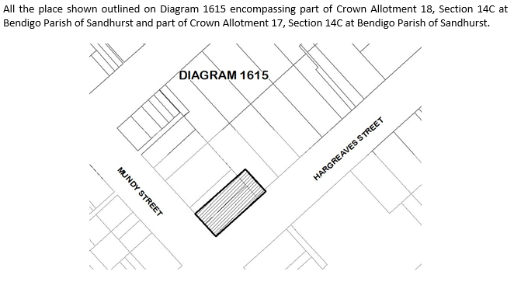

ATTACHMENT 2
EXTENT OF REGISTRATION

All the place shown outlined on Diagram 1615 encompassing part of Crown Allotment 18, Section 14C at Bendigo, Parish of Sandhurst to the extent of 7 metres from the north-west wall of the cottage; part of Crown Allotment 17, Section 14C at Bendigo, Parish of Sandhurst to the extent of 6.5 metres from the north-east wall of the cottage; and the pavement on Hargreaves Street to the extent of 4 metres from the title boundary, up to and including the kerb, but not including the road.

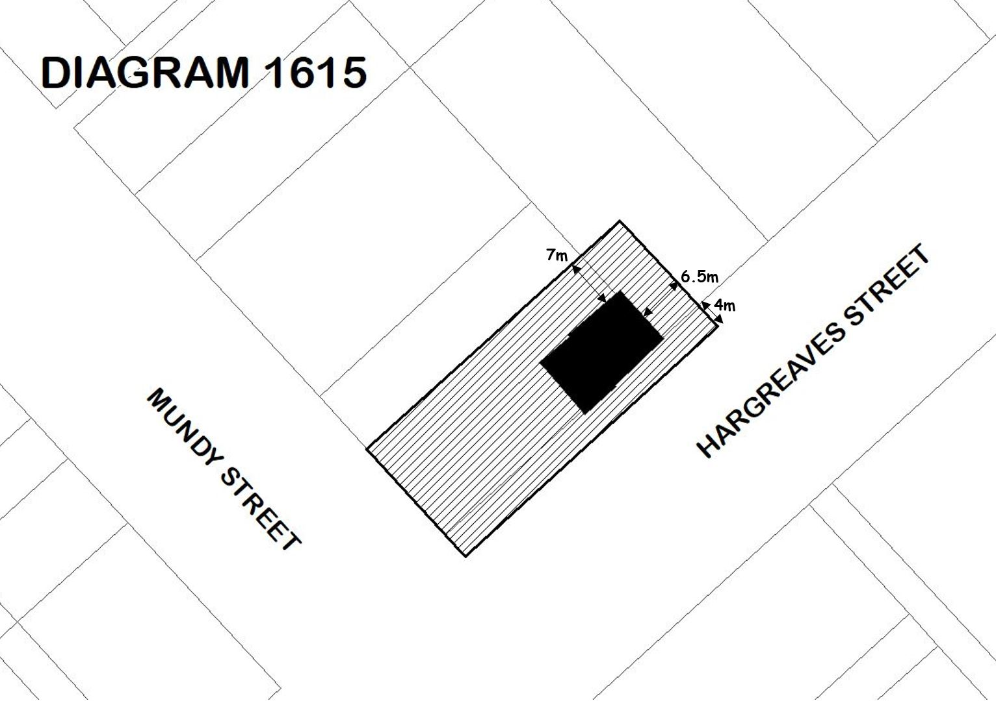

ATTACHMENT 3
CATEGORIES OF WORKS AND ACTIVITIES THAT MAY BE CARRIED OUT IN RELATION TO THE PLACE WITHOUT THE NEED FOR A PERMIT UNDER THE ACT
Specimen Cottage building
- Nil

1980s building (Building C of Bendigo TAFE)
Exterior
- All routine repair and maintenance works necessary for the upkeep of the building.

Interior
- All interior works.

Landscape
- Footpath, kerb and channel maintenance works
- Footpath, kerb and channel renewal (using like-for-like materials)
- Garden bed maintenance and renewal, including low level planting works

Revised Diagram 1615 provided by the Executive Director on 25 October 2019 was unchanged from that of the Recommendation, except where greater detail was provided in relation to the distance of the proposed extent from the building and title boundaries, respectively.

