Heritage Council Registrations and Reviews Committee

The Former Donaghy's Rope Walk Building (Part) and Rope-Making Machinery
95-103 Pakington Street, Geelong West, Greater Geelong City Council
Hearing – 12 December 2018 Members – Mr Lindsay Merritt (Chair), Dr Karen Murphy, Mr Jeffrey Robinson

DETERMINATION OF THE HERITAGE COUNCIL

After considering the Executive Director’s recommendation and submissions received, pursuant to Section 62 of the Heritage Act 2017, the Heritage Council has determined to amend item VHR H1169, The Former Donaghy's Rope Walk Building (Part) and Rope-Making Machinery in the Victorian Heritage Register by reducing the registered extent of the Place and including objects integral to the Place.

Lindsay Merritt (Chair)
Karen Murphy
Jeffrey Robinson

Decision Date – 18 April 2019

SUBMISSIONS
Executive Director, Heritage Victoria (‘the Executive Director’)
Further information was received from the Executive Director, Heritage Victoria (‘the Executive Director’) in relation to his recommendation.

Roperun Pty Ltd (‘the Nominator’)
The Nominator is the owner of that part of the Place west of the “canteen land” and was represented by Mr Nick Clements of Tract Consultants Pty Ltd. The Nominator was invited to make a written submission and provided some further information in relation to the Place.

Australia Bai Fu Xin (International) Investment Pty Ltd (‘Bai Fu Xin’)
Bai Fu Xin, represented by Mr Michael Liddy of Loop Architecture, is the owner of the land at the east end of the former rope walk building (Lot 1 on Plan of Subdivision 611365B) where remaining built fabric of the Place is located and provided some further information in relation to the Place and was invited to make a written submission.

Greater Geelong City Council (‘Geelong’)
A written submission was received from Geelong in response to the advertised recommendation.
INTRODUCTION/BACKGROUND
The place

- On 12 July 2018, the Executive Director made a recommendation (‘the Recommendation’) that 'The Former Donaghy's Rope Walk', located at 95-103 Pakington Street and 9 Scarlett Street, Geelong West (‘the Place’) be amended in the Victorian Heritage Register (‘the Register’); by removing land from the extent of registration; by listing objects at the Place in the Register pursuant to the Heritage Act 2017 (‘the Act’) as ‘Registered Objects Integral to a Registered Place’; by changing the name from: ‘The Former Donaghy's Rope Walk’ to ‘The Former Donaghy's Rope Walk Building and Rope Making Machinery’; and, by revising the Statement of Cultural Heritage Significance for the Place.
- The registration for the Place was first gazetted in the Register in 1996 under the Heritage Act 1995 and was to the extent of all of the land being the footprint of the former rope walk building between its eastern end nearest Pakington Street and the western boundary of what is referred to as the “canteen land” (Lot S4 on Plan of Subdivision 611365B abutting Waratah Street), being a distance of approximately 118.5 metres, together with all of the former rope walk building including its rope-making machinery, which occupied a distance of approximately 429.4 metres i.e approximately 310.9 metres beyond the land portion extent. The registration of the Place also included a permit exemption for demolition of the rope walk building beyond the western boundary of the canteen land. Reference to “the Place” in this document refers to the described extent as originally registered on 26 August 1996.
- The following is taken directly from the existing Statement of Cultural Heritage Significance (‘Statement of Significance’) for the Place:
“What is significant?
The former Donaghy's Rope Walk is located in the centre of Kinnear's Geelong rope works, a large industrial site. The rope walk is constructed of timber and corrugated iron and is approximately 500 metres in length. Within it rope was made up using specialised machinery known as "gallantynes, fore gears, travellers and top carts" two complete sets of which survive intact. The process has been redundant for many years and the original length of the rope walk has been shortened by several hundred metres. The present building, which is in very poor condition, especially beyond the western boundary of the former canteen, dates from the early twentieth century, but rope had been made at this site from 1874.
How is it significant?
The former Donaghy's rope walk is scientifically (technologically) and historically significant to the State of Victoria.
Why is it significant?
The former Donaghy's Rope Walk is historically and scientifically(technologically) important as a rare surviving example of the processor function of laying large ropes by the walk method. The rope walk building is of considerable age and important as the oldest and most intact of its type in Victoria. The rope walk contains equipment which is of at least three periods, possibly including the 1870s original machinery, early twentieth century improvements and 1950s imported components with local adaptations. Because of this the rope walk is of crucial scientific and historical importance for its ability to demonstrate technical accomplishment, especially in respect of the machinery designed and manufactured by Donaghy's themselves, such as the gallantyne, steel "top" and other rope making machinery.”
Nomination
- A nomination (application) to amend the extent of registration of the Place, by removing part of the Place from the Register, was lodged by the Nominator pursuant to s.62 of the Act on 4 June 2018 (‘the Nomination’) and the Nomination was accepted by the Executive Director on 25 June 2018.
Recommendation of the Executive Director
- On 12 July 2018, the Executive Director recommended pursuant to s.62 of the Act that the Place be amended in the Register by: removing land from the extent of registration; by listing objects at the Place in the Register as ‘Objects Integral to a Registered Place’; by changing the name from: ‘The Former Donaghy's Rope Walk’ to ‘The Former Donaghy's Rope Walk Building and Rope Making Machinery’; and, by revising the Statement of Significance for the Place.
Process following the Recommendation of the Executive Director

- After the Recommendation of 12 July 2018, notice was published in accordance with s.41 of the Act for a period of 60 days.
- One (1) submission was received pursuant to s.44 of the Act, from Geelong, supporting the Recommendation but requesting that several corrections and amendments be made to elements of the amended registration proposed by the Recommendation.
- In accordance with s.46(3) of the Act, the Heritage Council determined that a hearing would be conducted to determine the matter.
- The Heritage Council Registrations and Reviews Committee (‘the Committee’) was constituted to consider the Recommendation and the submission received in response to it and to make a determination, as delegated by the Heritage Council under ss.13, 15 of the Act. The Committee notified relevant parties, invited further written submissions under s.45 of the Act and a hearing was scheduled for 12 December 2018 (‘the hearing’).
- Following the notification of relevant parties, Geelong advised in writing that it did not wish for a hearing to be held and would not attend the hearing that had been scheduled. The Committee contacted other relevant parties in relation to the scheduled hearing and ascertained that other parties did not request that the scheduled hearing proceed. The Committee ultimately advised that the hearing would not proceed but that the scheduled hearing date would be retained in order to conduct a site visit. The Committee offered a further opportunity to make written or verbal submissions but no party elected to do so.

PRELIMINARY, PROCEDURAL AND OTHER MATTERS
Site inspection
- On 12 December 2018, the Committee made a site inspection of the Place accompanied by the Heritage Council Hearings Coordinator and the Heritage Council Business Support Officer. An agent representing Bai Fu Xin facilitated access to part of the Place. No submissions were sought, made or received at the time of the site inspection.
Conflicts of interest
- The Chair invited Committee members to make declarations, written or otherwise, in relation to any matters that may potentially give rise to an actual or apprehended conflict of interests. The Committee members were satisfied that there were no relevant conflicts of interests and made no such declarations.
Future use of the Place
- As with all Heritage Council registration matters, and pursuant to ss.44(4), 49 of the Act, the Committee notes that it is not within its remit to consider future development proposals, or pre-empt any decisions regarding future permits. Rather, it is the role of the Committee to determine whether or not all elements of the Place and land included in the extent of nomination, are of cultural heritage significance to the State of Victoria.

ISSUES
- The following section is not intended to be a complete record of submissions and information that were provided to the Committee. It is a summary of what the Committee considers to be the key issues, followed by an explanation of the position the Committee takes on each key issue.
- Any reference to Criteria refers to the Heritage Council Criteria for Assessment of Places of Cultural Heritage Significance (as adopted by the Heritage Council on 7 August 2008) [see Attachment 1].
- The extent of registration proposed by the Executive Director in the Recommendation was described as: “All of the place shown hatched on Diagram 1169 encompassing part of Lot 1 on Plan of Subdivision 611365 plus all the rope making machinery but minus the land shown cross hatched on Diagram 1169 being part of Lot S4 on Plan of Subdivision 611365” [see Attachment 2].
Summary of issues
- The Executive Director recommended that the registration for the Place be amended to remove land; to list objects at the Place in the Register as ‘Objects Integral to a Registered Place’; to change the name from: ‘The Former Donaghy's Rope Walk’ to ‘The Former Donaghy's Rope Walk Building and Rope-Making Machinery’; and, to revise the Statement of Significance for the Place.
- Geelong submitted that it was supportive of the Executive Director’s recommendation but submitted that several corrections should be made to elements of the proposed amended registration information and also that the description of the Place and the proposed Statement of Cultural Heritage Significance required further consideration.
Extent of registration
Submissions and evidence

- The Recommendation proposed an amended extent of registration on the basis that events which have occurred in relation to part of the originally registered extent have resulted in land, in the Executive Director’s view, as no longer having the cultural heritage values for which the Place was registered. The Executive Director justified the proposed extent on the basis that it would retain land, built heritage fabric and objects which still demonstrate the cultural heritage values for which the Place was originally registered.
- Geelong submitted that it was supportive of the amended extent of registration due to the demolition of parts of the former rope walk building, such demolition compromising or voiding the cultural heritage significance at State level.
Discussion and conclusions

- The Committee accepts that fabric of cultural heritage significance to the State of Victoria is no longer retained at the Place to the west of the canteen land.
- The Committee notes the 2017 demolition of that part of the rope walk building which was on land now described as 11 & 12 Sargeant Street and 9 & 10 Scarlett Street Geelong West (ie that part west of the canteen land) means that such land no longer has cultural heritage significance at a State level. Although not included in the application to amend the registration, the separate, earlier demolition of that part of the rope walk building on the canteen land (also refer paragraph 2 of this document) means that such land is also now being contemplated by the Committee as part of this determination.
- The Committee determines pursuant to ss.62, 49(1)(a) of the Act that the recommended extent of registration is appropriate and determines to amend the registration of the Place in line with the Recommendation. This is inclusive of the textual description for the recommended extent of registration containing the correction “Plan of Subdivision 611365B” (twice). The Committee appends improved mapping material to record the amended extent of registration as shown in Attachment 3, noting that only a minor part of the extent perimeter follows any title boundaries of Lot 1 on Plan of Subdivision 611365B. This means the east-west distance for the amended extent of registration is approximately 91.3 metres compared to the originally registered building extent of approximately 429.4 metres.
Categories of registration
Submissions and evidence

- The Executive Director recommended that, in addition to the Place being categorised as a ‘Registered Place’, that equipment and machinery at the Place be registered as “Registered Objects Integral to a Registered Place”.
- Geelong submitted that, in the event of the registration of the Place, the information included in the Register should include more detail about the equipment and machinery that is significant to the State as objects integral to the Place and submitted that an itemised list would be useful.

Discussion and conclusion

- The Committee agrees with Geelong that an itemised list of the equipment and machinery comprising the ‘Registered Objects Integral to the Registered Place’ should be developed.
- In conducting its site inspection of the Place, the Committee has made note of the objects integral to it and has also considered material provided by Geelong and the Executive Director relating to items found within the Place. Pursuant to s.49(1)(e) of the Act, the Committee determines that objects integral to the Place are to be included in the Register as set out in the appended schedule named ‘Extent of Registered Objects Integral to the Registered Place’ [Attachment 4].
- The Committee wishes to record its view that, in instances such as the present case, it would be preferable for a complete, itemised schedule of objects proposed to be registered as “Registered Objects Integral to a Registered Place” to be prepared as part of the assessment process under s.40(3)(c) of the Act and prior to the publication of the Recommendation.
- The Committee notes that under the Heritage Act 2017 objects that are part of the registration of a place are to be distinctly categorised as ‘Registered Objects Integral to a Registered Place’ to clearly ensure their protection. The Committee notes the submissions of Geelong in relation to the proposed amendment to the Statement of Significance to better reflect the fabric of the Place and its associated objects and requests the Executive Director consider this particular aspect when updating information on the Place in the Register to reflect this amendment..
The registered name and location description of the Place
Submissions and evidence

- The Executive Director in the Recommendation proposed the Place, formerly named “The Former Donaghy's Rope Walk”, be named “The Former Donaghy's Rope Walk Building and Rope Making Machinery”. The Executive Director’s view expressed in the Recommendation is that the proposed name better reflects the fabric of the Place and the objects integral to the Place.
Discussion and conclusion

- The Committee acknowledges the Executive Director’s reasoning for the name of the Place and agrees with the Executive Director that ‘The Former Donaghy's Rope Walk Building and Rope Making Machinery’ is, in principle, a suitable name for the Place.
- The Committee is of the view that, in addition to the name proposed by the Recommendation, the name of the Place should also include the term “(Part)”, to reflect the fact that the extant rope walk building is now only approximately one fifth of the overall length of the building as it was originally registered. The Committee therefore determines pursuant to s.49(1)(a) of the Act that the name of the Place is to be: ‘The Former Donaghy's Rope Walk Building (Part) and Rope-Making Machinery’.
- The Committee also determines pursuant to s.49(1)(a) of the Act that the location description in the Register for the reduced extent of the Place is to be “95-103 Pakington Street, Geelong West, Greater Geelong City Council.” In so doing, the Committee notes that the reduced extent of the Place is solely within Lot 1 on Plan of Subdivision 611365B, such lot not having any abuttal to Scarlett Street.
Statement of cultural heritage significance
- Geelong submitted that a more informed significance analysis should be given, based on a comparative analysis and submitted that the proposed wording does not provide sufficient information as to why the Place is of State significance.

Discussion and conclusion

- The Committee agrees with Geelong that the assessment process under s.40(3)(c) of the Act, and being integral to the Recommendation, should preferably have been undertaken in greater depth, for the following reasons: -

  - As shown in the relevant Register excerpt forming part of the amendment application (or nomination), the original registration of the Place took place at the time of transition between the former Historic Buildings Act 1981 and the former Heritage Act 1995. It is highly probable there has been considerable development and refinement between early 1996 and mid 2018 with respect to the relevant policy framework relating to criteria and threshold guidelines for assessment of places and objects of State-level cultural heritage significance.

  - The “How is it Significant?” part of the Statement of Significance states “The former Donaghy’s rope walk is scientifically (technologically) and historically significant to the State of Victoria” i.e. expressly referring to two aspects of consideration for State-level significance. The corresponding part within the Recommendation for “the Proposed Statement of Cultural Heritage Significance” states “The Former Donaghy’s Rope Walk Building and Rope Making Machinery is of historical significance to the State of Victoria. It satisfies the following criterion for inclusion in the Victorian Heritage Register:

Criterion A - Importance to the course, or pattern of Victoria’s cultural history

i.e. referring to one heritage assessment criterion for State-level significance being satisfied. The Recommendation does not contain any reasons by way of first-principles, present-day assessment for the reduced extent of the Place and objects integral to the Place against the tests set out in The Victorian Heritage Register Criteria and Threshold Guidelines (2014), nor does the Recommendation contain any comparison against any other extant rope walk sites in Victoria, inclusive of any surviving on-site equipment and machinery.

- The Committee finds that it is not in a position to further consider the question of which Criteria are now satisfied at State level as the Recommendation does not contain any assessment information thereto nor was this subject to any detailed and specific comments in Geelong’s submission.
- The Committee notes the “Proposed Statement of Cultural Heritage Significance” as in the Recommendation, also that Criterion A is consistent, in part, with the Statement of Significance.

Proposed permit EXEMPTIONS
Submissions and evidence

- Geelong made no submission in relation to the “Proposed Permit Exemptions” contained in the Recommendation.

Discussion and conclusion

- The Committee has received the clear impression that the part of the Recommendation under the overall heading of “Proposed Permit Policy” consists of two sub-parts. The first sub-part has minor headings of “Preamble”, “Conservation management plans”, “Aboriginal cultural heritage”, “Other approvals”, “Archaeology”, all intending to serve a purpose “to assist when considering or making decisions regarding works to a registered place”. The second sub-part is under the smaller font sub-heading of “Proposed Permit Exemptions (Under s.49(3) of the Heritage Act)” and includes five “general conditions” followed by a listing of “Specific Permit Exemptions”.
- The Committee notes that the first sub-part referred to in paragraph 39 and other aspects of the Recommendation do not take into account the additional category of registration, being Registered Object Integral to a Registered Place. The Committee requests that the Executive Director consider updating all relevant information on the Place in the Register to reflect this amendment.
- For the second sub-part referred to in paragraph 39 the Committee determines pursuant to s.49(3) of the Act that Attachment 5 to this document lists categories of works or activities which may be carried out in relation to the Place or objects integral to the Place for which a permit under the Act is not required. The contents of Attachment 5 are the same as those listed under the second sub-part referred to in paragraph 39 of this document, but containing several amendments to expressly take into account objects integral to the Place.
Other matters

Submissions and evidence

- Geelong submitted that some of the information in the Recommendation required correction.

Discussion and conclusion

- The Committee notes the submission of Geelong and after consideration of the Recommendation and the submission, requests the Executive Director consider that all relevant information on the Place in the Register is inclusive of the following, where appropriate;

  - The owner of that part of the currently registered extent situated west of the canteen land was the amendment nominator, not Geelong.

  - Aerial photography and documents included within Geelong’s submission suggests demolition of that part of the former rope walk building within the canteen land took place sometime in late 2008 after a change in ownership.

  - The rationale for removal of that part of land extent within the canteen land is now best described as “The 2017 demolition of that part of the rope walk building which was on land now described as 11, 12 Sargeant Street and 9, 10 Scarlett Street Geelong West (ie that part west of the canteen land) means that such land no longer has cultural heritage significance at a State level. Although not included in the application to amend the registration, the separate, earlier demolition of that part of the rope walk building on the canteen land means that such land is also being dealt with in the amendment process.”

CONCLUSION
- After considering the Executive Director’s recommendation and submissions received, pursuant to Section 62 of the Heritage Act 2017, the Heritage Council has determined to amend item VHR H1169 in the Victorian Heritage Register by reducing the registered extent of the Place and including registered objects integral to the Place.

ATTACHMENT 1
HERITAGE COUNCIL CRITERIA FOR ASSESSMENT OF PLACES OF CULTURAL HERITAGE SIGIFICANCE

CRITERION A | Importance to the course, or pattern, of Victoria’s cultural history
CRITERION B | Possession of uncommon, rare or endangered aspects of Victoria’s cultural history.
CRITERION C | Potential to yield information that will contribute to an understanding of Victoria’s cultural history.
CRITERION D | Importance in demonstrating the principal characteristics of a class of cultural places or environments.
CRITERION E | Importance in exhibiting particular aesthetic characteristics.
CRITERION F | Importance in demonstrating a high degree of creative or technical achievement at a particular period.
CRITERION G | Strong or special association with a particular community or cultural group for social, cultural or spiritual reasons. This includes the significance of a place to Indigenous peoples as part of their continuing and developing cultural traditions.
CRITERION H | Special association with the life or works of a person, or group of persons, of importance in Victoria’s history.

These were adopted by the Heritage Council at its meeting on 7 August 2008, and replace the previous criteria adopted by the Heritage Council on 6 March 1997.

ATTACHMENT 2

RECOMMENDED EXTENT OF REGISTRATION

All of the place shown hatched on Diagram 1169 encompassing part of Lot 1 on Plan of Subdivision 611365 plus all the rope making machinery but minus the land shown cross hatched on Diagram 1169 being part of Lot S4 on Plan of Subdivision 611365.

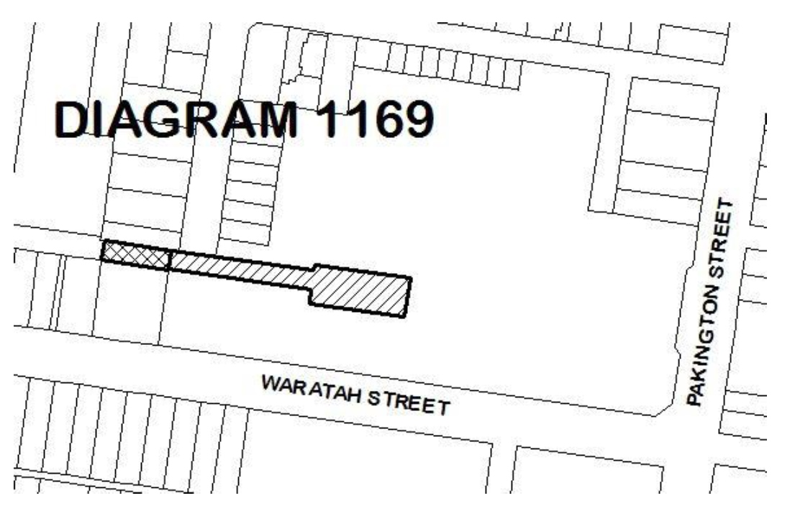

The extent of registration of place or object name [sic] in the Victorian Heritage Register affects the whole place shown on Diagram 1169 including the land, all buildings (including the exteriors and interiors) and other features.

ATTACHMENT 3
AMENDED EXTENT OF REGISTERED PLACE

All of the place shown hatched on Diagram 1169 encompassing part of Lot 1 on Plan of Subdivision 611365B and to the extent of the outer surfaces of the former rope walk building (part) on the northern, eastern and western edges of such buliding and for part of the southern edge of such building.

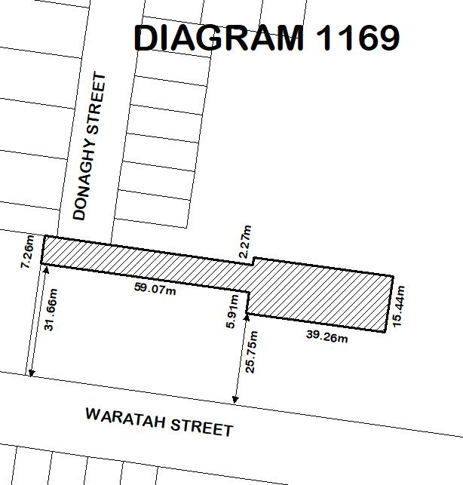

The extent of registration of The Former Donaghy’s Rope Walk Building (Part) and Rope-Making Machinery in the Victorian Heritage Register affects the whole place shown on Diagram 1169 including the land, all buildings (including the exteriors and interiors) and all registered objects integral to the registered place.

ATTACHMENT 4
EXTENT OF REGISTERED OBJECTS INTEGRAL TO THE REGISTERED PLACE

Reference No. | Description of Registered Object Integral to the Registered Place
1 | Dual tramlines on which mobile components run; 3’- 6” gauge, with 40lb rail, dog-spiked to timber sleepers.
2 | Fore gear (or fore twist) – stationary piece of equipment at head of each walk to impart twist on the strands.
3 | Rack of spools or bobbins in front of the fore gear and a die through which strands are threaded for running along walk.
4 | Traveller – solid 4-wheeled carriage (with seat for operator) – moves along tramline with several hooks to which strands are attached for drawing out and twisting. Central, freely revolving hook for final twist on finished rope – “laying” the rope.
5 | Top cart – between fore gear and traveller, carries the top and driven along the walk by the ground rope, running on one side on pulleys.
6 | Gallantyne – series of pulleys behind fore gear, with heavy weight attached to one pulley which descends into a pit in the floor. This includes cogs and shaft sleeve sets.
7 | Stake heads – hinged from wall posts on the north side and from free-standing or intermediate roof supports on south side. Generally have cast iron brackets of identical pattern which provide for the hinges and attachment of an upper and lower timber beam fitted with pegs. This supported the rope at about 5m intervals.
8 | Timber chute – running beside each walk to place the rope so it could be wound back.
9 | Wooden plates with painted distances from the fore gear.
10 | Control and signal ropes – for setting the top cart in motion and signalling to operator at fore gear to start or stop the machine.
Note: There is a ‘northern walk’ and a ‘southern walk’ within the building with the latter being approximately 30 metres shorter than the former. Each rope walk has a set of machinery and equipment, as above, but these differ in layout, design and hand-painted reference numbers or other markings. However, there does not appear to be any extant gallantyne at the head of the northern walk.

ATTACHMENT 5
PROPOSED PERMIT EXEMPTIONS (UNDER SECTION 49(3) OF THE HERITAGE ACT)

It should be noted that Permit Exemptions can be granted at the time of registration (under s.49(3) of the Heritage Act). Permit Exemptions can also be applied for and granted after registration (under s.92 of the Heritage Act).

General Condition 1
All exempted alterations are to be planned and carried out in a manner which prevents damage to the fabric of the registered place or registered object.

General Condition 2
Should it become apparent during further inspection or the carrying out of works that original or previously hidden or inaccessible details of the place or object are revealed which relate to the significance of the place or object, then the exemption covering such works shall cease and Heritage Victoria shall be notified as soon as possible.

General Condition 3
All works should ideally be informed by Conservation Management Plans prepared for the place. The Executive Director is not bound by any Conservation Management Plan, and permits still must be obtained for works suggested in any Conservation Management Plan.

General Condition 4
Nothing in this determination prevents the Heritage Council from amending or rescinding all or any of the permit exemptions.

General Condition 5
Nothing in this determination exempts owners or their agents from the responsibility to seek relevant planning or building permits from the relevant responsible authority, where applicable.

Specific Permit Exemptions

Exterior
- Minor patching, repair and maintenance which replaces like with like.
- Removal of non-original items such as pipe work, ducting, wiring and making good in a manner that does not have a detrimental effect on the heritage fabric.
- Removal of non-original external fixtures and fittings such as hot water services and taps in a manner that does not have a detrimental effect on the heritage fabric.

Interior
- Painting of previously painted walls and ceilings provided that preparation or painting does not remove evidence of any original paint or other decorative scheme.
- Installation, removal or replacement of non-original carpets and/or flexible floor coverings, curtain tracks, rods and blinds in a manner that does not have a detrimental effect on the heritage fabric.

- Installation, removal or replacement of hooks, nails and other devices for the hanging of mirrors, paintings and other wall mounted art in a manner that does not have a detrimental effect on the heritage fabric.
- Demolition or removal of non-original wall linings (including plasterboard, laminate and Masonite), non-original flush panel or part-glazed laminated doors, kitchen wall tiling and equipment, lights and built-in cupboards in a manner that does not have a detrimental effect on the heritage fabric.

- Installation, removal or replacement of bulk insulation and/or plant in the roof space in a manner that does not have a detrimental effect on the heritage fabric.

Note: The above exemptions do not apply to any registered object integral to the registered place within or attached to the building.

