**HERITAGE COUNCIL DETERMINATION**

|  |  |
| --- | --- |
| Determination Date | Thursday 2 June 2016 |
| Place/Object Name | Sandringham Masonic Hall |
| Location | 23 Abbott Street, Sandringham |
| VHR Number | H2355 |
| Place Category | Heritage Place |

At a meeting of the Heritage Council on 2 June 2016 it was determined to include this place in the Victorian Heritage Register.

The Heritage Council endorses the attached report.



**Professor Stuart Macintyre AO**

**Chair, Heritage Council of Victoria**

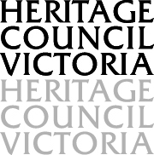

**ASSESSMENT OF CULTURAL**

**HERITAGE SIGNIFICANCE AND**

**EXECUTIVE DIRECTOR**

**RECOMMENDATION TO THE**

**HERITAGE COUNCIL**



|  |  |
| --- | --- |
| **NAME** | sandringham masonic HALL |
| **LOCATION** | 23 abbott street, sandringham  CITY OF BAYSIDE |
| **VHR NUMBER:** | PROV H2355 |
| **HERITAGE OVERLAY NO:** | CITY OF BAYSIDE, not in HO |
| **CATEGORY:** | HERITAGE PLACE |
| **FILE NUMBER:** | FOL/15/48539 |
| **HERMES NUMBER:** | 197956 |

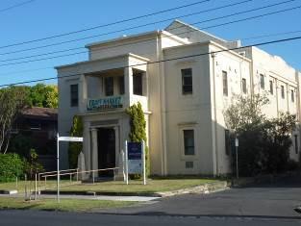 

**EXECUTIVE DIRECTOR RECOMMENDATION TO THE HERITAGE COUNCIL:**

* That the Sandringham Masonic Hall be included as a Heritage Place in the Victorian Heritage Register under the *Heritage Act 1995* [Section 32 (1)(a)].

**TIM SMITH**

**Executive Director**

**Recommendation Date:** 11 March 2016

# EXTENT OF NOMINATION

The extent of nomination includes the entire cadastral block which includes the forecourt and rear car park and the two storey building including ceilings, walls, doorways and stained glass.

# 

# RECOMMENDED REGISTRATION

DRAFT ONLY: NOT ENDORSED BY THE HERITAGE COUNCIL

All of the place shown hatched on Diagram 2355 encompassing all of Lot 88 on Lodged Plan 4632.

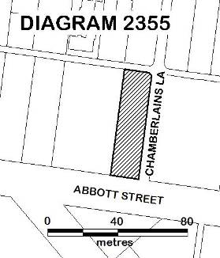

The extent of registration of the Sandringham Masonic Hall in the Victorian Heritage Register affects the whole place shown on Diagram 2355 including the land and building (including the interiors and exteriors).

# AERIAL PHOTO OF THE PLACE SHOWING PROPOSED REGISTRATION

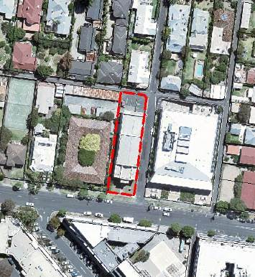

# STATEMENT OF CULTURAL HERITAGE SIGNIFICANCE

DRAFT ONLY: NOT ENDORSED BY THE HERITAGE COUNCIL

#### What is significant?

Sandringham Masonic Hall consisting of a large brick hall (1931), including interiors (main hall, lodge room, stairs and upper foyer) and adjoining rear brick addition (1956).

### History Summary

The Sandringham Masonic Hall was built in 1931 to provide a purpose-built facility for five lodges operating in the locality. The first of these, Sandringham Lodge No 220, was founded in 1912. The site in Abbott Street, Sandringham was acquired by the newly formed Sandringham District Hall Co Ltd in 1924 and plans for a masonic hall were prepared by architect Gordon J Sutherland. On 27 May 1931 the foundation stone for the Sandringham Masonic Hall was laid by Lord Somers, in his capacity as Grand Master of the Masonic Lodge in Victoria. At its peak the Sandringham Masonic Hall provided a meeting place for fourteen lodges and the building was enlarged in 1956 to provide for increasing membership.

### Description Summary

The Sandringham Masonic Hall is a two storey rendered brick building designed in an Egyptian Revival style. It is a large parapeted building with a concealed gabled roof above the main lodge room and a symmetrical front facade. The Egyptian Revival style is evident in the dominant projecting two storey central front porch which contains cavetto cornices, columns with palmiform capitals, papyrus-bundle capitals, side grilles with stylised columns, two winged solar discs and two flanking obelisks. Side elevations contain small window openings and a rear brick addition continues the two storey form of the original building.

The Sandringham Masonic Hall consists of a main hall and entrance foyer at ground level and a lodge room and foyer at first floor level. Panelled ceilings, wall pilasters, window and door frames and stained glass windows are decorated with Egyptian-themed motifs, including palmette and papyrus mouldings, astrological symbols, winged solar discs and pentangles. Masonic symbols, such as the compass and square, are incorporated into the decorative scheme. The lodge room contains original light fittings, ritual furniture and raised side platforms with timber bench seating. The 1956 addition at the rear of the building contains a small lodge room at the upper level .

This site is part of the traditional land of the people of the Kulin Nation.

#### How is it significant?

Sandringham Masonic Hall is of historical, architectural and aesthetic significance to the State of Victoria. It satisfies the following criterion for inclusion in the Victorian Heritage Register:

Criterion A

Importance to the course, or pattern, of Victoria’s cultural history.

**Criterion B**

Possession of uncommon, rare or endangered aspects of Victoria's cultural history.

Criterion E

Importance in exhibiting particular aesthetic characteristics.

#### Why is it significant?

Sandringham Masonic Hall is significant at the State level for the following reasons:

Sandringham Masonic Hall is of historical significance due to its associations with freemasonry which played an important cultural role in Victoria. The large and substantial building illustrates the popularity of freemasonry particularly after World War I. [Criterion A]

Sandringham Masonic Hall is a rare and distinctive example of the Egyptian Revival architectural style in Victoria. There are very few buildings that adopt this style in Victoria and the Sandringham Masonic Hall is one of only three known examples of this style applied to a masonic hall. It is of particular note as the style is applied to both the exterior and interior of the building. The adoption of the Egyptian Revival style demonstrates the ideological link between freemasonry and ancient Egypt. It reflects both the discovery of Tutankhamen’s tomb in 1922 and the return of Australian soldiers from World War I with Egyptian objects displaying such motifs as the winged disc. [Criterion B]

Sandringham Masonic Hall is of aesthetic significance for its extensive and largely intact symbolic Egyptian-themed interior decorative scheme, particularly in the main hall, lodge room and upper foyer. It is a rare and unusual style of decoration in Victoria. [Criterion E]

# RECOMMENDATION REASONS

REASONS FOR RECOMMENDING INCLUSION IN THE VICTORIAN HERITAGE REGISTER [s.34A(2)]

Following is the Executive Director's assessment of the place against the tests set out in *The Victorian Heritage Register Criteria and Thresholds Guidelines (2014).*

## CRITERION A

**Importance to the course, or pattern, of Victoria’s cultural history.**

STEP 1: A BASIC TEST FOR SATISFYING CRITERION A

The place/object has a *clear ASSOCIATION* with an event, phase, period, process, function, movement, custom or way of life in Victoria’s cultural history.

**Plus**

The association of the place/object to the event, phase, etc *IS EVIDENT* in the physical fabric of the place/object and/or in documentary resources or oral history.

**Plus**

The *EVENT, PHASE, etc* is of *HISTORICAL IMPORTANCE,* having made a strong or influential contribution to Victoria.

Executive Director’s Response

Sandringham Masonic Hall has clear associations with freemasonry which played an important cultural role in Victoria. This association is evident in the physical fabric and documentary resources. The existing fabric of this large and substantial building clearly illustrates the popularity of freemasonry particularly after World War I.

Criterion A is likely to be satisfied.

STEP 2: A BASIC TEST FOR DETERMINING STATE LEVEL SIGNIFICANCE FOR CRITERION A

The place/object allows the clear association with the event, phase etc. of historical importance to be *UNDERSTOOD BETTER THAN MOST OTHER PLACES OR OBJECTS IN VICTORIA WITH SUBSTANTIALLY THE SAME ASSOCIATION.*

Executive Director’s Response

Seven masonic halls are included in the Victorian Heritage Register. Four of these were constructed in the nineteenth century and illustrate an earlier period in the historical development of freemasonry in Victoria. These are the Masonic Hall, Camperdown, 1867-68 (VHR H1414), the Masonic Hall, Bendigo, 1873-74 (VHR H0119), the Former Freemasons Hall, South Melbourne, 1876 (VHR H0538) and Zetland Lodge, Kyneton, 1866 & redecorated in 1904 (VHR H1988).

Freemasonry saw enormous growth from the 1920s and one masonic hall, Emulation Hall, Canterbury 1927-28 (VHR H2298) from this period is included in the Victorian Heritage Register. Together with Emulation Hall, the Sandringham Masonic Hall clearly demonstrates the development of freemasonry in Victoria. They both remain highly intact to illustrate the popularity of freemasonry in Victoria after World War I.

Criterion A is likely to be satisfied at the State level.

## CRITERION B

**Possession of uncommon, rare or endangered aspects of Victoria’s cultural history.**

STEP 1: A BASIC TEST FOR SATISFYING CRITERION B

The place/object has a *clear ASSOCIATION* with an event, phase, period, process, function, movement, custom or way of life of importance in Victoria’s cultural history.

**Plus**

The association of the place/object to the event, phase, etc *IS EVIDENT* in the physical fabric of the place/object and/or in documentary resources or oral history.

**Plus**

The place/object is *RARE OR UNCOMMON*, being one of a small number of places/objects remaining that demonstrates the important event, phase etc.

OR

The place/object is  *RARE OR UNCOMMON*, containing unusual features of note that were not widely replicated

OR

The existence of the *class* of place/object that demonstrates the important event, phase etc is *ENDANGERED* to the point of rarity due to threats and pressures on such places/objects.

Executive Director’s Response

The Sandringham Masonic Hall has clear associations with freemasonry in Victoria. It is one of a group of masonic halls built in the late 1920s and early 1930s which demonstrate the rise in popularity of freemasonry after World War I. The association is evident in the physical fabric and documentary resources.

The Sandringham Masonic Hall is of particular note as a rare and distinctive example of the Egyptian Revival style in Victoria. There are few buildings in Victoria that adopt this style and fewer that apply the style to both the exterior and interior.

Criterion B is likely to be satisfied.

STEP 2: A BASIC TEST FOR DETERMINING STATE LEVEL SIGNIFICANCE FOR CRITERION B

The place/object is *RARE, UNCOMMON OR ENDANGERED* within Victoria.

Executive Director’s Response

Sandringham Masonic Hall is one of only three known examples of Egyptian Revival style masonic halls in Victoria. Together with Emulation Hall, Canterbury (VHR H2298) and Zetland Lodge, Kyneton (VHR H1988), the style adopted at the Sandringham Masonic Hall demonstrates the important ideological link between freemasonry and ancient Egypt. The rare adoption of this style reflects both the discovery of Tutankhamen’s tomb in 1922 and the return of Australian soldiers from World War I with Egyptian objects displaying such motifs as the winged disc.

Criterion B is likely to be satisfied at the Sate level.

## Criterion E

**Importance in exhibiting particular aesthetic characteristics.**

STEP 1: A BASIC TEST FOR SATISFYING CRITERION E

The *PHYSICAL FABRIC* of the place/object clearly exhibits particular aesthetic characteristics.

Executive Director’s Response

Sandringham Masonic Hall is of aesthetic significance for its extensive symbolic Egyptian-themed interior decorative scheme. This is particularly evident in the main hall, lodge room and upper foyer.

Criterion E is likely to be satisfied.

STEP 2: A BASIC TEST FOR DETERMINING STATE LEVEL SIGNIFICANCE FOR CRITERION E

The aesthetic characteristics are *APPRECIATED OR VALUED* by the wider community or an appropriately-related discipline as evidenced, for example, by:

* *critical recognition* of the aesthetic characteristics of the place/object within a relevant art, design, architectural or related discipline as an outstanding example within Victoria; or
* wide public *acknowledgement of exceptional merit*in Victoria in medium such as songs, poetry, literature, painting, sculpture, publications, print media etc.

Executive Director’s Response

The intact interiors at the Sandringham Masonic Hall form an outstanding and rare collection of an Egyptian-themed decorative scheme in Victoria. The aesthetic characteristics of the interiors at Emulation Hall, Canterbury ((VHR H2298) and the Sandringham Masonic Hall have received critical recognition as outstanding and rare examples in Victoria.

Criterion E is likely to be satisfied at the State level.

# PROPOSED PERMIT POLICY

DRAFT ONLY – NOT YET APPROVED BY THE HERITAGE COUNCIL

Preamble

The purpose of the Permit Policy is to assist when considering or making decisions regarding works to a registered place. It is recommended that any proposed works be discussed with an officer of Heritage Victoria prior to making a permit application. Discussing proposed works will assist in answering questions the owner may have and aid any decisions regarding works to the place.

**The extent of registration of the Sandringham Masonic Hall in the Victorian Heritage Register affects the whole place shown on Diagram 2355 including** **the land and building (including the interiors and exteriors).** Under the *Heritage Act 1995* a person must not remove or demolish, damage or despoil, develop or alter or excavate, relocate or disturb the position of any part of a registered place or object without approval. It is acknowledged, however, that alterations and other works may be required to keep places and objects in good repair and adapt them for use into the future.

If a person wishes to undertake works or activities in relation to a registered place or registered object, they must apply to the Executive Director, Heritage Victoria for a permit. The purpose of a permit is to enable appropriate change to a place and to effectively manage adverse impacts on the cultural heritage significance of a place as a consequence of change. If an owner is uncertain whether a heritage permit is required, it is recommended that Heritage Victoria be contacted.

Permits are required for anything which alters the place or object, unless a **permit exemption** is granted. Permit exemptions usually cover routine maintenance and upkeep issues faced by owners as well as minor works or works to the elements of the place or object that are not significant. They may include appropriate works that are specified in a conservation management plan. Permit exemptions can be granted at the time of registration (under s.42 of the Heritage Act) or after registration (under s.66 of the Heritage Act).

It should be noted that the addition of new buildings to the registered place, as well as alterations to the interior and exterior of existing buildings requires a permit, unless a specific permit exemption is granted.

Conservation management plans

It is recommended that a Conservation Management Plan is developed to manage the place in a manner which respects its cultural heritage significance.

**Aboriginal cultural heritage**

* Under the *Heritage Act 1995* permits are required for any works or activities which alter the place or object, unless a permit exemption is granted. This applies to all parts of the registered place including fabric associated with Aboriginal and non-Aboriginal cultural heritage values.
* If works are proposed which have the potential to disturb or have an impact on Aboriginal cultural heritage it is necessary to contact the Office of Aboriginal Affairs Victoria to ascertain any requirements under the *Aboriginal Heritage Act 2006.*
* If any Aboriginal cultural heritage is discovered or exposed at any time it is necessary to immediately contact the Office of Aboriginal Affairs Victoria to ascertain requirements under the*Aboriginal Heritage Act 2006*.

**Other approvals**

Please be aware that approval from other authorities (such as local government) may be required to undertake works.

**Archaeology**

Ground disturbance may affect the archaeological significance of the place and, subject to the exemptions stated in this document, requires a permit.

Under the terms of the Heritage Act 1995 (see section 127), it is an offence to disturb any historical archaeological site in Victoria, unless Consent has been obtained from the Executive Director. This is a requirement for all historical archaeological sites in the state, regardless of whether they are included in any statutory listing.

**Cultural heritage significance**

Overview of significance

The cultural heritage significance of the Sandringham Masonic Hall lies in its rarity and intactness as a masonic hall designed in an Egyptian Revival style. The display of this both externally and internally is of great importance.

**Land:** All of the land identified in Diagram 2355 is of primary cultural heritage significance.

# PROPOSED PERMIT EXEMPTIONS (under section 42 of the Heritage Act)

DRAFT ONLY – NOT YET APPROVED BY THE HERITAGE COUNCIL – RECOMMENDED UNDER SECTION 33 OF THE HERITAGE ACT

It should be noted that Permit Exemptions can be granted at the time of registration (under s.42(4) of the Heritage Act). Permit Exemptions can also be applied for and granted after registration (under s.66 of the Heritage Act)

General Condition 1

All exempted alterations are to be planned and carried out in a manner which prevents damage to the fabric of the registered place or object.

General Condition 2

Should it become apparent during further inspection or the carrying out of works that original or previously hidden or inaccessible details of the place or object are revealed which relate to the significance of the place or object, then the exemption covering such works shall cease and Heritage Victoria shall be notified as soon as possible.

General Condition 3

All works should be informed by Conservation Management Plans prepared for the place. The Executive Director is not bound by any Conservation Management Plan, and permits still must be obtained for works suggested in any Conservation Management Plan.

General Condition 4

Nothing in this determination prevents the Heritage Council from amending or rescinding all or any of the permit exemptions.

General Condition 5

Nothing in this determination exempts owners or their agents from the responsibility to seek relevant planning or building permits from the relevant responsible authority, where applicable.

Specific Permit Exemptions

#### Exterior

* Minor patching, repair and maintenance which replace like with like.
* Removal of non-original items such as air conditioners, pipe work, ducting, wiring, antennae, aerials etc and making good in a manner not detrimental to the cultural heritage significance of the place.
* Installation or removal of non-original external fixtures and fittings such as hot water services and taps in a manner not detrimental to the cultural heritage significance of the place.
* Installation or repair of damp-proofing by either injection method or grouted pocket method in a manner which does not affect the cultural heritage significance of the place.
* Painting of previously painted surfaces provided that preparation or painting does not remove the original paint or other decorative scheme.

#### Interior

* Painting of previously painted walls and ceilings provided that preparation or painting does not remove any original paint or other decorative scheme.
* Installation, removal or replacement of non-original curtain tracks, rods and blinds.
* Installation, removal or replacement of hooks, nails and other devices for the hanging of mirrors, paintings and other wall mounted art.
* Installation of honour boards and the like.
* Removal or replacement of non-original door and window furniture including, hinges, locks, knobsets and sash lifts.
* Refurbishment of existing bathrooms, toilets and kitchens including removal, installation or replacement of sanitary fixtures and associated piping, mirrors, wall and floor coverings.
* Removal of tiling or concrete slabs in wet areas provided there is no damage to or alteration of original structure or fabric.
* Installation, removal or replacement of ducted, hydronic or concealed radiant type heating provided that the installation does not damage existing skirtings and architraves and that the central plant is concealed, and is done in a manner not detrimental to the cultural heritage significance of the place.
* Installation, removal or replacement of electrical wiring provided that all new wiring is fully concealed and any original light switches, pull cords, push buttons or power outlets are retained in-situ. Note: if wiring original to the place was carried in timber conduits then the conduits should remain in situ.
* Installation, removal or replacement of electric clocks, public address systems, detectors, alarms, emergency lights, exit signs, luminaires and the like on plaster surfaces.
* Installation, removal or replacement of bulk insulation in the roof space.
* Installation of plant within the roof space.
* Installation of new fire hydrant services including sprinklers, fire doors and elements affixed to plaster surfaces provided it is done in a manner not detrimental to the cultural heritage significance of the place.

LANDSCAPE:

* The process of gardening, including mowing, hedge clipping, bedding displays, removal of dead shrubs and replanting the same species or cultivar, disease and weed control, and maintenance to care for existing plants.
* Pruning, lopping or removal of trees and vegetation.
* Subsurface works involving the installation, removal or replacement of watering and drainage systems or services outside the canopy edge of significant trees in accordance with AS4970 and on the condition that works do not impact on archaeological features or deposits
* Removal of plants listed as noxious weeds in the Catchment and Land Protection Act 1994
* Vegetation protection and management of possums and vermin.

# RELEVANT INFORMATION

|  |  |
| --- | --- |
| **Local Government Authority** | Bayside |
| **HERITAGE LISTING INFORMATION** |  |
| * **Heritage Overlay:** | No (see below) |
| * **Heritage Overlay Controls:** | No |
| * **Other listing:** | No |

#### Comments:

The Sandringham Masonic Hall was recommended for inclusion in the Schedule to the Heritage Overlay of the Bayside Planning Scheme by Heritage Alliance in the ‘City of Bayside Inter-War and Post-War Heritage Study’ (2008). The majority of the study’s recommendations were rejected by Bayside City Council in 2008.

#### HISTORY

CONTEXTUAL HISTORY

*Freemasonry*

The basic organisation of freemasonry is the masonic lodge of members and masonic halls were constructed to provide a meeting place for these groups as they were established in Victoria. When individual lodges were first established they often met in existing buildings such as recreation halls, and a lodge room was set up within these buildings to suit their needs. A number of different lodges often used the same rooms for their separate meetings. Once finances permitted, often a number of years later, individual lodges purchased either an existing building for their use, or purchased land and constructed a purpose-built hall. Again a number of individual lodges often met in the same building.

The first lodge meeting in Victoria was held in 1839. The United Grand Lodge of Victoria was established in 1889, bringing together lodges which had previously worked under separate constitutions and this resulted in increased numbers of suburban lodges. A large increase in the popularity of freemasonry in Victoria in the early 1920s resulted in the formation of many suburban and country lodges and the necessity for meeting places. More than twelve masonic halls were built in Victoria between 1922 and 1925 including halls at Brunswick, Greensborough, Ivanhoe, Oakleigh, Prahran, Avoca, Colac, Kaniva, Maffra, Nagambie, Wycheproof and Yarrawonga.

*The Egyptian Revival style*

Napoleonic discoveries in the late eighteenth and early nineteenth century brought accurate representations of Ancient Egyptian art and architecture to Europe. As a result the Egyptian Revival style was adopted in a variety of the arts, including the design of buildings, furniture and jewellery.

In Australia the style was used in the design of structures and buildings in the 1820s and remained popular until the 1840s. It was generally reserved for monuments and synagogues. Examples include an obelisk designed by Francis Greenway and constructed in Macquarie Place, Sydney in 1818 and synagogues in Sydney (1841), Hobart (1843-45) and Launceston (1844-46). As Melbourne was largely settled after this period there are no early examples of this style in Victoria and the Egyptian Revival style remains rare in the state.

Two early twentieth century examples of the Egyptian Revival style in Victoria are the Syme Memorial in the Boroondara General Cemetery (Walter Butler, 1908, VHR H0049) and the internal decoration of Zetland Lodge, Kyneton, (1905-11, VHR H1988). However the style remained rare in Victoria. Following both the return of Australian soldiers from World War I, who brought Egyptian objects incorporating scarab and winged disc motifs, and the discovery of Tutankhamen's tomb in 1922, Egyptian motifs appeared as part of Art Deco and Free Classical decorative schemes.

A strict application of the style was generally reserved for monuments or building types that had a philosophical connection with Egyptian culture, notably masonic halls. The belief that freemason ceremonies and rituals descended at least in part from the religious beliefs and practices of the latter, led to the adoption of this style in the design of masonic halls. Motifs found at the Sandringham Masonic Hall include the winged disc with uraeus (sacred serpent) which is an Egyptian symbol of protection.

*Freemasonry and the Egyptian Revival Style*

The relationship between Ancient Egypt and freemasonry has been discussed at length by a number of academics and appears to be complex. RG Carrott suggests that Ancient Egypt provided a main source of Freemasonic legend and wisdom and much of the dependency of the latter upon Egyptian rites and emblems can be traced back to their introduction in the late eighteenth century in Europe. He suggests they became part of the standard operating procedure of Freemasonry from this time. Despite this there were few masonic lodges built in Europe, or elsewhere, in an Egyptian style before the mid-nineteenth century.

A number of papers on the subject of freemasonry were delivered in Australia in the mid to late nineteenth century, addressing the interconnection between freemasonry and Ancient Egypt. For example in the lecture ‘The Lost Mysteries of Freemasonry Explained’ in 1862, Louis L Smith stated that ‘It is generally considered among Masons that the ceremonies of the Order have ever corresponded with the Egyptian Mysteries … That Masons to this day may be governed by the same ceremonies as were the Egyptians is probable’.

The adoption of the Egyptian Revival style in the design of masonic buildings resulted from this accepted connection between Ancient Egypt and freemasonry. Egyptian Revival style masonic buildings and structures became particularly popular in the United States in the twentieth century and examples include the Atrium of Scottish Rite’s House of the Temple, Washington (1911), the George Washington National Memorial, Alexandria (1922) and the Salt Lake City Masonic Temple (1925).

*The architect of the Sandringham Masonic Hall*

The architect Gordon John Sutherland (1891-1958) attended Caulfield Grammar and studied architecture at Melbourne University. He became an Associate of the RVIA in 1917 and began his career in 1918 by winning a competition for the design of a Melbourne University building in conjunction with established architects Bates, Peebles and Smart. His architectural work consisted largely of houses, flats and maisonettes, designed in a variety of styles including the Moderne, Tudor Revival and Georgian Revival style. Many of these residential designs were illustrated in the *Real Property Annual* in the late 1910s, the *Australian Home Builder* in the early 1920s and the *Argus* in the 1930s. Sutherland’s commercial work included the Kosky Brothers Offices and Warehouse in City Road, South Melbourne (1924) which was designed in a modernist asymmetric style with a projecting central section.

The Sandringham Masonic Hall was designed in 1931 at the height of Sutherland’s career. He became a Fellow of the RVIA on 7 November 1935 and lived in New Street, Brighton from the mid-1920s until his death in 1958.

HISTORY OF PLACE

The existing railway line from Melbourne was extended to Sandringham in 1887, encouraging the growth of the bayside villages in the Shire of Moorabbin. This growth eventually resulted in the formation of the Borough of Sandringham in 1917 and the City of Sandringham in 1923.

A masonic lodge was founded in the bayside suburb of Brighton as early as 1861 however it was not until 1912 that the first Sandringham Lodge No 220 was established in the nearby suburb. The growth of the Sandringham area in the early twentieth century resulted in the establishment of four more lodges: Hampton Lodge No 308, Black Rock Lodge No 370, Hollywood Lodge No 444 and the Cerberus Lodge No 452. These lodges all met in the town hall in Abbott Street, Sandringham.

On 24 July 1924 the Sandringham District Masonic Hall Co Ltd was formed and a site in Abbott Street was acquired that year to enable construction of a purpose-built masonic hall. Plans were prepared to build a hall as a joint venture of the lodges. The foundation stone was laid on 27 May 1931 by Lord Somers, in his capacity as Grand Master of the Masonic Lodge in Victoria. The hall was dedicated in October 1931 and the foundation stone records the names of the architect, G J Sutherland and the builder H S G Stephenson.

The Sandringham Masonic Hall was extended to the rear in 1956 with the addition of a supper room, kitchen, toilet and locker room to the ground floor and enlarged lodge room, ante room and candidates’ room on the first floor. Drawings for this work were prepared by A B Anderson of St Kilda Road.

At its peak, fourteen lodges met at the Sandringham Masonic Hall. In 1995 eleven lodges met and in 2014 only five lodges met there. These lodges are planning to relocate to the Gardenvale Masonic Centre.

**Construction details**

**Architect name**: Gordon J Sutherland

**Architectural style name**: Egyptian Revival

**Builder name**: H S C Stephenson

**Construction started date**: 1931

#### VICTORIAN HISTORICAL THEMES

**08 Building community life**

8.4 Forming community organisations

#### PHYSICAL DESCRIPTION

The Sandringham Masonic Hall is a two storey rendered brick building in the Egyptian Revival style. The front façade is a tripartite composition with a projecting two storey central section containing an entrance porch with slender columns with palmiform capitals and open side windows with grilles in the form of stylised columns with papyrus-bundle capitals. The same column and capital form is used above as support for the balcony. The entrance porch, balcony and central and side sections of the façade are crowned with cavetto cornices. A highly stylised winged disc is included on the front lintel support and a more naturalistic form is included on the balcony front. Two small obelisks with tapering triangular tops are positioned in front of the porch, resembling sundials.

The building contains a foyer, hall and kitchen amenities at ground level and a foyer, lodge room and additional secondary lodge room at first floor level. The rear unrendered brick portion of the building was added in 1956.

#### OBJECTS AND INTERIORS

The interiors of the lower hall, lodge room, foyers and stairway incorporate a variety of Egyptian Revival motifs. The walls and ceilings of halls at both levels are divided into panels flanked by pilasters, painted to resemble bundles of papyrus with palm-frond capitals on the walls and either columns with papyrus capitals or floral bouquets on the ceilings. Windows and doors are framed and capped with cavetto cornices, and lead-light windows have winged solar discs flanked by uraei, a motif that also occurs on the ceilings. Several of the door frames are ornamented with double columns supporting papyrus capitals.

The focal point of each hall is at the west end opposite the entrances. In the lower hall this comprises a dias flanked by pilasters, a double column motif and a winged disc. In the upper hall this comprises an elaborately carved timber frame with columns, cavetto cornice and winged disc. Masonic symbols, signs of the zodiac, the Star of David and the pentangle complete the decorative scheme. Raised timber platforms line three sides of the upper lodge room.

A number of chairs and other objects which relate to the use of the building as a masonic hall are contained within the building. These objects are not included in the registration.

#### LANDSCAPES, TREES & GARDENS

There are no significant landscapes, trees or gardens associated with the place.

#### ARCHAEOLOGY

NA

#### INTEGRITY/INTACTNESS

The original building at the Sandringham Masonic Hall remains highly intact. The original use of the place is clearly evident in the existing fabric and its use as a facility by the freemasons is clearly evident in the form, decoration and fittings at the place. An addition to the rear of the building in 1956 does not impact on the integrity of the original 1931 building. [February 2016]

#### CONDITION

The Sandringham Masonic Hall is in very good condition. This includes the interior decoration and fittings. [February 2016]

#### COMPARISONS

The application of the Egyptian style, as evident at the Sandringham Masonic Hall, was generally reserved for monuments or for building types that had a philosophical connection with Egyptian culture, including masonic temples. The Syme Memorial at Boroondara Cemetery, Kew (1908, VHR H0049) is an excellent example of the former and is largely a replica of the Kiosk of Trajan at the Temple of Isis, Philae. Designed a number of years later in 1923, the main form of the Shrine of Remembrance (VHR H0848) drew on the Egyptian Tomb of Halicarnassus in its design.

[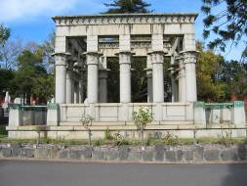](http://applications.doi.vic.gov.au/ImageFactoryWeb/getfile?path=2005-10-07/h00049/boroondara%20cemetery_jh_june%202005_031.jpg/medium.jpg&context=ImageFactory.Hermes&delete=no&version=)

Syme Memorial, Boroondara Cemetery, Kew (VHR H0049)

There are only three known examples of Egyptian Revival masonic temples in Victoria: Zetland Lodge, Kyneton; Emulation Lodge, Canterbury and Sandringham Masonic Hall. Both Zetland Lodge and Emulation Hall are included in the Victorian Heritage Register. At Zetland Lodge the Egyptian theme is confined to the interior of the building and was applied in the early twentieth century to an existing building. At Emulation Hall the style was applied to both the interior and exterior of the building.

### Masonic Halls in the Egyptian Revival style included in the Victorian Heritage Register

**Zetland Lodge, Kyneton, (VHR H1988)**

Zetland Lodge, Kyneton was originally constructed in 1866 as an Oddfellows Hall, and a room was added at either side of the building in 1904 when it was acquired by the freemasons. Egyptian influence is restricted to the interior of the building where a lavish Egyptian themed scheme was executed between 1905 and 1911 by lodge member, Thomas Levick. It clearly shows the link between freemasonry and ancient Egypt, with the inclusion of wall panels framed by pilasters with Egyptian capitals, murals of ancient Egyptian scenes, openings in the form of temple doorways with cavetto cornices, and depictions of the lotus, papyrus, scarab and solar disc. Thomas Levick's work was described at the time as 'a scheme of decoration for the hall which renders it unique among Masonic Lodge rooms, the style throughout being Egyptian'. [*Australasian Keystone*, 31 May 1905, p 45]

[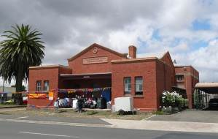](http://applications.doi.vic.gov.au/ImageFactoryWeb/getfile?path=hvi2009/western_rural_2_compressed/h1988-1.jpg/medium.jpg&context=ImageFactory.Hermes&delete=no&version=) [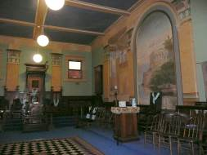](http://applications.doi.vic.gov.au/ImageFactoryWeb/getfile?path=hvi2009/western_rural_2_compressed/h1988-2.jpg/medium.jpg&context=ImageFactory.Hermes&delete=no&version=)

Zetland Lodge, Kyneton (VHR H198)

**Emulation Hall, Canterbury (VHR H2298)**

The masonic lodge known as Emulation Hall was constructed in 1927-28 to designs by architects Dunstan Reynolds & Partners to provide a facility for both the freemasons and the local community. Since construction Emulation Hall has provided a temple for a number of lodges that were sponsored by Emulation Lodge and also provided a public venue for club meetings and functions.

Emulation Hall is a large two storey rendered brick building designed in an Egyptian Revival style. The symmetrical front facade is in the form of an Egyptian temple pylon and incorporates symbolic Egyptian motifs such as a large scarab and three discs. The building contains a main hall at ground level and a lodge room above, both of which are decorated with Egyptian themed motifs, including palmette, lotus and papyrus mouldings, astrological symbols, winged solar disc and the eye of Horus. The lodge room contains raised side platforms with timber bench seating, ritual furniture and glass and metal light fittings. An addition was made at the rear of the building in 1958 and minor internal modifications were made to accommodate this.

Emulation Hall is of historical, architectural and aesthetic significance to the state of Victoria. Its historical significance lies in its associations with freemasonry and the building illustrates the popularity of freemasonry particularly after World War I. Its architectural significance lies in its rare and distinctive nature as an example of the Egyptian Revival style in Victoria. It adopts the style in its strictest sense, recalling ancient temples such as that of Isis, Philae and Horus, Edfu and is important for its application of the style both externally and internally. The style demonstrates the ideological link between freemasonry and ancient Egypt. The extensive symbolic Egyptian-themed decorative scheme evident in the interior, particularly the main hall and the lodge room, is of aesthetic significance.

[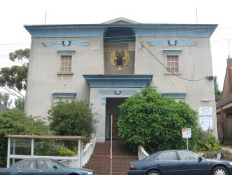](http://applications.doi.vic.gov.au/ImageFactoryWeb/getfile?path=13345/Emulation_Hall_Canterbury.jpg/medium.jpg&context=ImageFactory.Hermes&delete=no&version=)

Emulation Hall, Canterbury (VHR H2298)

[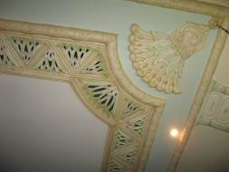](http://applications.doi.vic.gov.au/ImageFactoryWeb/getfile?path=13345/13345_Emulation_Hall_Canterbury_interior_HV_0102.JPG/medium.jpg&context=ImageFactory.Hermes&delete=no&version=)[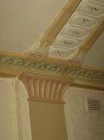](http://applications.doi.vic.gov.au/ImageFactoryWeb/getfile?path=13345/13345_Emulation_Hall_Canterbury_interior_HV_0108.JPG/medium.jpg&context=ImageFactory.Hermes&delete=no&version=)

Details at Emulation Hall, Canterbury

### Other Masonic Halls included in the VHR

Masonic halls in Victoria more commonly employ the classical form. Three former masonic halls are included in the Victorian Heritage Register and these are designed in a classical Renaissance Revival style. Constructed in the nineteenth century, these are:

* **Masonic Hall, Camperdown (VHR H1414)** designed by lodge member John Young and constructed 1867-68
* **Masonic Hall, Bendigo (VHR H0119)** designed by Vahland and Getzschmann and constructed 1873-74
* **Former Freemasons Hall, South Melbourne (VHR H0538)** designed by Adamson and McKean and constructed in 1876.

[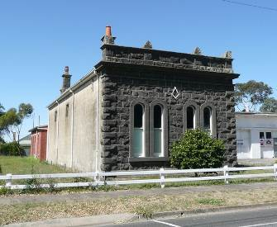](http://applications.doi.vic.gov.au/ImageFactoryWeb/getfile?path=hvi2009/western_rural_1_compressed/h1414-2.jpg/medium.jpg&context=ImageFactory.Hermes&delete=no&version=)

Masonic Hall, Camperdown (VHR H1414)

[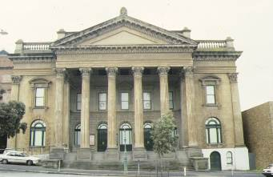](http://applications.doi.vic.gov.au/ImageFactoryWeb/getfile?path=2005-10-07/H00119/1_masonic_hall_bendigo_front_view.jpg/medium.jpg&context=ImageFactory.Hermes&delete=no&version=)

Masonic Hall, Bendigo (VHR H0119)

[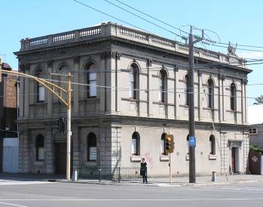](http://applications.doi.vic.gov.au/ImageFactoryWeb/getfile?path=hvi2009/western_metropolitan/h0538.jpg/medium.jpg&context=ImageFactory.Hermes&delete=no&version=)

Former Freemasons Hall, South Melbourne (VHR H0538)

### Other buildings in Victoria designed in the Egyptian Revival Style

Few buildings in Victoria display characteristics of the Egyptian Revival style. Three buildings that demonstrate the Egyptian Revival style are the Bank of NSW, 190 Bourke Street, Melbourne (VHR H0799), the Former Wimmera Stock Bazaar, Horsham (VHR H1985) and the Theosophical Society Building, 181 Collins Street, Melbourne. These buildings incorporate elements of Egyptian origin into the overall building design.

The facade of the **Bank of NSW, Melbourne (1929, VHR H0799)** by Godfrey and Spowers, is a modern interpretation of the Egyptian Revival style. Designed as an entrance to an Egyptian temple, it includes details such as a cavetto cornice and a winged solar disc. The building is architecturally significant for exemplifying the architectural eclecticism and exoticism of the late 1920s and early 1930s and for its unusual application of Egyptian motifs.

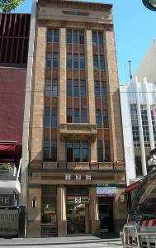

Bank of NSW, Melbourne (VHR H0799)

The **Former Wimmera Stock Bazaar, Horsham (1934, VHR H1985)** displays an unusual Moderne facade which incorporates abstracted Egyptian pylon towers either side of the main entrance. The significance of the building lies in its association with the working horse industry and its rarity as an example of this building type.

[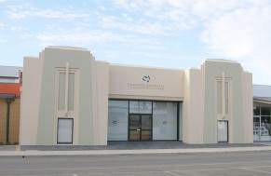](http://applications.doi.vic.gov.au/ImageFactoryWeb/getfile?path=hvi2009/western_rural_2_compressed/h1985-1.jpg/medium.jpg&context=ImageFactory.Hermes&delete=no&version=)

Former Wimmera Stock Bazaar, Horsham VHR H1985)

Like the Bank of NSW, Melbourne, the **Theosophical Society Building, 181 Collins St, Melbourne** (1936-37, not included in the HVR) is conceived as an entrance to an Egyptian temple. It incorporates two slender columns with palmiform capitals set within a frame topped with an angular cornice.

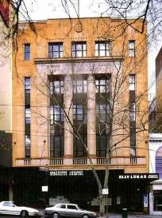

Theosophical Society Building, 181 Collins St, Melbourne

### Conclusion

There are very few examples of the Egyptian Revival style in Victoria and only three known examples of the style applied to masonic halls. Direct comparison can be made between Emulation Hall and the Sandringham Masonic Hall. Both masonic halls were designed at a similar time and both adopt the Egyptian Revival style externally and internally. Externally the style is adopted in a highly academic manner at Emulation Hall while at Sandringham the style is less of a copy of an Egyptian temple and more an interpretation in a modernist style. Internally they both display similar decorative characteristics.

#### KEY REFERENCES USED TO PREPARE ASSESSMENT

C Hope, ‘Ancient Egypt in Melbourne and the State of Victoria’ in J Humbert & C Price[ed]. *Imhotep Today: Egyptianizing Architecture’*. London 2003

R G Carrott. *The Egyptian Revival: its Sources, Monuments and Meaning 1808-1858*. California 1978

Lecture by L L Smith. ‘The Lost Mysteries of Freemasonry Explained’, Melbourne 7 April 1862

Heritage Alliance, ‘City of Bayside Inter War and Post War Heritage Study’, 2008

*Brighton Southern Cross*, 13 July 1912, p 8 ‘Forming a Lodge at Sandringham’

‘New Masonic Temple’, *Argus*, 14 April 1931, p 9

M Lewis, *Australian Architectural Index* [references to architect Gordon J Sutherland]

Public Building File No 9443, VPRS 7882/P1, Drawings of ‘Extension to Masonic Temple’, 1956, Public Records Office of Victoria

#### ADDITIONAL IMAGES

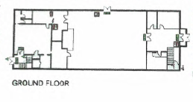

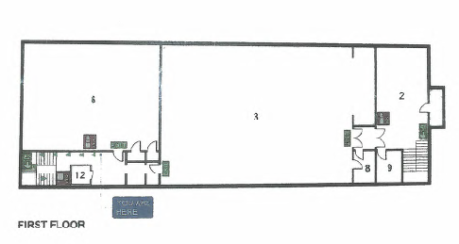

Ground and first floor plans of the Sandringham Masonic Hall, showing the Lower Hall at ground floor level and Lodge Room and rear secondary Lodge Room at first floor level

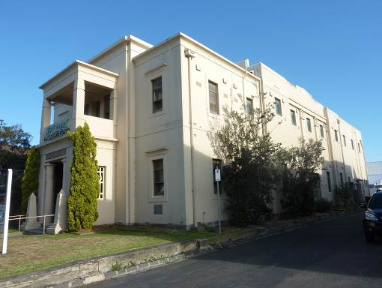

View of the Sandringham Masonic Hall from south east

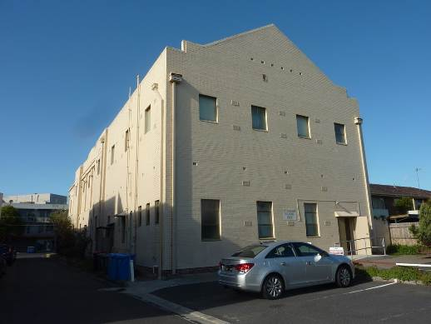

View of the Sandringham Masonic Hall from north east

#### P1230597 P1230602

Entrance to the Sandringham Masonic Hall, showing palmiform capitals and obelisks ( note winged disc obscured by sign)

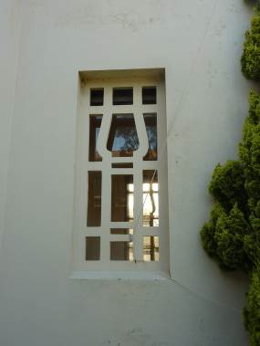

Stylised Egyptian column motif in the entrance grille

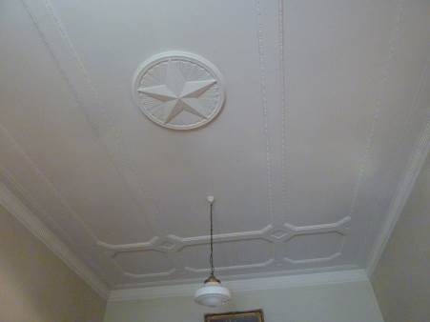

Ceiling of the entrance foyer

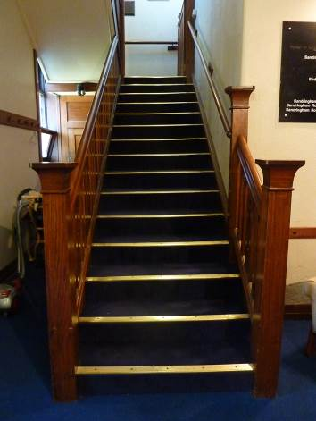

Stairs to the upper foyer

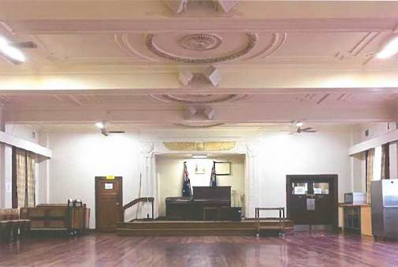

View to the front of the Lower Hall from entrance, note the winged disc above platform

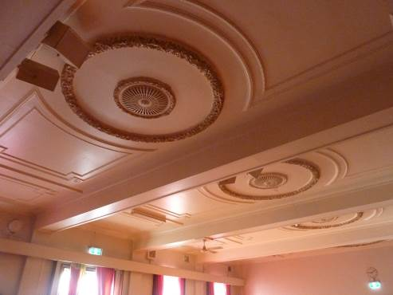

Ceiling detail of the Lower Hall

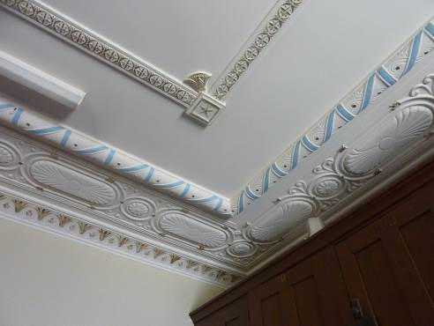

Detail of the ceiling of the upper foyer

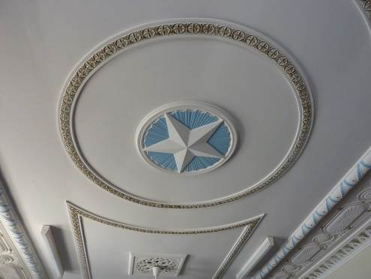

Detail of the ceiling of the upper foyer

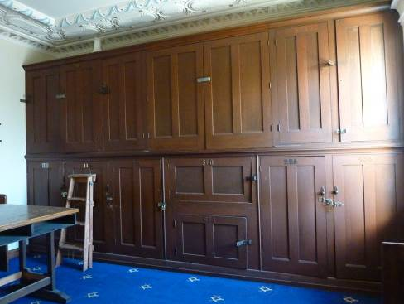

Cupboards in the upper foyer

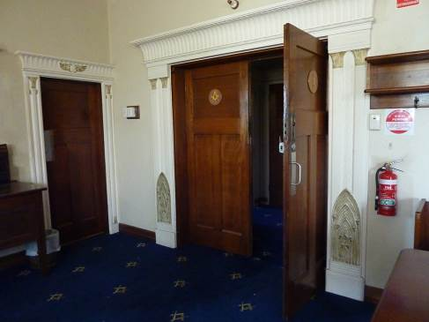

Doors from the upper foyer to the Lodge Room

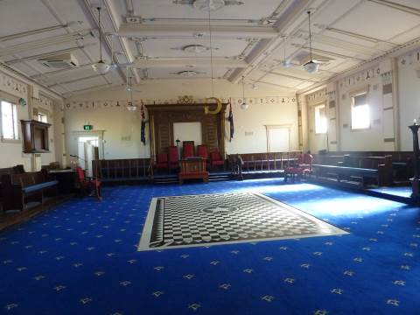

View to the front of the Lodge Room from entrance

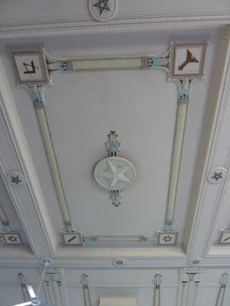 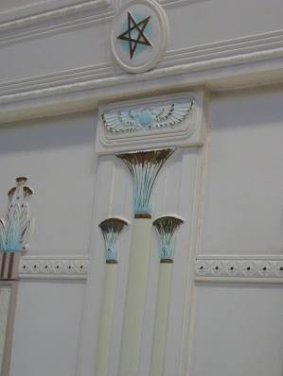

Details of the Lodge Room decoration

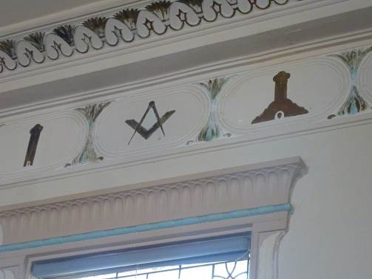

Detail of the Lodge Room decoration

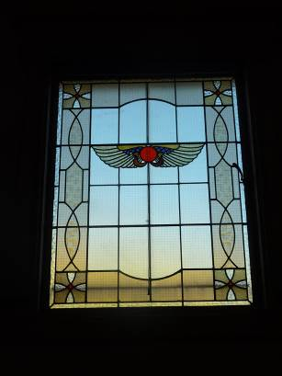 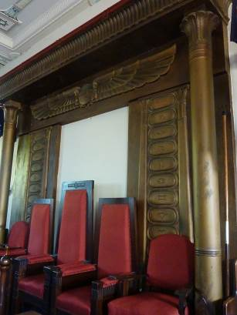

Stained glass window and front aedicule in the Lodge Room

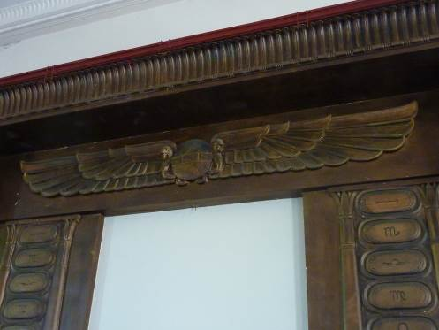

Detail of the aedicule showing winged disc and astrological symbols, Lodge Room

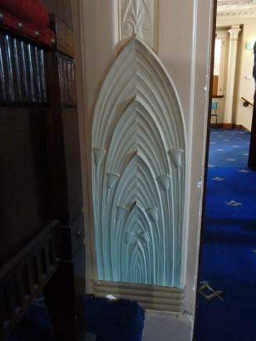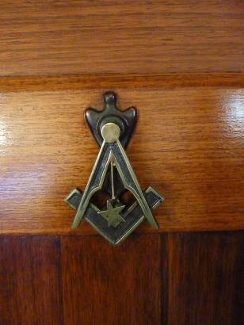

Various details in the Lodge Room

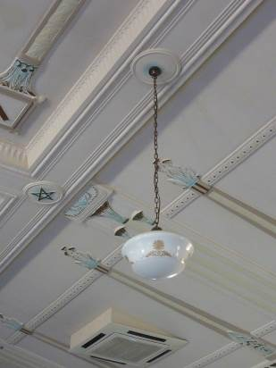

Light fitting in the Lodge Room

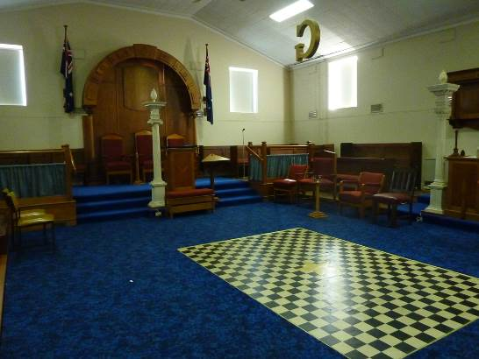

Secondary Lodge Room, rear addition (1956), first floor