ENDORSED VERSION
OF THE ASSESSMENT
REPORT

ENDORSED BY HERITAGE COUNCIL
5 June 2014


NAME: SAILORS’ REST ELECTRIC SIGN
LOCATION: 3 MOORABOOL STREET, GEELONG
VHR NUMBER: H2338
CATEGORY: HERITAGE OBJECT
FILE NO: 607519
HERMES NUMBER: 4953

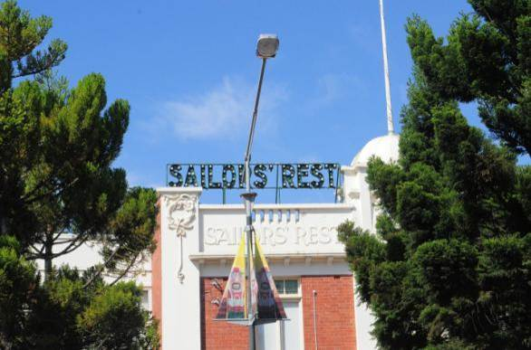
EXECUTIVE DIRECTOR RECOMMENDATION TO THE HERITAGE COUNCIL:
- That the SAILORS’ REST ELECTRIC SIGN be included in the Heritage Register as a HERITAGE OBJECT under the Heritage Act 1995 [Section 32 (1)(a)]

Tim Smith
Executive Director

Recommendation Date: 21 March 2014

EXTENT OF NOMINATION
- The letters reading “Sailors’ Rest” and their frame
- Four diagonal bracing arms from the back of the sign frame onto the roof
- Original conduit with bell mouth travelling from the wall next to the sign to the floor of the hexagonal domed room
- Original earth wire from sign to conduit
- Plate on the floor of the hexagonal domed room where the original Electric controller (now lost) rested

EXTENT OF REGISTRATION
The extent of registration on the Victorian Heritage Register affects the whole object known as the Sailors’ Rest Electric sign. The object comprises the following components:
- The letters reading “Sailors’ Rest” and their frame
- Four diagonal bracing arms from the back of the sign frame onto the roof
- Original conduit with bell mouth travelling from the wall next to the sign to the floor of the hexagonal domed room
- Original earth wire from sign to conduit
- Plate on the floor of the hexagonal domed room where the original Electric controller (now lost)
STATEMENT OF CULTURAL HERITAGE SIGNIFICANCE
What is significant?
The Sailors’ Rest Electric Sign mounted on the parapet of the King Edward VII Sailors’ Rest building in Geelong.
History Summary
The King Edward VII Sailors’ Rest building was built in Geelong to a design by the Geelong architect, Percy Everett in 1912. The Sailors’ Rest was an evangelical temperance organisation designed to provide welfare services to sailors; to attempt to divert them away from alcohol and other temptations of the town and to encourage them to return to or continue to practice Christianity. In order to attract more sailors to the ‘Rest’ an electric bulb sign was installed in 1926. The animated sign operated with flashing letters and words and was intended to be very noticeable from Yarra and Cunningham piers as the sailors disembarked. The sign was built by the nearby Melbourne Electric Supply Company and donated to the Sailors’ Rest by Howard Hitchcock former mayor of Geelong and Chairman of the Sailors’ Rest Committee. The sign is understood to have ceased operation from the 1950s until 1997 when it again operated but without animation.
Description Summary
The Sailors’ Rest Electric Sign consists of galvanised steel trough letters containing light bulbs spelling “SAILORS’ REST.” The bulbs are held by porcelain, Edison Screw lamp holders held in a galvanised steel plate fitted to the interior of each letter. The letters are held in a rectangular galvanised pipe frame with four diagonal bracing arms travelling from the top back of the frame to the roof of the King Edward VII Sailors’ Rest building. All these sign components except the bulbs and lamp holders are painted dark green. The original steel conduit containing twelve original wires runs from a downward facing bell-mouth fitting on the wall next to the sign, to just above the floor of the hexagonal domed room nearby, where there is a galvanised steel plate tacked to the floor. The original electromechanical drum controller (now lost) rested on this plate. The original single earth wire runs from the sign frame to the conduit. The surviving original wiring consists of tinned copper wires covered with waxed cotton and insulated with vulcanized rubber.
This site is part of the traditional land of the Wadawurrung people.
How is it significant?
The Sailors’ Rest Electrical Sign is of historical and social significance to the State of Victoria. It satisfies the following criterion for inclusion in the Victorian Heritage Register:
Criterion A Importance to the course, or pattern, of Victoria’s Cultural History
Criterion B Possession of uncommon, rare or endangered aspects of Victoria’s cultural history
Criterion G Strong or special association with a particular community or cultural group for social, cultural or spiritual reasons. This includes the significance of a place to Indigenous peoples as part of their continuing and developing cultural traditions.
Why is it significant?
The Sailors’ Rest Electric Sign is significant at the State level for the following reasons:
The Sailors’ Rest Electric Sign is historically significant for its use in the advertising and promotion of welfare services, the Temperance Movement and Christianity to sailors. It demonstrates the zeal and commitment of the Temperance Movement, which led to many changes in Australian society. It is historically significant for its landmark quality from the waterfront and wharves, and has been appreciated by visitors to the waterfront for nearly ninety years. [Criterion A]
The Sailors’ Rest Electric Sign is historically significant as a rare surviving original electric bulb sign in Victoria. Bulb signs were the first type of electric signage, preceding neon signage. [Criterion B]
The Sailors’ Rest Electric Sign is socially significant for its association with the long-standing and continuing relationship with seafarers visiting Victorian ports from the 1850s to today. It is tangible evidence of a charitable Christian organisation valued by thousands of sailors past and present. [Criterion G]

The Sailors’ Rest Electric Sign is also significant for the following reasons, but not at the State level:
It is one of very few surviving historic electric signs in Geelong.
It is associated with a former mayor of Geelong, Howard Hitchcock.
It is a well known and visible landmark in Geelong.
It is associated with the Geelong branch of the Melbourne Electric Supply Company which made the sign and supplied electricity for it.

PERMIT POLICY

Preamble
The purpose of the Permit Policy is to assist when considering or making decisions regarding works to a registered place. It is recommended that any proposed works be discussed with an officer of Heritage Victoria prior to making a permit application. Discussing proposed works will assist in answering questions the owner may have and aid any decisions regarding works to the place.

The registration of the Sailors’ Rest Electric Sign on the Victorian Heritage Register affects the whole object. Under the Heritage Act 1995 a person must not remove or demolish, damage or despoil, develop or alter or excavate, relocate or disturb the position of any part of a registered place or object without approval. It is acknowledged, however, that alterations and other works may be required to keep places and objects in good repair and adapt them for use into the future.

If a person wishes to undertake works or activities in relation to a registered place or registered object, they must apply to the Executive Director, Heritage Victoria for a permit. The purpose of a permit is to enable appropriate change to that place or object and to effectively manage adverse impacts on the cultural heritage significance of a place or object as a consequence of change. If an owner is uncertain whether a heritage permit is required, it is recommended that Heritage Victoria be contacted.

Permits are required for anything which alters the place or object, unless a permit exemption is granted. Permit exemptions usually cover routine maintenance and upkeep issues faced by owners as well as minor works. They may include appropriate works that are specified in a conservation management plan. Permit exemptions can be granted at the time of registration (under s.42 of the Heritage Act) or after registration (under s.66 of the Heritage Act).

Conservation management plans
It is recommended that a Conservation Management Plan is developed to manage the object in a manner which respects its cultural heritage significance.

Cultural heritage significance
Overview of significance
The cultural heritage significance of the Sailors’ Rest Electric Sign is embodied in its day and night landmark qualities, the lighting and animation of the sign, its position on its original building, and the extent of the remaining original fabric.

- All of the components of the object listed here are of primary cultural heritage significance. A permit is required for most works or alterations. See Permit Exemptions section for specific permit exempt activities:
- The letters
- The frame
- Four diagonal bracing arms from the back of the sign onto the roof
- Original conduit from the wall next to the sign to the floor of the hexagonal domed room
- The components of the object listed here are deemed to have contributory cultural heritage significance. A permit is required for most works or alterations. See Permit Exemptions section for specific permit exempt activities:
- Original earth wire from the sign to the conduit
- Galvanised steel plate on the floor of the hexagonal domed room where the original electromechanical drum controller (now lost) rested.
Location of the sign
The sign was specifically installed to direct sailors to the Sailors’ Rest building from the Geelong waterfront. Its location is linked to its cultural heritage significance.
Treatment of metal components
When corroded, the metal letters and sign frame should be treated by a qualified metals conservator. The works should aim to retain as much of the original metal, flat rivets and cheese head nuts and bolts as possible. New metal should be attached with modern pop rivets to distinguish the repairs from the original joins which used flat rivets. New metal must be of similar composition to the original.
The letters are most likely to have been a dark colour (contemporary US signs used black or dark blue). Given the red and cream colours of the building, black is a more probable colour but dark blue or green, or Indian Red could have been used. Paint should be re-applied following conservation treatment of the metal letters.
Operation of the sign
Based on contemporary sources including the use of a drum controller, the Sailors’ Rest Electric Sign is almost certain to have been ‘animated’ in the sense of its bulbs being cycled ‘on’ and ‘off’ in some predetermined sequence.
Historical records document the potential for up to four patterns of switching individual bulbs, letters and words on and off repeatedly. The eleven original wires indicate that each letter would have lit up one by one (with the apostrophe operating with the ‘S’ of “Sailors’). This may have been followed by other illumination patterns such as those below; however still more patterns may also have been used.
- Each word lighting up one by one and flashing on and off
- Both words lighting and flashing together on and off

It is likely that 40 W standard incandescent lamps were originally used in the sign. These would have produced a warm yellowish light. The operation of these was managed by a mechanical drum controller (now missing). It is not necessary to operate the sign using these now technologically obsolete items. Modern items which give the same effect may be used (listed below). If new wiring is needed this must use the existing holes made for the current (February, 2014) plastic junction boxes.
- Control of the ‘flashing’ sequences may be achieved by a small electronic programmable logic controller (PLC) device located nearby. A new dedicated single-phase circuit from the building main switchboard – or a convenient distribution switchboard – would need to be used to power the PLC and its outgoing sub-circuits.
- LED bulbs may be used instead of incandescent bulbs. LED lamps are far more suited to constant switching on and off than compact fluorescent bulbs. All LED bulbs used on the sign should be equivalent to 40W and warm white in colour. All should be the same shape and colour (round and white) to ensure that the unlit bulbs are visible in daylight.
- The present single circuit wiring would have to be replaced to provide a single separate sub-circuit for each of the eleven letters, however, with some adjustments, the present flexible plastic junction boxes and flexible conduits affixed to the rear of the sign could probably be reused.
If it is necessary to replace any of the lamp holders they should be replaced with unglazed porcelain Edison Screw lamp holders.

PERMIT EXEMPTIONS (under section 42 of the Heritage Act)
It should be noted that Permit Exemptions can be granted at the time of registration (under s.42(4) of the Heritage Act). Permit Exemptions can also be applied for and granted after registration (under s.66 of the Heritage Act)
General Condition: 1.
All exempted alterations are to be planned and carried out in a manner which prevents damage to the fabric of the registered place or object.
General Condition: 2.
Should it become apparent during further inspection or the carrying out of works that original or previously hidden or inaccessible details of the place or object are revealed which relate to the significance of the place or object, then the exemption covering such works shall cease and Heritage Victoria shall be notified as soon as possible.
General Condition: 3.
All works should be informed by Conservation Management Plans prepared for the object. The Executive Director is not bound by any Conservation Management Plan, and permits still must be obtained for works suggested in any Conservation Management Plan.
General Conditions: 4.
Nothing in this determination prevents the Executive Director from amending or rescinding all or any of the permit exemptions.
General Condition: 5.
Nothing in this determination exempts owners or their agents from the responsibility to seek relevant planning or building permits from the relevant responsible authority, where applicable.
Specific Exemptions:
Works and alterations to the following are permit exempt:
- Replacement of bulbs with Edison Screw 40W warm white LED bulbs
- Rewiring providing no new holes are drilled into the metal of the lettering and no original conduit or wire (pre 1996) is removed
- Touching up and painting the metal trough letters black or other dark colour following conservation treatment which has resulted in a stable metal surface
- Replacing non-functioning unglazed porcelain Edison Screw lamp holders with new unglazed porcelain Edison Screw lamp holders

RELEVANT INFORMATION

Local Government Authority City of Greater Geelong
HERITAGE LISTING INFORMATION
Heritage Overlay: Yes HO Number: HO221
Heritage Overlay Controls:
External Paint Yes
Internal Alteration Yes
Tree No

Other Listing:
The King Edward VII Sailors' Rest - Geelong Woolstores Historic Area is classified as being of State Significance by the National Trust of Australia (Victoria) number B4705.
The Sailors’ Rest (former) including Electric Bulb Sign is identified as having heritage value by the Department of Environment and Primary Industries.
Comments:
The Sailors’ Rest Electric Sign is mounted on the parapet of the Sailors’ Rest Building. The building is included in the City of Greater Geelong’s Heritage Overlay Precinct - Woolstores Industrial Heritage Area. The building and sign have individual significance within the precinct.
HISTORY
History of the Sailors’ Rest building in Geelong
The Sailors’ Rest mission has operated in Geelong for many years. The Port of Geelong was very busy in the 1880s and 1900s with large amounts of agricultural produce such as wheat and wool being exported and timber and other exotic items being imported. The Geelong Historical Society notes that various groups in Geelong recognised that there was a need for support for the sailors from all visiting ships.
In February 1895 following the death of a sailor in gaol in January, the Geelong Advertiser announced the opening of a Sailors’ Rest in the Bethel (non-conformist chapel) in Corio Street. Activities for sailors were organised by the YMCA, Baptist and Methodist churches and private individuals, first at the Corio Street Bethel Chapel and then at 51 Moorabool Street. Mr H.R. Reid who was associated with the Melbourne Mission to Seamen (established 1858) was invited to speak at a meeting at the Chamber of Commerce in 1900 and after outlining how the Melbourne Mission worked, said that it:
...showed Jack that there was entertainment for him without resorting to drink, and that he could be of far better service to his master.
The meeting formed a superintending committee for a Geelong Sailors’ Rest, and from 1910 began agitating for its own premises. Their efforts were successful and on 3rd February 1912, the Premier of Victoria, the Hon. John Murray, MLA laid the foundation stone of the 'King Edward VII Sailors’ Rest' building on the corner of Moorabool Street and Victoria Parade, Geelong. The two storey brick and cement rendered Edwardian period structure was designed by architects Seeley, King and Everett, the design being attributed to Percy Everett.
Soon after its establishment, the Geelong King Edward VII Sailors’ Rest joined the British and Foreign Sailors’ Society which was an interdenominational Protestant group; now know as the Sailors’ Society. There were a number of Christian evangelical, temperance charities ministering to seafarers at the same time.
The Temperance Movement began in Australia in the 1830s and was most active from the mid Victorian period until the start of WWII. The movement in Australia was part of a mass movement in English speaking countries led by Protestant religious groups. It was promoted by a number of groups such as the Salvation Army, the Woman's Christian Temperance Union and The Independent Order of Rechabites, all of which still have an anti-alcohol mission today. The Temperance Movement was a major driver for the development of Sailors’ Rests and other missions to seafarers. The stereotype of the ‘drunken sailor’ was based in fact with many sailors drinking heavily and getting into trouble while on shore. Sailors are documented to have signed the Temperance Pledge and returned to or converted to Christianity at the UK Sailors’ Rests, and it is likely that similar events occurred at the equivalent Australian organisations.
The Geelong Sailors’ Rest continues to provide support to seafarers today and is now known as the Mission to Seafarers. It is part of the international Anglican mission organisation of the same name. It continues to be supported by a number of Geelong’s Anglican parishes. As has always been the practice in other Missions to Seafarers in Victoria, alcohol is not served. The King Edward VII Sailors’ Rest building was sold in 1989 and is now a licensed cafe called “Sailors’ Rest”. The Mission to Seafarers now operates from a building at North Shore, Geelong.
Other Missions to seafarers were established in Melbourne, Port Melbourne, Williamstown, Portland and Hastings. Those in Melbourne, Portland and Hastings continue today. The Melbourne Mission to Seafarers is the only one to still operate from its original building.
History of the Sailors’ Rest sign
Early committees of the Sailors’ Rest made a variety of attempts to advertise the location of the building and attract sailors to it. Agnes Weston founder of the UK Sailors’ Rest organisation, aimed to create ‘...a (bright and inviting) public house without the drink, close to the Dockyard,’ and it seems that the Geelong Sailors’ Rest group had the same aims. In 1926 the annual report of the Geelong Sailors’ Rest noted that:
...it is useless to ask the men to keep away from the danger of the Hotel if we do not provide some counter attraction...
Entertainments for sailors at this time included non-alcoholic refreshments, music and games such bagatelle, billiards and quoits on the roof. These games were followed by a prayer service. It seems that the Sailors’ Rest had to compete strenuously with Geelong’s hotels to attract sailors and that the Sailors’ Rest Executive Committee saw an electric sign as important to that competition. In the 1930s, the Executive Committee erected a painted sign in town, also to direct sailors to the Rest.
The 1916 minutes of the Sailors’ Rest Executive Committee noted that they wished to put a sign on the Sailors’ Rest building. The size and prominence of the sign seems to have been intended to ensure that sailors could easily identify the site:
The question of a prominent sign Sailors’ Rest on the building to be seen from Yarra Street was left with Captain Molland, Mr Gowty and the Hon. Seely for consideration and recommendation.
In 1920 in a meeting chaired by Ald. Howard Hitchcock, who was chair of the Executive Committee and the Mayor of the City of Geelong, it was noted that:
it would be an excellent idea if we could have a big electric sign placed on top of the building stating what building it was. Then the sailors entering ... would see where his shore home was long ... he reached the wharf. In responding the Mayor said it was an excellent idea to have an electric sign that if the executive committee would give the necessary permission and have the sign erected he would be only too pleased to defray the cost.
During 1926 the Committee was reporting slow progress on the manufacture of the sign:
In referring to the electric sign on the roof the Mayor regretted the delay in the erection but said it was unavoidable. He suggested that the sign be alternating and said it would be attended to.
The word ‘alternating’ may indicate that the lamps were intended to cycle ‘on’ and ‘off’ in some way.
The sign was finally erected on 13 December 1926 and reported in the Geelong Advertiser the next day.
A very interesting function took place last evening at King Edward VII Sailors’ Rest. Members of the Executive met officially to take possession of an electric sign recently erected on the roof of the Rest by the Melbourne Electric Supply company. The sign will flash out across the harbour the words “Sailors’ Rest” directing sailors to this popular haven. A welcome awaits them by a group of honorary workers who provide comfort to the men of the marine. The turning on of the sign current took place at 8pm by representatives of the Electric supply company.
Operation of the sign
The sign is almost certain to have been a type known as ‘animated’ where lights flashing on and off give the impression of movement and make the sign more noticeable. The Geelong Advertiser of 14 December 1926 described how the sign operated:
The apparatus connected with the light is of a drum controlled type, electrically operated, controlling eleven complete currents each current being independently fused with four distinct on and off positions.
A drum controller or drum sequencer is a reprogrammable electromechanical timing device used to activate electric switches in repetitive sequences; in this case it is assumed to have switched different bulbs and groups of bulbs on and off. As the drum revolved – driven by a small electric motor - ‘cams’ or pegs set into the edge of the drum would have successively ‘closed’ and ‘opened’ switches controlling the eleven lamp circuits. These devices were not available ready made in the 1920s and it is likely that it was fabricated in the Melbourne Electric Supply company (MESCo) workshops.
There are eleven letters in the sign and the presence of the eleven complete currents in the original operation indicates that each letter could have been lit one by one. The apostrophe would presumably have lit with its adjoining ‘S.’ “Four distinct on and off positions” would have allowed four different types of animations to flash on and off. Each word could have illuminated individually and both words could have flashed on and off either separately or together.
The sign may have been expensive to operate as the Executive Committee minutes of 10 March 1927 record:
It was decided to have the illuminated sign switched on at the following times 7pm to 7.30pm. 8pm to 8.15. 8.45 till 9pm, till 1st May, when vessels are in port; and to be switched on only by Caretaker.
An indicative estimate of the costs of operating the sign was developed by an electrical engineer, Miles Pierce of Engineering Heritage Victoria. Using contemporary electricity costs and calculations based on the number of bulbs and their wattage, he has estimated that in the 1920s it would have cost approximately £140 per annum to operate the sign. In 1926, the whole annual expenditure of the Sailors’ Rest was £603, with only £14 per annum spent on fuel and lighting (the sign was installed in December 1926). This indicates that the sign was an expensive addition to the budget of the Sailors’ Rest organisation.
Electric signs were designed to be seen by day and night. Sign makers developed a mathematical formula to calculate visibility of ‘exposed incandescent filament lamp signs’ based on the height of the letters. Miles Pierce has used this formula to determine that legibility of the lit letters of the Sailor’s Rest sign at night would be good to approximately the middle of the Cunningham and former Yarra Street piers. Beyond that distance legibility would be reduced but with the sign still likely to be readable, or at least able to attract attention to itself, for much of the length of the two piers where ships would be berthed. This is confirmed by the Geelong Advertiser of 14 December 1926 describing the launch of the sign:
Following this ceremony members present inspected the sign from the wharves and it was announced a great success.
The Geelong Advertiser in 1997 noted that the sign had been dark for approximately 40 years (presumably since the 1950s). This may have been due to high operating costs or to a failure in some part of the system (e.g. wiring or the drum controller) in the 1950s that was not then repaired or replaced.

History of illuminated signage in Victoria
Signage in the urban areas in Victoria appeared in the following order with many sign types being used concurrently. Exact dates are not known as there is little documentary information and few photographs of historic signs at night.
- ca. 1840s – Painted signs - only visible in the day time
- Late 1890s – Temporary electric incandescent decorations
- ca. 1920s – Permanent electric incandescent bulb signs (oil and gas lights seem to have only been used as street illumination, not as part of signs)
- ca. 1930s – Neon signs and neon / bulb combination signs
- ca. 1950s – Back lit acrylic signs – now the most common
Commercial premises have a long tradition of advertising using painted signs. Once synthetic pigments became available during the industrial revolution, the colours became brighter and gilding and silvering was used to give added emphasis to the lettering. Signs were mounted on the facades of buildings and sometimes covered most of the surface of a building. Signs could be classified as ‘heraldic’ signs which are meant to get the customer’s attention; and ‘informational’ signs which provide supporting information such as cost or opening hours. Heraldic signs projecting above the top of the building are known as ‘sky signs.’
Incandescent signage
The first electric power stations were constructed in Victoria in the 1880s and the Melbourne CBD was lit with electric light from 1894. Gas street lighting was replaced by carbon arc lamps in the major streets and incandescent lamps in minor streets and laneways.
Incandescent bulbs using carbon filaments were patented by Thomas Edison and others from 1879. These improved somewhat in performance over time but were replaced by more reliable tungsten filament electric bulbs which were patented by the Tungsram Company in Hungary in 1904. Incandescent bulbs were mostly used inside. The first frosted incandescent bulbs were produced in 1925 but were probably not available in Australia until the 1930s and are unlikely to have been used for the sign originally.
Images from the 1880s show festoons of electric bulbs illuminating buildings on special occasions, for example, public buildings and the streets of Melbourne were lit from dawn to dusk to mark the Queen’s Jubilee in 1887. A photograph shows Flinders Street Station building decorated with incandescent bulbs for the 1901 visit of Duke and Duchess of Cornwall and York. This illumination was designed by James Fawcett, the architect of Flinders Street Station. It appears that the skills to design and install temporary bulb illuminations were well developed in Victoria in the late nineteenth century.
The first permanent electric sign in the USA was erected in Chicago in 1893 and the technology to create permanent signage is likely to have appeared in Victoria soon after. A photograph from 1901 shows a possibly temporary sign on the Princess Theatre (VHR H0093). Bulbs decorate the entrance to Luna Park (VHR H0938) and appear in photos dating from its construction in 1912. However permits for the first electric signs in Geelong were not lodged and approved until 1925. Theatre canopies are still often outlined in flashing incandescent bulbs such as the canopy of the Astor Theatre (VHR H1751).
Neon signage
The first neon sign was installed in Paris in 1912 and the patent for neon light arrived in Australia in 1924. It is not known when the first neon sign was installed in Victoria. An early one was the MacRobertson’s sign (now demolished), which was installed on the top of the company’s Old Gold Building in 1921 as a bulb sign with neon added later. Permits were granted for the first neon signs in Geelong in 1930 although it would appear that floodlighting commercial buildings and their painted signs was more common until at least the c.1940s. In some cases combination bulb and neon lighting was used. This would be to take advantage of the instantaneous nature of incandescent lights which can be switched on and off more rapidly than neon.
Electric neon signs were controversial. In 1960 the Architect Robin Boyd deplored excesses of commercialism typified by the Oakleigh Motel's signage in his book The Australian Ugliness:
Lettering and illustrations, crying for attention to the wares of each little shop, grew from fairly discrete signwriting to huge placards and cut-outs ... Australians grew after the middle of the twentieth century into the most vigorous and undisciplined advertisers in the world.
However, many Victorians remember electric signs such as the now demolished Allen’s Sweets bulb and neon sign in Southbank (1969) with great fondness. Children in particular enjoyed electric signs, with Dame Phyllis Frost recalling:
At the age of three (in ca. 1920) I spelled my first word of five letters, Aspro. That was because there was a big electrical sign that winked on and off on the south bank of the Yarra spelling out A-S-P-R-O, ASPRO, day and night. Beside it was a bear, also in lights, licking a Sennitts ice-cream. We loved those electric signs. As a small child I became ecstatic when I first saw the Skipping Girl Vinegar animated sign in Abbottsford. It was fascinating and we watched it every time we passed.
Town planners began to oppose flashing bulb and neon signs as being too distracting to traffic and for aesthetic reasons; although a 1975 survey by the outdoor Advertising Association of Australia found that most people felt that illuminated signs contributed to the character of the city. Some inner city electric signs became more acceptable from the 1980s for sentimental reasons and due to movements such as pop art and post-modernism.
VICTORIAN HISTORICAL THEMES
03 Connecting Victorians by transport and communications
3.2 Travelling by water
08 Building community life
8.1 Maintaining spiritual life
8.3 Providing health and welfare services

PHYSICAL DESCRIPTION
The Sailors’ Rest Electric Sign is a large single sided sky sign illuminated with incandescent bulbs mounted inside green, letter-shaped troughs of sheet galvanised iron. No particular font can be identified. The sans serif, upper case letters spell ‘S A I L O R S’ R E S T‘. Each individual letter has been fabricated from sheet steel, using ferrous cheese head screws and/or flat rivets to fix the separate sections. New metal sections have been fixed using modern pop rivets.
Each letter contains from six to eleven incandescent bulbs. The apostrophe uses one bulb. The overall length of the sign is 4.5 m. The letters are 0.62m high with a typical width of 0.34m. The ‘U’ shaped fabricated sheet metal forming each letter is 0.11m wide and 0.130m deep.
The ‘U’ shaped, trough, green painted sheet-metal letters incorporate an internal plate with holes to hold Edison Screw (ES) type ceramic lamp holders that are inserted through a hole in the plate and are secured by a front bezel ring. Wiring to the individual lamp holders within each letter is hidden behind the internal sheet metal mounting plate and thus not exposed to the weather. Similarly, the wiring connections to the terminals on each lamp holder are protected.
About 50% of the lamp holders now contain 8 Watt modern compact fluorescent lamps with spherical white bulbs. The other lamp holders are empty. Light output of these lamps is approximately equivalent to a 40 Watt standard incandescent lamp. There are modern circular, white plastic junction boxes and flexible conduits attached to the back of each letter.
The letters are individually attached by custom formed ferrous brackets to a rectangular galvanised iron frame made from 35mm gauge pipe. This frame is supported by four legs made from the same 35mm gauge pipe. The frame, brackets, letters and legs are all painted dark green.
The sign is mounted to the top of the parapet of the Sailors’ Rest building (sitting about 1.1 m above the parapet) and the four diagonal supporting rods go from the top of the sign to the roof below.
A painted steel pipe conduit runs from the rooftop hexagonal room to finish in a downward facing bell-mouth fitting adjacent to the rear left-hand bottom area of the sign. Twelve, painted, waxed cotton, vulcanized India rubber (VIR) insulated, tinned copper wires protrude from the bell-mouth fitting. Within the hexagonal room, the conduit drops to floor level then travels across the floor to a 24 inch square galvanised steel plate near the central column. Twelve, painted, waxed cotton, VIR insulated, tinned copper wires protrude from this end of the conduit in the hexagonal room. These wires are bound together with string. There is also a single painted, waxed cotton, VIR insulated, tinned copper earthing wire running from the letter ‘T’ to the conduit.
PVC insulated wires run in rigid white PVC conduit from the south-west corner of the main building roof to the rear left-hand end of the sign with white plastic flexible conduits then looping from PVC conduit type junction boxes mounted on the back of each of the letters making up the sign. This is a single supply circuit, originating from a small programmable timer on the switchboard in the ground floor kitchen area. Several spotlights used to illuminate the static sign on the top of the west wall are also supplied off this same circuit. Accordingly, all of the installed bulbs in the illuminated sign would now turn ‘on’ and ‘off’ together controlled by the programmable timer.

INTEGRITY/INTACTNESS
The sign was restored in 1997. The Geelong Advertiser 2 May 1997 reported it being lit at this time after being dark for ca. 40 years. The works were funded by a Heritage Council of Victoria grant of $2,500 allocated on 12 July 1997.
Letters
It appears that corroded parts of the letters were cut out and replaced in 1997. Originally each individual letter has been fabricated from sheet steel, using ferrous cheese head nuts and bolts and/or flat rivets to fix the separate sections. New metal sections have been fixed to using modern pop rivets. The customised hand forged brackets holding the letters to the frame are still present. (February 2014)
Controller
The original hand built drum controller is missing and has been replaced by a programmable timer located in the ground floor kitchen. (February 2014)
Wiring
The wiring would have consisted of a bundle of wires travelling along the base of the frame and would have entered the letters from the base to the letters appears to have been removed during the 1997 works. The new wiring enters the letters from the back. The original earth wire is still present. (February 2014)
Lamp holders
The current unglazed porcelain lamp holders are Edison Screw type and have the same appearance as the originals would have had. Two lamp holders were examined closely. Both were branded as Nilsen Cat. PH 31 and carry a Victorian ‘Approval Number’ (V94138R). The SECV (Appliances) Act (1952) legislated that 'all approved equipment must be stamped or labelled as prescribed'. Therefore it appears that the lamp holders could not date from before the early to mid 1950s. It is likely that they were replaced during the 1997 rewiring works. (February 2014)
Frame and struts
These are all original. (February 2014)
Colour
Photographs of the sign before restoration show that the letters were corroded with traces of white paint in 1996 (probably undercoat). No trace of original paint was visible in the 1996 photos. The present dark green paint finish appears to date from when the sign was rewired in 1996 or after. The original colour is likely to have been a dark colour so that sign was visible in daylight. (February 2014)

CONDITION
Water collects in the base of the letters causing corrosion. This has led to the bases of some of the letters being replaced in 1997. However the base of several of the letters are corroding again. The green paint is chalky and has been lost from the corroded areas. The porcelain of the lamp holders is somewhat weathered but appears to be in good condition. The interiors of the letters behind the plates that hold the globes were not examined. The plastic junction boxes and flexible conduits from the 1996 rewiring are in good condition. The original wires protruding from the bell mouth and in the hexagonal room are somewhat stiff but in generally good condition. The earth wire, metal frame and conduit are all covered with a heavy layer of paint but appear to be in good condition beneath this. (February 2014)

COMPARISONS
VHR signs
Two painted signs are included on the VHR in their own right - the Velvet Soap sign in Kyneton (VHR H1969) and the Aqua Profunda sign at Fitzroy Pool (VHR H1687). Both these are registered as Heritage Places with some land included.
Three electric signs are included in the Victorian Heritage Register in their own right and others are included as part of registered places.
The Nylex sign (VHR H2049) dates from 1961. It is a large double sided sky sign. It is registered as a Heritage Place with no land as it was not possible to register Heritage Objects when it was added to the VHR.
The Pelaco sign (VHR H1149) is a large double sided sky sign illuminated with neon tubes and a formerly flashing bulb border which was erected in 1939. It is registered as a Heritage Place with no land as it was not possible to register Heritage Objects when it was added to the VHR.
The Skipping Girl Vinegar sign (VHR H2083) is an animated neon sign which is a smaller 1970 replica of the original 1936 sign. It is not mounted on the original factory building (which was demolished). It is registered as a Heritage Place with land in order to have some controls over the building on which the sign is located, as this building is not on the HO.
The Sailors’ Rest sign is proposed to be registered as a Heritage Object as the King Edward VII Sailors’ Rest building is listed on the HO of the City of Greater Geelong, and management would be difficult if part of the building was on the VHR and part on the HO.
Signs on VHR buildings
Electric signs are found on a number of Heritage Places, although not always documented or included in the extent of registration. Many theatres had flashing bulb signs in a ‘chasing’ illumination pattern around entrance canopies although these are becoming less common.
- Princess Theatre bulb sign, ca.1900-1920, VHR H0093
- Luna Park bulb decorations, 1912, VHR H0938
- Capitol Theatre bulb and neon sign, 1931, VHR H0471
- Astor Theatre animated neon sign, 1936, VHR H1751
- Oakleigh Motel, 1957, back lit acrylic sign with later neon sign, VHR H2193
Flashing bulb signs are traditionally associated with the theatre and the earliest surviving bulb sign in Victoria appears to be the ‘Princess’ bulb sign on the Princess Theatre in Melbourne. It first appears in an image dated 1901, but this version may have been temporary as it is not visible in good quality State Library images dated 1908, 1910 or 1916. However it does appear in a photo dated from ca. 1920 where it reads ‘New Princess’ and may date from the 1923 remodelling of the theatre. The ‘New’ Princess Theatre was built in 1886 after demolition of the earlier one. The next good quality photo shows the sign in ca. 1920 where it reads ‘Princess.’
Another early surviving bulb sign was the Myer / Myer’s sign on the Lonsdale Street building of Myer Melbourne, former Myer Emporium (VHR H2100). This sign appeared to consist of bulbs fixed to metal backing plates which were inset into letter shaped recesses in the masonry. It originally read MYERS and was later altered to read ‘Myer’ by filling in the ‘S’. Construction of Myer’s Lonsdale Street building started in 1925 and was completed in 1926. This sign was dismantled ca.2009 and the letter shaped recesses in the masonry were filled in, although they are still visible. However based on examination of photos of the removed plates it appears that the bulbs were removed earlier than 2009. More research is needed to determine how this sign operated and when it ceased operating.
The Capitol sign is situated on the veranda canopy of the Capital Building (VHR H0471) at 107-119 Swanston Street. The Capitol sign is made from individual two metre high trough letters with a neon tube inside. The perimeter of the sign consists of small incandescent bulbs. It is mostly obscured from view by the neighbouring canopy.
The Newspaper House neon sign (no longer operating) on Newspaper House dating from 1933 is probably the earliest surviving neon sign in Victoria. [The Napier Waller mosaic on Newspaper House is on the VHR (H0447) but not the building or sign.]
The original Herald Sun neon sign on the Herald and Weekly Times building (VHR H1147) may have been installed between 1933 and 1940, but much of the present sign is a replica.
The Astor Theatre (VHR H1751) neon sign dates from its opening in 1936 and the rising ‘fireworks’ motif on it is animated neon sign which is still operating. The canopy over the entrance is outlined with bulbs.
Analysis
All the individually registered electric signs have a number of aspects in common:
- They are all sky signs with their landmark qualities noted as an important aspect of their significance
- They are rare survivors of once common illuminated advertising signage
- They are all in Richmond
- They all advertise commercial companies, which is unsurprising given Richmond’s industrial heritage
- They are all illuminated with neon except for the Nylex sign which uses small LED lights and bulb illumination as well as neon.
The majority of electric signs on registered buildings also advertise commercial products or companies. However the Sailors’ Rest sign, unusually, was advertising the presence of welfare and religion as well as the name of the building.
It appears that the Princess Theatre sign is the oldest bulb sign in Victoria; however due to the poor quality of some surviving dated photos it is not possible to be confirm this. The Capitol Theatre sign would have been installed when the building was constructed in 1931 and is therefore slightly later than the Sailors’ Rest sign. In any case, the bulbs on the Capitol sign form edging not lettering. The Nylex sign has bulb letters but the Sailors’ Rest sign dates from more than thirty years earlier.
Given the fragile nature of the materials and the need to update electrical technology for safety reasons, it is likely that little original fabric survives on the few remaining historical signs. The survival of much of the original fabric of the Sailors’ Rest sign (the sheet metal of the letters and some of the original wiring) is unusual. Electric bulb and neon signs were very common from the 1900s to 1970s but few historic electric signs survive today. Of the surviving signs, neon illuminated signs are more common, and a few combined bulb and neon signs also exist. Signs made entirely of bulbs are rare. It seems that only two historic letter bulb signs from the pre-neon era now survive in Victoria – the Princess Theatre and the Sailors’ Rest signs.

KEY REFERENCES USED TO PREPARE ASSESSMENT
Grateful acknowledgement is given for considerable assistance from:
- Miles Pierce and Owen Peake, electrical engineers from Engineering Heritage Victoria whose enormous expertise in the history of electrical technology and its use in Victoria was invaluable in identifying the operation and components of the sign.
- Kevin Krastins, Heritage Planner, City of Greater Geelong, whose report and initial research in the Geelong Advertiser and other sources informed this assessment.
- David Rowe, Heritage Advisor, City of Greater Geelong for many useful comments and contacts.
- Father Noah Park and the volunteers at the Geelong Mission to Seafarers for access to the minutes and annual reports of the Sailors’ Rest Society.
- Janine Flew, Australian National Maritime Museum for assistance with images.
Anon., Geelong Advertiser, 14 December 1926, pp 5
Anon., Harbour Lights. Annual Report 1926, King Edward VII Sailors’ Rest Geelong, Ernest Deller, Geelong, 1926
Anon., Minutes of the Executive Committee, King Edward VII Sailors’ Rest Geelong, Unpublished. 1926-1927 and 1936
Stephen Banham, Characters. Cultural Stories revealed through typography, Thames and Hudson and State Library of Victoria, Melbourne, 2011
Ruth Hill, ‘King Edward VII Sailors’ Rest’, in Investigator, Geelong Historical Society, September 1985
The Illuminating Engineering Society of North America, IES Lighting Handbook – Applications Volume, Chapter 17, ‘Lighting for Advertising’ 1981
Kevin Krastins, Sailors’ Rest Bulb Sign 1926 Conservation Management Plan, Student Project, Deakin University, Unpublished, 1996
Julie Willis, 'Signs of the Times', in Stephen, Goad & McNamara (eds), Modern Times. The Untold Story of Modernism in Australia, Carlton [Vic] 2008, pp 208-213
David Wixted, Historic Electric Signage in Victoria. A study of Historic Illuminated Signs prepared for Heritage Victoria and the City of Yarra, Unpublished, 2002
Wikipedia entry, Drum Sequencer, http://en.wikipedia.org/wiki/Drum_sequencer (accessed 21 February 2014)

ADDITIONAL IMAGES

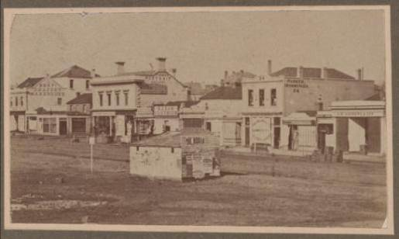
Moorabool Street, Geelong, 1852, showing extent of painted signage on buildings. State Library of Victoria http://handle.slv.vic.gov.au/10381/73897

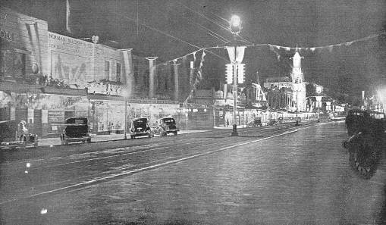
Ryrie St Geelong, showing painted signs illuminated by floodlights ca. 1930s-40s. Geelong Heritage Centre, image GRP2, Ryrie 007
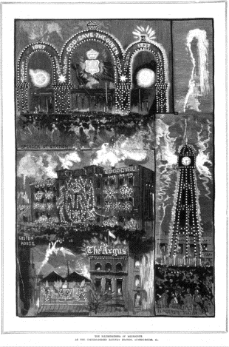
The Illuminations of Melbourne from Australian Sketcher, showing Spencer Street Station, Customs House and the Water Clock tower at Flinders Street Station, all with lighting displays to mark the Jubilee celebrations where streets were lit from dusk to midnight on 21 June 1887. State Library of Victoria http://handle.slv.vic.gov.au/10381/258230

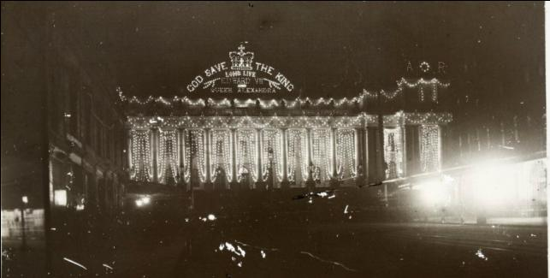
Night time view of railway buildings west of Flinders Street Station lit with electric lights... installed for the royal visit in 1901. http://handle.slv.vic.gov.au/10381/83483
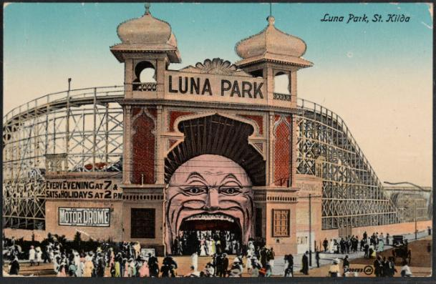
Luna Park, 1912, showing bulbs around the edges of all decorative elements. State Library of Victoria. http://handle.slv.vic.gov.au/10381/57353

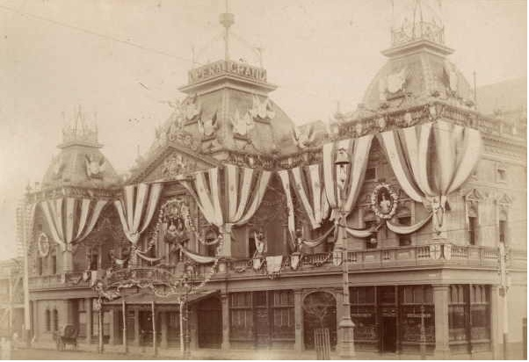
Detail of Princess Theatre Melbourne decorated for the visit of Duke and Duchess of Cornwall and York for opening of Australia's first Parliament ca. 1901 showing sign. http://www.slv.vic.gov.au/pictures/gid/slv-pic-aaa37757 State Library of Victoria.
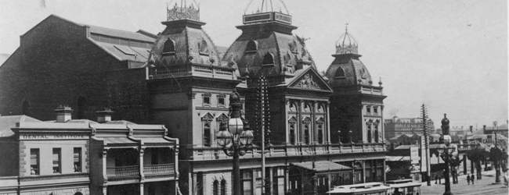
Postcard of Princess Theatre, 1908 from the collection of National Maritime Museum of Australia. No sign.

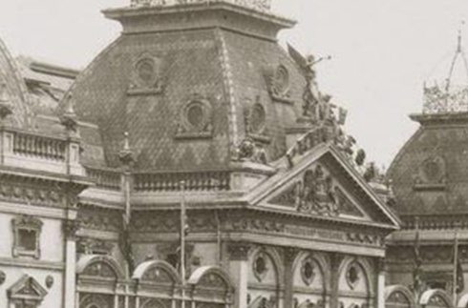
Detail of Princess Theatre Melbourne, sign reads NEW PRINCESS [ca. 1920] Rose Stereograph Company State Library of Victoria http://handle.slv.vic.gov.au/10381/15643

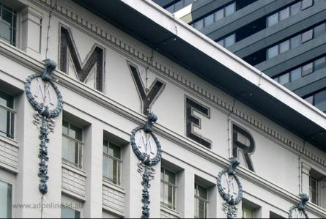
Myer sign 1925-6, Image by Adam Dimech, date unknown http://www.adonline.id.au/neon/myer-emporium/

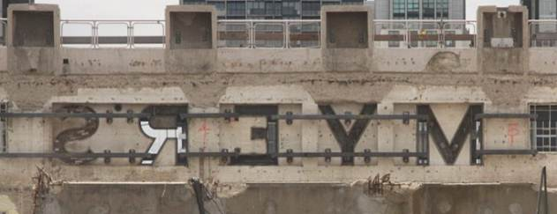
Myer sign from rear during demolition showing the metals plates that would have held the globes, Image by Steven Wong approx January 2013. http://www.flickr.com/photos/legoblock/6524560361/

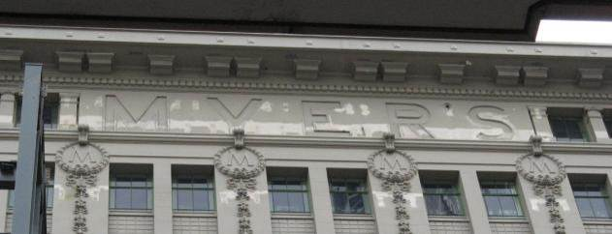
Myer’s sign, 17 January 2014.

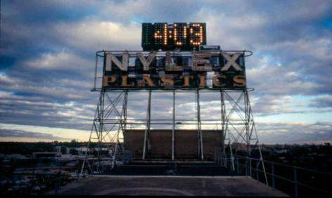
NYLEX PLASTICS SIGN VHR H2049, 1961

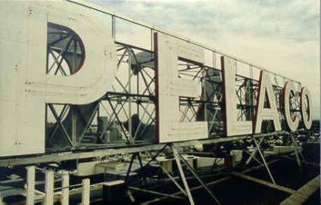
PELACO SIGN VHR H1149, 1939

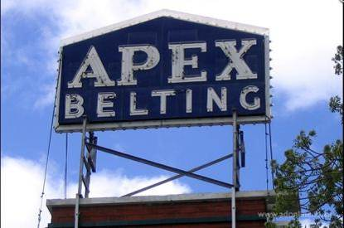
APEX BELTING SIGN, City of Maribynong

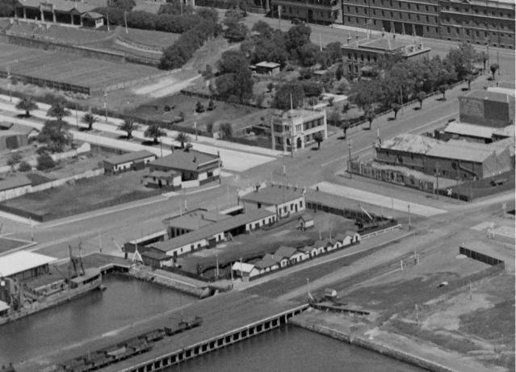
Detail of ‘GEELONG, shows Western Beach and wool stores’ November 1938, by Charles Daniel Pratt. This image shows how close the Sailor’s Rest building was to the docks, and how noticeable the sign would have been with no other tall buildings between the Sailors’ Rest and the foreshore. State Library of Victoria http://handle.slv.vic.gov.au/10381/20679

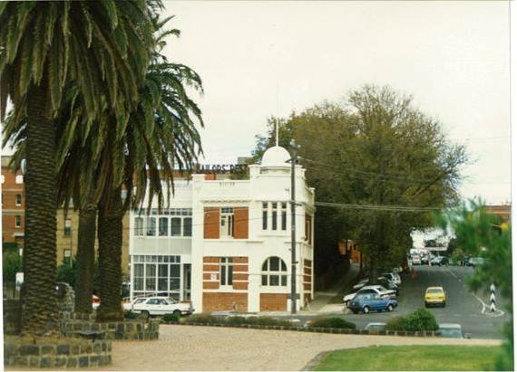
Sailors’ Rest building 1996 [image Kevin Krastins]
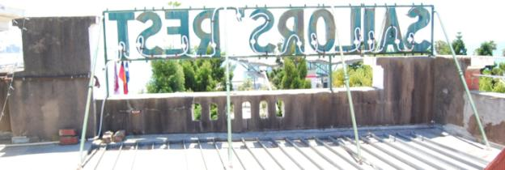
Back of sign showing diagonal bracing and frame and modern wiring (February 2014)

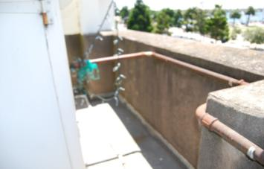
Conduit detail (February 2014)
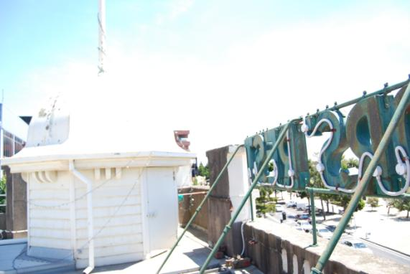
Hexagonal room and modern wiring (February 2014)

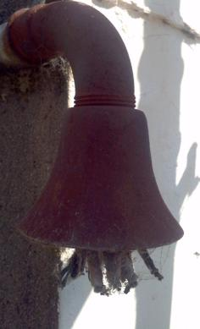
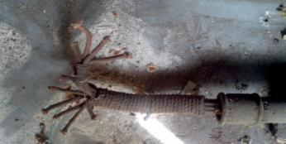
Other end of conduit in hexagonal room showing twelve wires (eleven for the eleven letters and the twelfth neutral wire on the side) (February 2014)

Bell mouth conduit near sign showing original wires (February 2014)

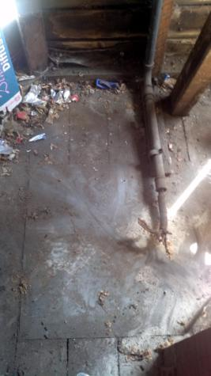
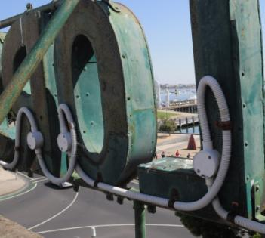Detail of letters showing fastenings. (February 2014)

Metal plate on floor of hexagonal room with wrapped cut wires. (February 2014)

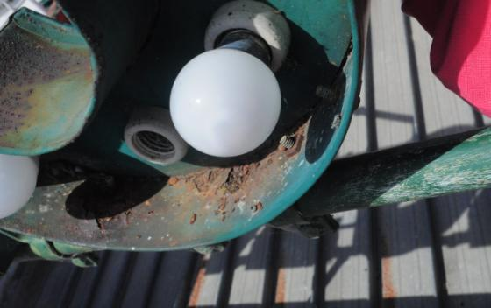
Lamp holders and corrosion [Image Owen Peake] (February 2014)

