ASSESSMENT OF CULTURAL HERITAGE SIGNIFICANCE TO AMEND AN EXISTING REGISTRATION
Endorsed By The
Heritage Council of Victoria
7 August 2014


NAME: PURRUMBETE
DATE REGISTERED: 9 October 1974
VHR NUMBER: VHR H301
LOCATION: 3551 PRINCES HIGHWAY, WEERITE, CORANGAMITE SHIRE
CATEGORY: HERITAGE PLACE, ARCHAEOLOGICAL PLACE
FILE NO: 602553, HER/2000/000037, 13/009996
HERMES NUMBER: 196

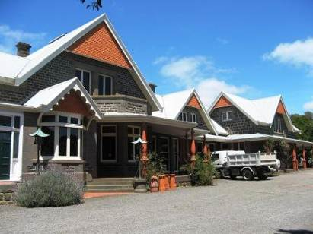
EXECUTIVE DIRECTOR RECOMMENDATION TO THE HERITAGE COUNCIL:
To amend the existing registration for VHR H301 in accordance with s.54 of the Heritage Act 1995 by:
- Clarifying the extent of registration
- Adding a permit policy and permit exemptions in accordance with s.42(4) of the Act.

Reasons for the proposed amendment:
The registration of Purrumbete, which was gazetted in 1974, requires updating because no land is registered. Until 1982, no land was able to be registered under the historic Buildings Act. For places added before that time, only the buildings are included in the registration.
The existing registration documentation is provided at Attachment 1 of this report.

Recommendation Date: 23 May 2014

EXTENT OF REGISTRATION
All of the place known as Purrumbete, shown hatched on Diagram 301 held by the Executive Director encompassing all of Lot 5 on LP34229

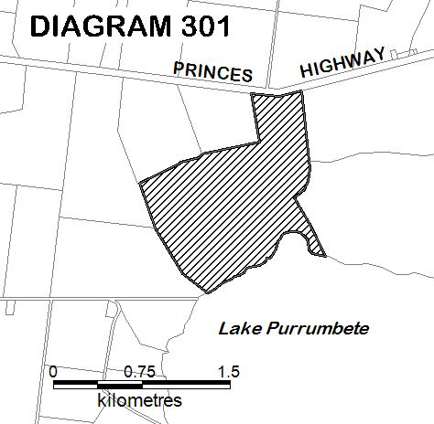

STATEMENT OF CULTURAL HERITAGE SIGNIFICANCE
What is significant?
Purrumbete homestead, the former conservatory, the outbuildings, structures and walls, water reticulation system, driveways, garden, orchard, avenues and plantations.
History Summary
Purrumbete was established by the brothers John and Peter Manifold in 1839, when they became squatters on the land around Lake Purrumbete. During the nineteenth century the Manifold family became one of the largest landholders in Victoria, and Purrumbete developed into a substantial and prosperous farming complex, accommodating the growing demands of cattle, sheep and later bullock and dairy farming. A small house was first constructed on the site of the present homestead in 1842, and in 1857-1860 a large bluestone wing was added, part of which remains. Major additions which doubled the size of the homestead were made in 1882 to designs by the Camperdown architect, Alexander Hamilton. The resulting single storey bluestone Italianate style house included a verandah with elaborate ironwork and an extensive cellar. In 1884 an elaborate conservatory was constructed at the western end of the house. By the early 1890s at least twenty outbuildings had been constructed at Purrumbete, all built in timber except for the bluestone men's quarters. The Manifolds made good use of the lake as a water resource, and installed an advanced water reticulation system. In 1901 the architect Guyon Purchas designed major alterations and additions to the house, resulting in an unusual Federation Arts and Crafts style building, with remnants of the earlier building phases retained. The most significant changes were made to the main rooms along the north front, which were rebuilt with outstanding Art Nouveau interiors. After the First World War, much of the Manifold family landholdings were sold for soldier settlement. Successive generations of the Manifold family lived at Purrumbete until 1983.

Description Summary
Purrumbete is a 170 hectare farm complex in a landscaped lakeside setting. It includes a large homestead in a Federation Arts and Crafts style, located in an elevated position overlooking Lake Purrumbete. The house contains outstanding Art Nouveau interiors with hand-crafted timber and metal work, especially in the substantial central living hall and the adjoining drawing, dining and morning rooms. The hall features timber panelled walls and ceiling, a minstrel's gallery with an intricately-carved screen and staircase, and around the upper level of the hall is a mural made up of six paintings by the leading Heidelberg School artist Walter Withers, depicting the settlement of Purrumbete by the Manifold family. The extensive timber work was crafted by the Melbourne joiners, Murray and Crow. Notable features near the house are the remains of the 1884 conservatory, an early twentieth century glasshouse, a berry cage, and tunnels excavated beneath the house. Several of the original farm outbuildings have been demolished but six remain largely intact: the horse stables and dairy; the carpenters/blacksmith’s shop; the manager’s house; the men’s stables; the cart, cow and store shed; and the bluestone men’s quarters. Extant water reticulation infrastructure includes two bluestone water tanks, early galvanized iron corrugated steel water tanks on a large tank stand, an underground water storage tank, remnant cast iron water pipes and a c1860s drain partly lined with basalt north of the homestead.
The landscape and garden created in a picturesque style on the shore of Lake Purrumbete retain features from the late nineteenth and early twentieth centuries, including the layout and the character of the planting in the different parts of the garden, the driveway and avenues of elms, oaks, poplars, pine and cypress, the tennis court, stone walling and pond, and the southern set of basalt steps leading down to the lake. Original trees include Monterey Cypress, Golden Cypress and Monterey Pine trees in The Wood and on Picnic Point. A collection of plants and trees representative of the periods of development remains. The late nineteenth century planting is represented by mature specimens of Abies pinsapo, Picea smithiana, Araucaria bidwillii, Araucaria heterophylla, Cordyline australia, Cupressus torulosa, Erythrina crista-galli, Corynocarpus laevigatus, Hesperocyparis macrocarpa, Hesperocyparis macrocarpa ‘Horizontalis Aurea’, Fraxinua excelsior, Magnolia grandiflora, Taxus baccata, Tilia x europaea and Ulmus x hollandica. The ornamental planting includes two outstanding and rare Ilex x alterclarenis and a Melicytus ramiflorus. Intact layout and planting of the 1930s includes the rose beds, Betula pendula, Fagus sylvatica f. Purpurea, Prunus cv (Sato-zakura group), Diospyrus kaki, Populus x Canadensis ‘Aurea’ and Quercus palustris.
How is it significant?
Purrumbete is of aesthetic, architectural, historical and archaeological significance to the State of Victoria. It satisfies the following criteria for inclusion in the Victorian Heritage Register:
Criterion A Importance to the course, or pattern, of Victoria’s cultural history
Criterion B Possession of uncommon, rare or endangered aspects of Victoria’s cultural history
Criterion C Potential to yield information that will contribute to an understanding of Victoria’s cultural history
Criterion D Importance in demonstrating the principal characteristics of a class of cultural places and objects
Criterion E Importance in exhibiting particular aesthetic characteristics
Criterion F Importance in demonstrating a high degree of creative or technical achievement at a particular period
Criterion H Special association with the life or works of a person, or group of persons, of importance in Victoria’s history.

Why is it significant?
Purrumbete is significant at the State level for the following reasons:
Purrumbete is historically significant for its association with the early settlement of Victoria and with the Manifold family, who were among the earliest and most successful of the settlers in Victoria’s Western District. During the nineteenth century the Manifolds were among the largest landholders in Victoria and one of Australia’s most influential families. Purrumbete became one of the largest farming properties in Victoria and remained in Manifold ownership until 1983. The property is associated with the heyday of the pastoral era in Victoria and the prosperity of the Western District pastoralists in the nineteenth and early twentieth centuries. (Criteria A and H)
Purrumbete is significant for its unusually intact collection of picturesque Victorian-era farm buildings, which is one of the most intact such groups in Victoria, and for its unusual nineteenth century water reticulation system of underground cast iron pipes, drains and above ground bluestone water tanks. [Criterion B]
Purrumbete is archaeologically significant for the existence of ruins and remains of former outbuildings which have the potential to contain archaeological features and relics related to the development of the site. [Criterion C]
Purrumbete homestead is architecturally significant as an outstanding example of Arts and Crafts architecture in Victoria. The interiors, in particular the main hall, drawing room, dining room and morning room, display highly developed Art Nouveau interior design. The unique integration of six original paintings by Walter Withers, recording the history of the Manifold family at Purrumbete, is also significant, as is the intricate timber work produced by Murray and Crow. Purrumbete is also of architectural significance for its collection of intact nineteenth century outbuildings, and help to illustrate the various activities undertaken at the property. [Criterion D and E]
Purrumbete homestead is of aesthetic significance for its outstanding Art Nouveau interiors, its rare lake-side setting and the retention of plantings from the later nineteenth and early twentieth century. The picturesque landscape is of outstanding beauty and quality, with a rich collection of plants more typical of public than private gardens. It includes a diverse collection of conifers, evergreen and deciduous trees and shrubs, with contrasting foliage, forms and autumn and flower colour. Plantings include specimen trees, shrubs, rose gardens, hedges, an orchard, a driveway avenue and shelter belt plantings, and the plantings in The Wood and on Picnic Point. The Melicytus ramiflorus is the only one known outside the Royal Botanic Garden, and the Ilex x alterclarensis is exceptionally large and rare in Victoria. [Criterion E]
Purrumbete is of scientific (technical) significance for the remnants of the water reticulation system, which is an advanced example of nineteenth century technology adapted for use on a private farm. [Criterion F]
Purrumbete is significant for its long association, from 1836 until 1983, with the Manifold family. The homestead is an important example of the work of the architect Guyon Purchas, one of the pioneers of the Australian Arts and Crafts movement, who designed some of the movement’s most spectacular domestic interiors. It is significant for its association with the artist Walter Withers, a major and influential member of the Heidelberg School of artists. [Criterion H]

Purrumbete is also significant for the following reasons, but not at the State level:
Purrumbete homestead has local historical significance for its association with the prominent Western District architect Alexander Hamilton in the development of the property in the 1870s and 1880s, and the retention of much of the form and some of the detail of his design in the 1901 remodelling of the homestead. It is significant for the early recording of the property in an 1842 watercolour and the 1857-58 painting by Eugene von Guérard, which contribute to an understanding of the development of the homestead.

PERMIT POLICY

Preamble
The purpose of the Permit Policy is to assist when considering or making decisions regarding works to a registered place. It is recommended that any proposed works be discussed with an officer of Heritage Victoria prior to making a permit application. Discussing proposed works will assist in answering questions the owner may have and aid any decisions regarding works to the place.

The extent of registration of Purrumbete on the Victorian Heritage Register affects the whole place shown on Diagram 301 including the land, all buildings, roads, trees, landscape elements and other features. Under the Heritage Act 1995 a person must not remove or demolish, damage or despoil, develop or alter or excavate, relocate or disturb the position of any part of a registered place or object without approval. It is acknowledged, however, that alterations and other works may be required to keep places and objects in good repair and adapt them for use into the future.

If a person wishes to undertake works or activities in relation to a registered place, they must apply to the Executive Director, Heritage Victoria for a permit. The purpose of a permit is to enable appropriate change to a place and to effectively manage adverse impacts on the cultural heritage significance of a place as a consequence of change. If an owner is uncertain whether a heritage permit is required, it is recommended that Heritage Victoria be contacted.

Permits are required for anything which alters the place, unless a permit exemption is granted. Permit exemptions usually cover routine maintenance and upkeep issues faced by owners as well as minor works. They may include appropriate works that are specified in a conservation management plan. Permit exemptions can be granted at the time of registration (under s.42 of the Heritage Act) or after registration (under s.66 of the Heritage Act).

It should be noted that the addition of new buildings to the registered place, as well as alterations to the interior and exterior of existing buildings requires a permit, unless a specific permit exemption is granted.

Conservation management plans
‘Purrumbete Homestead, Princes Highway, Weerite, Conservation Management Plan’, by Dr David Rowe of Authentic Heritage Services Pty Ltd in association with Wendy Jacobs and Pamela Jellie, November 2001, may provide guidance for the future management of the place.

Cultural heritage significance
Overview of significance
The cultural heritage significance of the homestead lies in its history and the three main stages of construction (1857-60, 1882 and 1901), which are apparent in its form and fabric. It is especially notable for the intact Art Nouveau decoration of the 1901 additions, including outstanding timber and metal work in the main rooms and the original murals in the central living hall. Other important features associated with the homestead include the remains of the nineteenth century conservatory, the early twentieth century glasshouse, the remnants of the early water reticulation system, including the water storage tanks, the garden and park, the driveway and plantations, and the tunnels in the escarpment below the house. The picturesque farm outbuildings are fine examples of their kind. The site also has archaeological potential for the existence of above- and below-ground evidence of former outbuildings and features.

- All of the buildings and features listed here are of primary cultural heritage significance in the context of the place. A permit is required for most works or alterations. See Permit Exemptions section for specific permit exempt activities:
- homestead, including the interiors, and the adjacent conservatory floor
- horse stables, coach house and dairy
- carpenter’s/ blacksmith’s shop
- manager’s house
- cool store adjacent to manager’s house
- bluestone men’s quarters
- cart shed, store and cow shed
- men’s stables
- glass house
- two bluestone water tanks
- tunnels opening from near the lake.

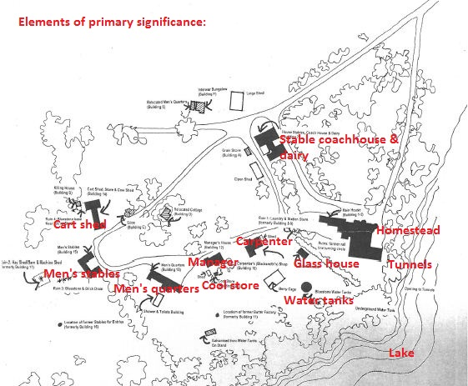

- Buildings and features that are listed here or not listed in a) or c) are deemed to have contributory cultural heritage significance to the place. A permit is required for most works or alterations. See Permit Exemptions section for specific permit exempt activities:
- grain store west of horse stables, coach house and dairy
- killing house, west of cart shed, store and cow shed
- silos east of cart shed, store and cow shed
- relocated cottage east of silos
- relocated men’s quarters on north side of complex
- inter-war bungalow to north-west of house stables, coach house and dairy
- boat house on lake
- berry cage to south-west of house
- galvanised iron water tanks on stand adjacent to lake
- underground water tank
- remains of: station store and laundry; hay shed, barn and machine shed west of Men’s Stables; bluestone and brick drain behind men’s stables; butter factory: bluestone base near the killing shed; and rail line turning circle near the house.

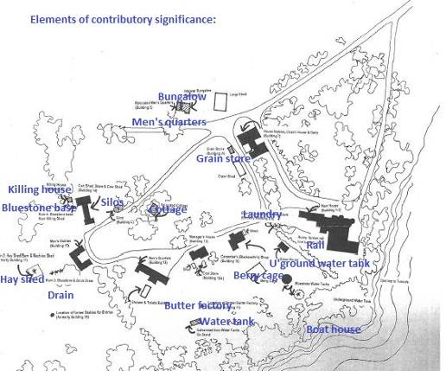

- The following buildings and features are of no cultural heritage significance. Specific permit exemptions are provided for these items:
- 1980s colorbond shed to north-west of house stables, coach house and dairy
- cement block shower building south of men’s quarters
- open machine shed to south-west of house stables, coach house and dairy
- shed adjoining carpenter’s shop to the east
- open shed to south-west of manager’s house
- other buildings recently relocated to Purrumbete from elsewhere
- other features which are new or relocated to Purrumbete from elsewhere, including: the bluestone pillars and decorative iron gates at the entrance to the rose garden, originally from the Geelong Public Library; the new northern set of stone steps east of the house; the lamp posts and fountain east of the house; and the bluestone wall and pillars at the garden entrances.

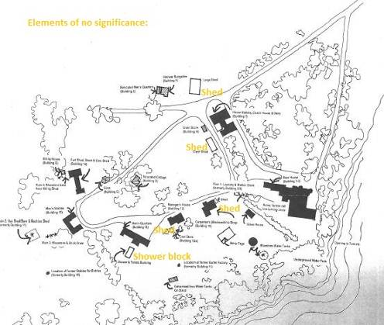

- Archaeology: Ground disturbance may affect the archaeological significance of the place and, subject to the exemptions stated in this document, requires a permit. The various ruins at Purrumbete have the potential to provide information about the development and operation of the complex.

PERMIT EXEMPTIONS (under section 42 of the Heritage Act)
It should be noted that Permit Exemptions can be granted at the time of registration (under s.42(4) of the Heritage Act). Permit Exemptions can also be applied for and granted after registration (under s.66 of the Heritage Act)
General Condition: 1.
All exempted alterations are to be planned and carried out in a manner which prevents damage to the fabric of the registered place or object.
General Condition: 2.
Should it become apparent during further inspection or the carrying out of works that original or previously hidden or inaccessible details of the place or object are revealed which relate to the significance of the place or object, then the exemption covering such works shall cease and Heritage Victoria shall be notified as soon as possible.
General Condition: 3.
All works should be informed by Conservation Management Plans prepared for the place. The Executive Director is not bound by any Conservation Management Plan, and permits still must be obtained for works suggested in any Conservation Management Plan.

General Conditions: 4.
Nothing in this determination prevents the Heritage Council from amending or rescinding all or any of the permit exemptions.

General Condition: 5.
Nothing in this determination exempts owners or their agents from the responsibility to seek relevant planning or building permits from the relevant responsible authority, where applicable.

Exterior
- Repairs and maintenance of contributory elements which replace like with like.
- Removal of non-original items such as air conditioners, pipe work, ducting, wiring, antennae, aerials etc and making good in a manner appropriate to the heritage fabric of the place.
- Installation or removal of non-original external fixtures and fittings, such as hot water services and taps, of contributory elements in a manner not detrimental to the cultural heritage significance of the place.
- Installation and repairing of damp proofing by either injection method or grouted pocket method.

Interior
- Painting of non-decorative painted walls and ceilings provided that preparation or painting does not damage or remove any original paint, varnish or other decorative scheme.
- Installation, removal or replacement of non-original carpets and/or flexible floor coverings.
- Installation, removal or replacement of non-original curtain tracks, rods and blinds.
- Installation, removal or replacement of hooks, nails and other devices for the hanging of mirrors, paintings and other wall mounted art.
- Demolition or removal of non-original stud/partition walls, suspended ceilings or non-original wall linings (including plasterboard, laminate and Masonite), non-original glazed screens, non-original flush panel or part-glazed laminated doors, aluminium-framed windows, bathroom partitions and tiling, sanitary fixtures and fittings, kitchen wall tiling and equipment, lights, built-in cupboards, cubicle partitions, computer and office fitout and the like.
- Removal or replacement of non-original door and window furniture including, hinges, locks, knobsets and sash lifts.
- Installation of stud walls, which are removable, other than in corridors.
- Refurbishment of existing bathrooms, toilets and kitchens including removal, installation or replacement of non-original sanitary fixtures and associated piping, mirrors, wall and floor coverings.
- Removal of tiling or concrete slabs in wet areas provided there is no damage to or alteration of original structure or fabric.
- Installation, removal or replacement of non-original ducted hydronic heating provided that the installation does not damage existing skirtings and architraves and that the central plant is concealed, and is done in a manner not detrimental to the cultural heritage significance of the place.
- Installation, removal or replacement of electrical wiring provided that all new wiring is fully concealed and any original light switches, pull cords, push buttons or power outlets are retained in-situ. Note: if wiring original to the place was carried in timber conduits then the conduits should remain in situ.
- Installation, removal or replacement of bulk insulation in the roof space.
- Installation of plant within the roof space.

Non-contributory elements
Demolition and all works to buildings of no cultural heritage significance that don’t increase the footprint of the building:
- 1980s colorbond shed to north-west of house stables, coach house and dairy
- cement block shower building south of men’s quarters
- open machine shed to south-west of house stables, coach house and dairy
- shed adjoining carpenter’s shop to the east
- open shed to south-west of manager’s house
- other buildings relocated to Purrumbete from elsewhere.

Landscape
- The process of gardening, including mowing, hedge clipping, bedding displays, removal of dead shrubs and replanting the same species or cultivar, disease and weed control, and maintenance to care for existing plants.
- Repairs and maintenance to hard landscape elements, such as driveways, pond, stone walls, steps, paths, gutters, drainage and irrigation systems excluding the original drainage system, edging, fences and gates, and tennis court in a manner which preserves the cultural heritage significance of the place.
- Removal of dead or dangerous trees and emergency works to maintain safety and to protect buildings and structures, provided a report detailing the works undertaken is submitted to the Executive Director within 21 days of the works occurring.
- Replanting removed or dead trees and vegetation with the same plant species to conserve the significant landscape character and values.
- Management of trees in accordance with Australian Standard; Pruning of Amenity Trees AS 4373-2007.
- Management of trees in accordance with Australian Standard; Protection of Trees on Development Sites AS 4970-2009
- Subsurface works involving the installation, removal or replacement of watering and drainage systems or services, outside the canopy edge of significant trees in accordance with AS4970 and on the condition that works do not impact on archaeological features or deposits.
- Removal of plants listed as noxious weeds in the Catchment and Land Protection Act 1994
- Vegetation protection and management of possums and vermin.

Specific Exemptions:
Alterations to the following features are permit exempt:
- Works to or removal of the two bluestone pillars and decorative iron gates, originally from the Geelong Public Library, which were erected at the entrance to the rose garden in 2013.
- Works to or removal of the stone steps east of the house which were constructed in 2013.
- Works to or removal of the lamp posts and fountain added to the garden east of the house and to the rose garden in 2013.
- Removal of two bluestone wall and two former church bluestone pillars at the two garden entrances.
- Works to buildings of no heritage significance.

RELEVANT INFORMATION

Local Government Authority Corangamite

HERITAGE LISTING INFORMATION
Heritage Overlay: Yes HO Number: HO102

UPDATED HISTORY
[Information mainly from ‘Purrumbete Homestead, Princes Highway, Weerite, Conservation Management Plan’, Vol 1-4, by Dr David Rowe of Authentic Heritage Services Pty Ltd, in association with Wendy Jacobs and Pamela Jellie, November 2001.]
The Manifold family were among the first and most successful of the settlers in the fertile Western District of what was to become the Colony of Victoria. The Manifolds became some of the largest landholders in colonial Victoria, and their descendants were eminent citizens, as pastoralists, philanthropists and politicians.
Thomas Manifold was sent to Van Diemen’s Land from Cheshire at the age of 18 in 1828 and obtained a grant of land on the Tamar River. The rest of the family: parents William and Mary, brothers Peter and John and their three sisters, followed him in 1831. Their land however proved to be poor, and having seen in 1836 the rich land on the mainland, John purchases stock, landed it at Port Henry near Geelong and occupied land on the Barwon River. In the following two years the brothers explored the country near Ballarat, discovered Lake Purrumbete and in January 1839 occupied the Lake Purrumbete run.
They at first bred both sheep and cattle, but from the mid-1840s concentrated on cattle. A herd of Shorthorn cattle was established by John, and along with the Purrumbete stud, which was famous among cattle breeders by 1854, this paved the way for the family’s rise to eminence in the Western District.
When John Manifold died in 1877 Purrumbete was inherited by the eldest son, William Thomson Manifold, and his younger sons took possession of separate estates carved off from the original Purrumbete run: James Chester at Talindert and Thomas at Wiridgil (both properties are still owned by Manifolds).
The Manifold’s affluence is reflected in the large number of staff employed at Purrumbete. Between 1872 and 1885 some 106 staff were recorded in the wages book as house servants, station hands, cooks, gardeners, laundresses, carpenters and bullock drivers.
Purrumbete remained in the Manifold family until it was sold in 1983. It was purchased by the Melbourne property developer David Marriner in 1986, resold the following year to high profile stock-broker Rene Rivkin, and had several owners during the following years.
The homestead at Purrumbete
The first Manifold homestead at Purrumbete was a slab hut on the north side of Lake Purrumbete, but in 1842 a small house (probably of pise) was built on the site of the present house. Between 1858 and 1860 a large bluestone wing was added to the 1842 house. This is extant, though altered, as part of the southern wing of the present house. Some early depictions of the property exist, notably one by Captain Walter Synot (1842) and one by Eugene von Guérard (1857-8).

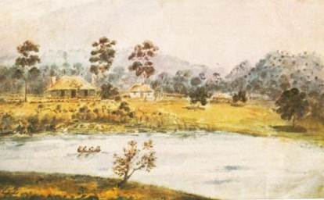
1842 Synot view

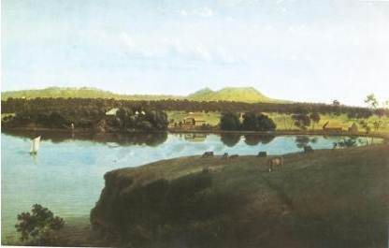
1857-58 von Guérard view

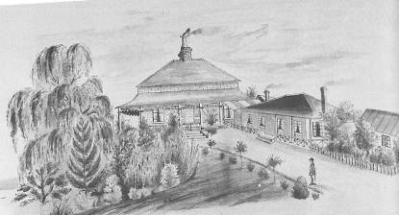
1842 house (right) and 1858-60 bluestone wing (centre)

In 1881 Peter Manifold engaged the Camperdown architect Alexander Hamilton (who had already designed various drainage works and farm buildings at Purrumbete) to design major extensions to the house. The additions incorporated the 1860 wing but the 1842 building was demolished. The new building had elaborate interiors typical of the period, complete with marble fire surrounds and mantles. It also had an extensive cellar, with a coal furnace for heating the house. During construction in 1882-84 the Manifolds travelled overseas to England and Scotland. The view below is of the 1882 homestead viewed from the north.

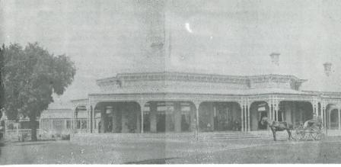

In 1884, after the completion of the house, an elaborate conservatory, which had been ordered in Scotland by Peter Manifold during their overseas tour, was built to the west of the house. It had a cast iron frame on a stone base, a glazed hipped roof and an encaustic tiled floor. Only the stone base and tiled floor remain.
In 1901 the Melbourne architect Guyon Purchas, a proponent of the English Arts and Crafts Movement, was engaged to design new alterations and additions to the house. The changes markedly altered the appearance of the 1880s northern side of the house to an unusual Federation Arts and Crafts style. Internally the walls of the northern part of the house were removed to form a large central living hall with a minstrel’s gallery, and with the drawing and dining rooms opening off the hall by means of wide elaborately-decorated sliding doors. The planning and decoration reflected the most advanced architectural thinking of the day. A first floor was also introduced in the northern part of the house to provide a billiard room, store room and servants’ bedrooms. The southern part of the house (including the 1860 wing) was also remodelled, though many original features were retained. (These changes are detailed in the Conservation Management Plan.)
The interiors of the main rooms, the main hall, drawing room, dining room and morning room, with their unique hand-crafted fittings, are extraordinary examples of Art Nouveau design. The timberwork was crafted by Murray & Crow, contractors and joiners of Melbourne. The main hall has been described by Terence Lane and Jessie Serle as ‘Australia’s most distinguished Art Nouveau interior’. It features timber panelling and a minstrel’s gallery with an intricately carved timber screen and a timber staircase with a finely carved newel post. Adorning the upper levels of the hall is a six-panel allegorical mural by Walter Withers, painted on canvas, representing the early history of the Manifold family at Purrumbete. It is the only time a leading member of the Heidelberg School was commissioned to provide this kind of decoration, and the integration of the architecture and artwork enhanced Purchas’s aim for a complete Arts and Crafts interior.
By the early 1930s many of the rich coloured wallpapers and glazed fire surround tiles had been painted and the copper fire hood of the main hall had been removed. The servants’ quarters, to the south west of the main wing, were demolished in the 1940s and the conservatory was removed in the late 1950s, although the base remains. Considerable restoration work was carried out in the early twenty-first century.
The outbuildings
Early outbuildings
A number of timber outbuildings were constructed at Purrumbete in the 1840s and 1850s. Remnants of these early structures form part of the existing cow shed and the carpenter’s/blacksmith’s shop.
Later outbuildings: 1860s-1900
By the early 1890s there were at least 20 outbuildings at Purrumbete, most of which were probably designed by Alexander Hamilton. Most were of sawn weatherboards with iron roofs, designed in a Picturesque style with gable roofs decorated with carved bargeboards, finials and lancet gable ventilators. Those extant include:
- The house stables, coach house and dairy, constructed in 1884
- The manager’s house, which may have been built c1861
- The small stone cool house behind the manager’s house
- The cart shed, store and cow shed, possibly added to the old cow shed in 1884
- The men’s stables (the stables for the workmen’s horses)
- The bluestone men’s quarters built in 1884.

Of the structures built during this period, many no longer exist, or only ruins remain, including the station store and laundry; a hay shed, barn and machine shed west of the men’s stables; the bluestone and brick drain behind the men’s stables; the butter factory; a bluestone base near the killing shed; and the rail line turning circle south-west of the house.

Twentieth century structures
- A new dairy was added in 1904 to the existing house stables and coach house building,
which was altered several times during the following years.
- A glass house was built south-west of the house in the early twentieth century.
- A large shed was built south-west of the house stables, possibly in the 1980s.

A number of outbuildings were removed from or relocated to Purrumbete in the 1950s. Buildings removed or demolished include the gate lodge and wood house. A timber cottage was relocated from near Talindert to a position west of the men’s quarters in the inter-war period, and another was placed on the north side near the 1980s shed.
Water reticulation system
A complex water reticulation and irrigation system designed by Alexander Hamilton was installed at Purrumbete during the 1870s and 1880s. He organised the construction of two bluestone water tanks, drains, windmills to pump water from the lake, and a complex network of cast iron piping around the property.

Tunnels
Two tunnels under the house which may have started as natural caves, were extended and connected to teh cellar in the early 1880s.
The garden
[A detailed history of the garden and plantings is provided in Volume 4 of the Conservation Management Plan.]
The first planting at Purrumbete was said to be an English oak planted in 1839 (not extant), and exotic plants are shown in drawings and paintings of the property from then on, including in the 1858 painting by Eugene von Guerard, which shows climbing plants on the verandah, a rose garden and a shrubbery with a large tree fern, a willow and a small Norfolk Island pine. By the 1860s there was an ornamental garden around the homestead and an enclosed garden north of the original homestead. A driveway avenue was established, leading to a carriage drive north of the house.
With the expansion of the homestead in the 1880s the garden was enlarged in the ‘Gardenesque’ style to provide an appropriate setting for the house. Beyond the immediate garden the wider landscape was drawn into the garden via woodland planting north-east of the homestead and planting known as The Wood on Picnic Point. William Guilfoyle visited Purrumbete in 1887, but while some of the plantings could reflect his influence there is no record of him designing a garden plan.
A tennis court was constructed c1886 in its present location, and an ornamental lake with a bridge leading to an island in the centre was constructed in front of the house by c1897. A gate lodge, tennis pavilion, boat shed and shade house were also built during this period.
The garden continued to develop after the 1901 Purchas additions. The main decorative garden was concentrated south of the house, where there were formal garden beds with spectacular massed plantings. There was at least one full-time gardener employed at this time. Planting continued during the twentieth century. The 34 metre long stone wall east of the house above the lake was constructed in the 1960s, creating a terraced area. Steps lead down to the lake edge and to two tunnels which have been excavated beneath the escarpment from the lake to the house.

VICTORIAN HISTORICAL THEMES
02 Peopling Victoria’s places and landscapes
2.5 Migrating and making a home

04 Transforming and managing land and natural resources
4.3 Grazing and raising livestock
4.4 Farming

- Shaping cultural and creative life
9.3 Achieving design and artistic distinction

UPDATED PHYSICAL DESCRIPTION
Purrumbete is a largely intact 170.1 hectare farm complex in a landscaped lakeside setting. It includes the large homestead in an elevated position overlooking Lake Purrumbete. It was constructed in three main stages (1857-60, 1882 and 1901). The house now has a Federation Arts and Crafts facade and outstanding Art Nouveau interiors in the central living hall and the adjoining drawing, dining and morning rooms. They are notable for their hand-crafted timber and metal work, complemented by the allegorical Walter Withers paintings in the hall.

Six of the farm outbuildings remain largely intact: the horse stables and dairy; the carpenters/blacksmith’s shop; the manager’s house; the men’s stables; the cart, cow and store shed and the bluestone men’s quarters. Other notable features are the glasshouse (with four very old grape vines inside), the berry cage, and the tunnels excavated beneath the house. Purrumbete also retains some unusual nineteenth century water reticulation infrastructure, including remnant cast iron water pipes, bluestone water tanks, early galvanized iron corrugated steel water tanks on a large tank stand, an underground water storage tank and a c1860s drain partly lined with basalt north of the house.

The garden has an entry avenue of mature trees (elms, oaks, poplars and pines), extensive lawns, mature ornamental trees planted in the gardenesque style, a formal rose garden, a woodland garden (known as The Wood), which is reached by means of a footbridge over the drain, shrub and perennial beds and a tennis court. Intact elements are the layout and planting of the entry drive, including some of the original pine trees (Pinus radiata), the ornamental planting in The Wood and on Picnic Point, the layout of the garden boundaries and the character of the planting in the different parts of the garden, and the southern set of basalt steps leading down to the lake. The late nineteenth century plantings are represented by mature specimens of Abies pinsapo, Araucaria bidwillii, Araucaria heterophylla, Cordyline Australia, Cupressus macrocarpa, Taxus baccata, Tilia x europaea and Ulmus x hollandica. Intact layout and planting of the 1930s includes the rose beds, Betula pendula, Fagus sylvatica f. purpurea and Quercus palustris. South of the blacksmith shop is a fine example of Hesperocyparis benthamii. Purrumbete has a notable collection of conifers, which includes a notable Abies nordmanniana.

UPDATED OBJECTS AND INTERIORS
No original furniture associated with the Manifold ownership has been retained in the house and the interiors have been repainted. The 1882 southern part of the house retains many original features, including marble fire surrounds and timber detailing. The 1901 additions retain original features such as wood carving, metal work, sliding doors, fireplace surrounds and the Walter Withers paintings in the living hall.

UPDATED ARCHAEOLOGY
Purrumbete has had a long history, dating from the late 1830s, and is likely to retain archaeological remains of the various structures and features which have existed on the site since it was established in 1839.

UPDATED INTEGRITY/INTACTNESS
The complex is largely intact, though some outbuildings have been demolished or relocated and some changes have been made to the garden and landscapes.
The integrity of the house is very high. The most substantial changes have been the removal of the conservatory and the demolition of the servants’ quarters at the rear (south-west) of the house. Part of the verandah at the north-east corner of the house has been enclosed.
The outbuildings retain their original arrangement and general appearance, but have been subject to some changes over the years. These changes are outlined in the 2001 Conservation Management Plan.
(December 2013).

UPDATED CONDITION
The house is overall in very good condition. The tiled floor of the conservatory at the west end of the house has been exposed to the weather for a long period and is in poor condition.
The outbuildings are generally in fair condition.
(December 2013).

KEY REFERENCES USED TO PREPARE RECOMMENDATION REPORT
‘Purrumbete Homestead, Princes Highway, Weerite, Conservation Management Plan’, Vol 1-4, by Dr David Rowe of Authentic Heritage Services Pty Ltd, in association with Wendy Jacobs and Pamela Jellie, November 2001.
W G Manifold, The Wished-for Land. The Migration and Settlement of the Manifolds in Western Victoria, Camperdown 1984.

ADDITIONAL IMAGES

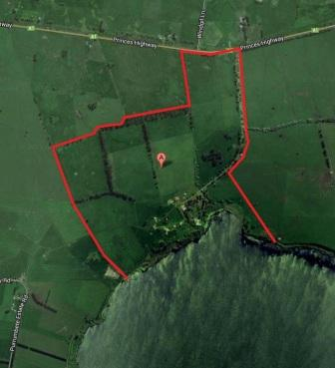
Aerial view of Purrumbete (outlined in red): the Princes Highway is at the top & Lake Purrumbete at the bottom. The Purrumbete buildings are located in the area adjacent to the lake.

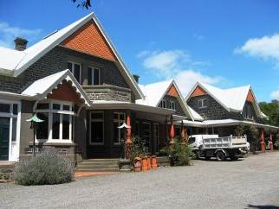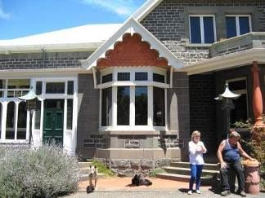
North elevation of house Main entrance

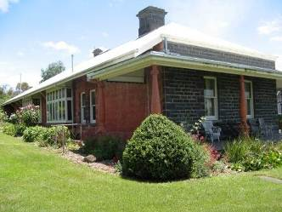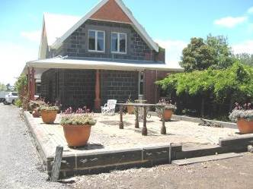
South wing (c1860 bluestone with 1902 details) View of house from west & base of 1884 conservatory

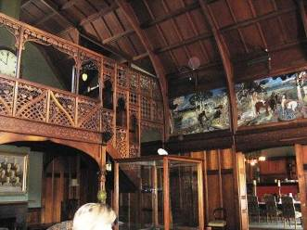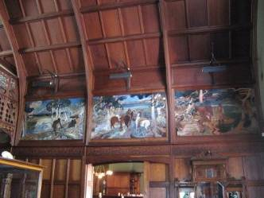
Main hall with Walter Withers mural

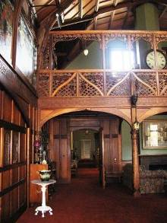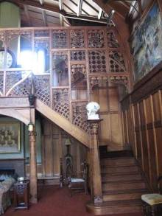
Main hall, minstrel gallery and staircase, with details of timber work
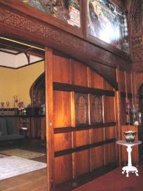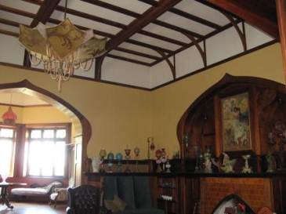
Sliding door to drawing room Drawing room

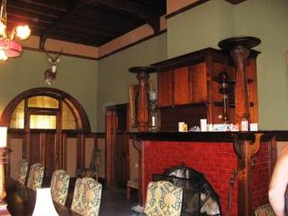
Dining room

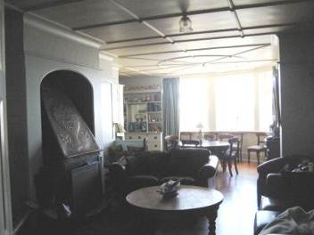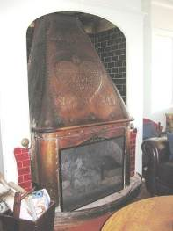
Morning room (left) and detail (right) of copper hood over fireplace

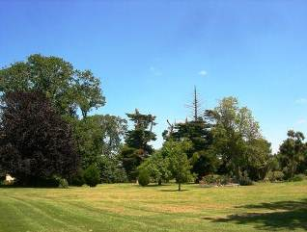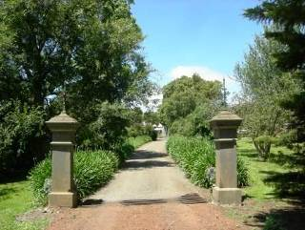
Views of garden

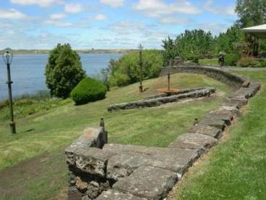
Garden terrace overlooking Lake Purrumbete

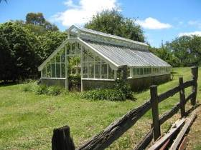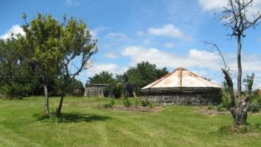
Glasshouse Bluestone water tanks

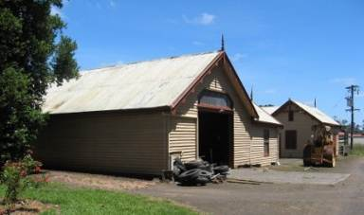
House stables, coach house & dairy

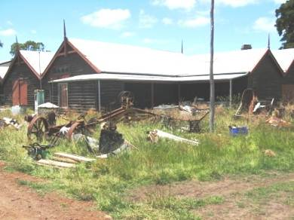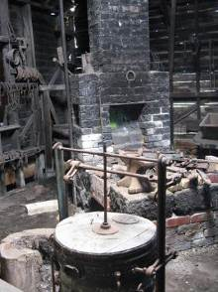
Carpenters / blacksmiths shop

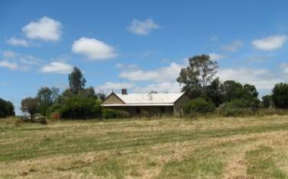 Manager’s house

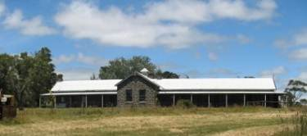 Bluestone men’s quarters

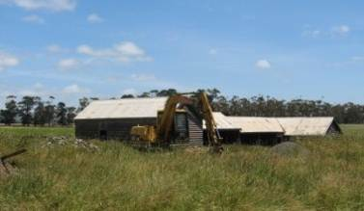 Cart shed, store & cow shed

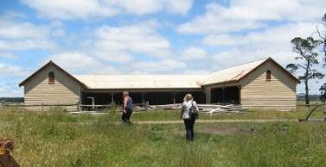 Men’s stables

ATTACHMENT 1
Existing registration details
To be superseded by the foregoing recommendation

EXISTING EXTENT OF REGISTRATION
Shire of Hampden. No.301. Purrumbete, Camperdown.
[Victoria Government Gazette No 100 Wednesday, October 9 1974 p.3649]

EXISTING STATEMENT OF CULTURAL HERITAGE SIGNIFICANCE
What is significant?
Purrumbete, Weerite was settled by brothers Thomas, John and Peter Manifold in 1839 and the family subsequently became one of Victoria's largest landholders. The Purrumbete property developed into a highly prosperous and substantial farming complex during the latter half of the nineteenth century and the homestead grew from a core built in 1857-60, which was extended in 1882 and extensively altered in 1901. Successive generations of the Manifold family lived there until 1983.
John and Peter Manifold arrived in Tasmania from England in 1831 and first sighted the land on Lake Purrumbete in 1836. Together with Thomas, they laid claim to 100,000 acres around Lake Purrumbete in 1839, and John and Peter remained as squatters on this land until the mid-1850s when their land was converted to freehold. John died in 1877, and after Peter died in 1885 the property was divided between John's sons. The eldest, William Thomson Manifold, acquired the portion containing the homestead on 10,809 acres. After the First World War, much of the Manifold family landholdings were sold for soldier settlement and by 1963 only 991 acres of the original estate remained.
Extensive building work was undertaken at the Purrumbete property between the years 1842 to 1901. This included the development of the main homestead and the construction of outbuildings and affiliated garden and farm works. A house was originally constructed on the site of the present homestead in 1842, and in 1857-1860 a large bluestone addition was built, part of which remains as the south east wing of the homestead. Major additions were made to this house in 1882 to designs by Western District architect, Alexander Hamilton. The resulting single storey Italianate bluestone house with iron hipped roof, doubled the size of the homestead and included bay windows and an encircling verandah with elaborate ironwork. A cellar was added under the entrance, drawing room and morning room and in 1884 a conservatory was constructed at the western end of the house.
In 1901 architect Guyon Purchas was commissioned by W. T. Manifold to again enlarge and modify the house, resulting in a highly unusual Federation Arts and Crafts style building. The most significant changes were made to the rooms along the front wing with the addition of a first floor, the inclusion of a substantial central hall with minstrel's gallery, and the modification of the drawing room.
Externally the resulting homestead is Arts and Crafts in character, with remnants of the earlier phases evident. The textured bluestone and red brick building is highly asymmetrical in composition with dominant multi-gabled roofs containing dormer windows, and encircling verandahs. Detailing includes terracotta shingles in gable ends and bulbous terracotta verandah columns, exaggerated timber brackets and dressed bluestone quoining and architraves. Decorative Art Nouveau lamps remain at the porch steps.
Internally the main spaces are Arts and Crafts in character with Art Nouveau detailing. Extensive timber work, such as panelled walls and ceilings, frieze bands, sliding doors, screens, newell posts, fire surrounds, overmantles and inglenook seats, and metal work incorporate sinuous details. The timber fittings were crafted by Melbourne joiners, Murray and Crow, between 1902 and 1904 and, together with the metal work, were probably designed by Guyon Purchas. Manifold commissioned the leading Heidelberg School artist, Walter Withers, to execute six paintings depicting the early settlement and development of the family at Purrumbete, to line the main hall of the homestead.
By the early 1930s many of the rich coloured wallpapers and glazed fire surround tiles had been painted and the copper fire hood of the main hall had been replaced. The servants' quarters, to the south west of the main wing, were demolished in the 1940s and the conservatory was removed in the late 1950s, although the base remains.
By the early 1890s at least twenty outbuildings had been constructed at Purrumbete, all built in timber except for the bluestone men's quarters. The six predominantly intact buildings include the Coach House, House Stables and Dairy, Carpenter's (Blacksmith's) Shop, Manager's House and Cool Store, Men's Stables, Cart, Cow and Store Shed and Men's Quarters. Most of these were designed in a picturesque style, possibly by Alexander Hamilton, with gable roof forms, often with decorative features. Other contributory outbuildings, and the ruins of others, remain on the site.
The Manifolds made ample use of the lake as a water resource. A water reticulation system, including a network of underground cast iron water pipes, three tunnels, three above ground bluestone water tanks, steps to the lake and an early drain, remains from the 1870s and 1880s. Alexander Hamilton was largely responsible for the development and supervision of this work. A remnant turntable from the late nineteenth century rail system, used to run wood carts to the rear of the main house, also remains.
Some of the design elements of the homestead garden have been retained from the late nineteenth and early twentieth century, including the driveway, garden layout and the base of the former conservatory. A collection of plants and trees, representative of the periods of development, remain, as does ornamental planting in the wider landscape, in particular the areas known as the Wood and Picnic Point on Lake Purrumbete. A glass house, with original water reticulation system, situated to the west of the main house and probably dating from the early 20th century, also remains.
How is it significant?
Purrumbete homestead is of historical, architectural, scientific and aesthetic significance to the state of Victoria.
Why is it significant?
Purrumbete homestead is of historical significance for its association with the leading Victorian pastoralist family, the Manifolds. Developed from 1839 into one of the largest and most successful farming properties in Victoria, it remained in their ownership until 1983, and epitomises the pastoralist era in Victoria. It reflects the wealth and success of the Western District of Victoria pastoralists in the nineteenth and early twentieth centuries. The early recording of the property, by Captain Walter Synot in 1842 and Eugene von Guerard in 1857-8, is also of note.
Purrumbete homestead is of architectural significance as an outstanding example of Arts and Crafts architecture in Victoria and as a highly important example of the work of architect, Guyon Purchas. The interiors, in particular the main hall, drawing room and dining room, display highly developed, and highly significant, Art Nouveau interior design. The unique integration of six original paintings by Walter Withers, recording the development of Purrumbete, is also highly significant as is the intricate timber work produced by Murray and Crow.
Purrumbete homestead is of architectural significance for the involvement of Western District architect Alexander Hamilton in the development of the property in the 1870s and 1880s, and the retention of much of the form and some of the detail of his design in the 1901 remodelling of the homestead.
Purrumbete homestead is of architectural significance for its intact nineteenth century, picturesquely designed outbuildings which collectively illustrate the activities undertaken at the property.
Purrumbete homestead is of scientific (technical) significance for the remnants of the water reticulation system and railway turntable which represent unusual nineteenth century technology for a private farm complex. Together with the ruins of some outbuildings, they contribute to the understanding of the development of this property.
Purrumbete homestead is of aesthetic significance for its rare lake setting and the retention of the original driveway and circulation around the homestead, planting in the Wood and on Picnic Point and remnant trees, gardens, lawns, fences, pathways and steps.
EXISTING PERMIT POLICY
There is no existing permit policy.

EXISTING PERMIT EXEMPTIONS
General Conditions: 1. All exempted alterations are to be planned and carried out in a manner which prevents damage to the fabric of the registered place or object.
General Conditions: 2. Should it become apparent during further inspection or the carrying out of works that original or previously hidden or inaccessible details of the place or object are revealed which relate to the significance of the place or object, then the exemption covering such works shall cease and Heritage Victoria shall be notified as soon as possible. Note: All archaeological places have the potential to contain significant sub-surface artefacts and other remains. In most cases it will be necessary to obtain approval from the Executive Director, Heritage Victoria before the undertaking any works that have a significant sub-surface component.
General Conditions: 3. If there is a conservation policy and planall works shall be in accordance with it. Note:A Conservation Management Plan or a Heritage Action Plan provides guidance for the management of the heritage values associated with the site. It may not be necessary to obtain a heritage permit for certain works specified in the management plan.
General Conditions: 4. Nothing in this determination prevents the Executive Director from amending or rescinding all or any of the permit exemptions.
General Conditions: 5. Nothing in this determination exempts owners or their agents from the responsibility to seek relevant planning or building permits from the responsible authorities where applicable.
Minor Works : Note: Any Minor Works that in the opinion of the Executive Director will not adversely affect the heritage significance of the place may be exempt from the permit requirements of the Heritage Act. A person proposing to undertake minor works must submit a proposal to the Executive Director. If the Executive Director is satisfied that the proposed works will not adversely affect the heritage values of the site, the applicant may be exempted from the requirement to obtain a heritage permit. If an applicant is uncertain whether a heritage permit is required, it is recommended that the permits co-ordinator be contacted.

