ASSESSMENT REPORT ENDORSED BY THE HERITAGE COUNCIL OF VICTORIA TO AMEND AN EXISTING REGISTRATION
at its meeting on 4 December 2014


NAME: FORMER beechworth gaol
DATE REGISTERED: 20 August 1982
VHR NUMBER: VHR H1549
LOCATION: Williams, Ford and High STreets, Beechworth
CATEGORY: HERITAGE PLACE/ ARCHAEOLOGICAL PLACE
FILE NO: 14/002851
HERMES NUMBER: 119

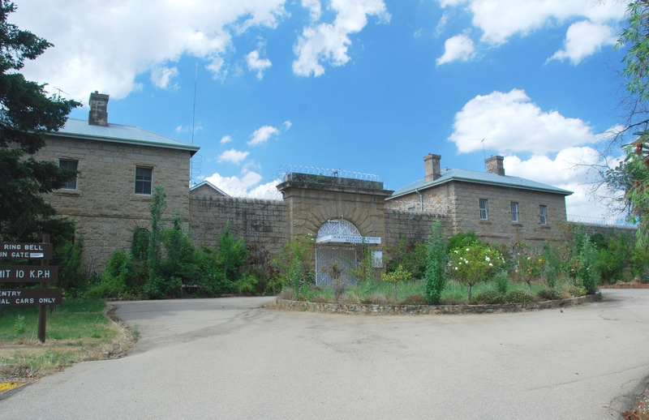

HERITAGE COUNCIL DETERMINATION:
To amend the existing registration for VHR H1549 by:
- including it in the Register as an Archaeological Place as well as a Heritage Place
- updating the Statement of Significance.

Reasons:
A number of prisoners were executed and buried at Beechworth Gaol in the nineteenth century, but the archaeological significance is not acknowledged in the existing registration. It is currently registered only as a Heritage Place, and it should also be registered as an Archaeological Place.

Executive Director Recommendation Date: 19 September 2014
Heritage Council Determination Date: 4 December 2014

EXTENT OF REGISTRATION
All of the place shown hatched on Diagram 1549 encompassing all of Crown Allotment 2011 Township of Beechworth.

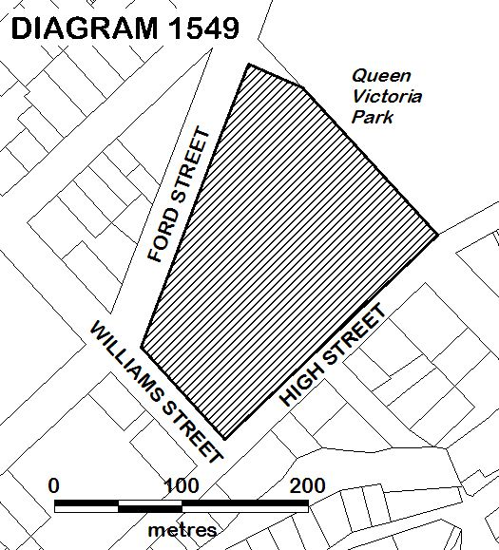

STATEMENT OF CULTURAL HERITAGE SIGNIFICANCE
What is significant?
The Former Beechworth Gaol, including: the perimeter walls and watch towers, the entrance gateways and iron gates; the gaolers quarters and turnkeys quarters on either side of the entrance; the interior division walls; the two cell blocks, the central hall, the kitchen wing, the former dining hall and office wing; the former governor’s residence to the east; the stone quarry at the rear; the front garden; the external granite retaining walls around the site; and the archaeological potential, including the nineteenth century burials.
History Summary
A major period of gaol construction began in Victoria during the late 1850s, with nine imposing stone gaols built between 1857 and 1864. These were all designed by the Public Works Department, and conformed to a new English concept in prison design, called the panopticon, where radiating wings of cells could be kept under observation from a central hub. The gaols were all enclosed by high perimeter walls with observation towers and stone gateways flanked by staff living quarters. The Beechworth Gaol was built in several stages, using granite quarried on the site by prisoners. The panopticon with two wings of cells, a central hall and a kitchen wing were built in 1859-60, and the gaol opened in 1860 while still incomplete. The walls, offices, outhouses and staff accommodation were completed by 1864. The contractors were H Dalrymple and George Simmie and the total cost was £46,763. Conditions were primitive and it was not until 1993 that the cells were provided with toilets and running water. The gaol has a close association with the Kelly gang, with Ned Kelly imprisoned there for a total of about two years between 1870 and 1880. Ned’s brothers Dan and James, other members of his gang and his mother, Ellen, and her new-born baby also spent time there. Twenty-five Kelly sympathisers were held there awaiting trial, as were Crown witnesses during committal hearings. Between 1865 and 1881 eight prisoners were executed at Beechworth, and were buried in unmarked graves within the gaol grounds. Subsequent executions of prisoners from Beechworth Gaol were carried out in Melbourne. The coming of the railway in 1876 resulted in many prisoners being transferred to Pentridge rather than remaining at Beechworth, and by the early twentieth century prisoner numbers were so low that the government closed the gaol in 1918. It was renovated and re-opened in 1926 as the Beechworth Reformatory Prison for hardened male criminals. In 1951 it became the Beechworth Training Prison, intended for the rehabilitation of younger prisoners. At that time new facilities for work, accommodation, education and recreation were added. In 1990 the gaol became the Beechworth Integration Prison. With the building of a new minimum security prison outside the town, the gaol was closed in 2004 and sold for private development.

Description Summary
The Former Beechworth Gaol is located in a landscaped setting on an elevated site at the northern part of the town, and is a prominent feature in views along the main street from the south. The buildings are of light-coloured granite. The gaol is enclosed by high walls with watchtowers and arched entrances with iron gates on the east and west sides. On either side of the main entrance are two-storey Turnkeys’ and Gaolers’ Quarters. Within the perimeter walls are the two two-storey cell blocks, the dining hall and office wing, all radiating from a central observation hall. There are further high walls dividing the gaol internally and forming a number of open yards. To the east of the perimeter wall is the former Governor’s and Warders’ Quarters, a single-storey stone building with verandahs along the east and south sides. At the front of the gaol is a formal entry forecourt with landscaped gardens (now deteriorated), driveways and pathways with stone edgings. Around the site are various stone retaining walls, and on the northern boundary is the quarry from which the stone of the buildings was excavated (partly concealed by late twentieth century buildings). Burials of the prisoners executed at the gaol are probably located adjacent to the interior of the western wall.

How is it significant?
The Former Beechworth Gaol is of historical, architectural and archaeological significance to the State of Victoria. It satisfies the following criterion for inclusion in the Victorian Heritage Register:
Criterion A Importance to the course, or pattern, of Victoria’s cultural history
Criterion C Potential to yield information that will contribute to an understanding of Victoria’s cultural history
Criterion D Importance in demonstrating the principal characteristics of a class of cultural places and objects

Why is it significant?
The Former Beechworth Gaol is historically significant for its association with the major program of prison construction which occurred in Victoria in c1859-64, when nine new prisons were constructed around the state, transforming the Victorian penal system. The Former Beechworth Gaol reflects the great increase in the population of Victoria after the discovery of gold, and the resulting increase in crime, especially in the goldfields areas. The Former Beechworth Gaol is associated with the development of the penal system in Victoria, having been in use from 1860 until it was closed permanently in 2004. It demonstrates the conditions under which prisoners were kept in the mid-nineteenth century, when prisoners were subjected to solitary confinement in single cells without adequate lighting, heating, sewerage or running water. The quarry at the rear is significant as a demonstration of the hard labour carried out by the prisoners, in excavating the stone for the construction of the prison and other public buildings in the town. The Former Beechworth Gaol is a key element in the group of nineteenth century public buildings in Beechworth, which reflect the role of Beechworth as the government administrative centre of north-eastern Victoria at the height of the gold rushes. It is of historical significance for its associations with the bushranger Ned Kelly, who served a total of about two years there between 1870 and 1880. Kelly's mother and brothers and suspected Kelly sympathisers were also held in the Gaol. [Criterion A]
The Former Beechworth Gaol is architecturally significant as a substantially intact example of the panopticon-type prisons erected in Victoria in the nineteenth century. It demonstrates the restrained ornamentation and high quality construction characteristic of Public Works Department buildings at the time. The Former Beechworth Gaol is a major architectural work of Gustav Joachimi, whose other designs include the entrance to Melbourne's Pentridge Prison (1858-9, VHR H1551), Benalla Court House (1864, VHR H1070), and A-Block and J-Block at Victoria Barracks in Melbourne (1860-7). It forms part of an important precinct of public buildings in Beechworth. [Criterion D]
The Former Beechworth Gaol is archaeologically significant as the burial place of eight prisoners executed at the Gaol between 1865 and 1881. [Criterion C]

The Former Beechworth Gaol is also significant for the following reasons, but not at the State level:
The Former Beechworth Gaol is of historical significance for its associations with the early development of the town of Beechworth. It is significant for its association with Chinese miners in Beechworth in the mid-nineteenth century. Many of the prisoners at the Gaol were Chinese, and the Gaol is important for its association with this significant ethnic minority on the north-eastern goldfields. The Former Beechworth Gaol is of historical significance for its early association with John Castieau, Victoria's Inspector General of Prisons from 1880 to 1884, who was gaoler at Beechworth between 1856 and 1869. It is significant for its association with the bushranger Harry Power, who was also imprisoned here in the 1860s.

PERMIT POLICY
Preamble
The purpose of the Permit Policy is to assist when considering or making decisions regarding works to a registered place. It is recommended that any proposed works be discussed with an officer of Heritage Victoria prior to making a permit application. Discussing proposed works will assist in answering questions the owner may have and aid any decisions regarding works to the place.

The extent of registration of the Former Beechworth Gaol on the Victorian Heritage Register affects the whole place shown on Diagram 1549 including the land, all buildings, roads, trees, landscape elements and other features. Under the Heritage Act 1995 a person must not remove or demolish, damage or despoil, develop or alter or excavate, relocate or disturb the position of any part of a registered place or object without approval. It is acknowledged, however, that alterations and other works may be required to keep places and objects in good repair and adapt them for use into the future.

If a person wishes to undertake works or activities in relation to a registered place or registered object, they must apply to the Executive Director, Heritage Victoria for a permit. The purpose of a permit is to enable appropriate change to a place and to effectively manage adverse impacts on the cultural heritage significance of a place as a consequence of change. If an owner is uncertain whether a heritage permit is required, it is recommended that Heritage Victoria be contacted.

Permits are required for anything which alters the place or object, unless a permit exemption is granted. Permit exemptions usually cover routine maintenance and upkeep issues faced by owners as well as minor works. They may include appropriate works that are specified in a conservation management plan. Permit exemptions can be granted at the time of registration (under s.42 of the Heritage Act) or after registration (under s.66 of the Heritage Act).

It should be noted that the addition of new buildings to the registered place, as well as alterations to the interior and exterior of existing buildings requires a permit, unless a specific permit exemption is granted.

Conservation management plans
Lovell Chen & John Patrick, ‘Beechworth Gaol Conservation Management Plan’, 2005, and W Keeble, ‘Heritage Impact Statement. Beechworth Gaol (Victorian Heritage Register H1549), September 2006, may provide guidance for the future management of the site.

Cultural heritage significance
Overview of significance
The cultural heritage significance of the Former Beechworth Gaol lies in it being a substantially intact example of the large panopticon prisons which were constructed throughout Victoria from the late 1850s. It demonstrates the form and function of a nineteenth century gaol. The current two-storey dining hall wing was built in 1925 as a dining hall and chapel, and was built on the footprint of the original office wing and so demonstrates both the original layout of the gaol and its evolution, and is important in the understanding of the place. The burials thought to be located adjacent to the interior of the western wall are important archaeological features, and the entire site has the potential for subsurface remains of prisoner occupation and activity.

- All of the buildings and features listed here are of primary cultural heritage significance in the context of the place. A permit is required for most works or alterations. See Permit Exemptions section for any specific permit exempt activities:
- Perimeter Walls and Watch Towers
- Entry Gateway and Iron Gates
- Entrance court
- Interior division walls, including remnant service yard wall from Kitchen wing, and the yards
- Main gaol building, including the two Cell Blocks, Central Hall, Kitchen Wing, Dining Hall and Office Wing
- Turnkeys’ and Gaolers’ Quarters on either side of main entrance
- Governor’s and Warders’ Quarters outside the gaol walls
- Stone Quarry to the north of the gaol walls
- External granite retaining walls around the perimeter of the site
- Entrance forecourt outside the main entrance and the landscape to the west, south and south-east of the gaol walls
- The paths to the Governor’s and Warders’ Quarters
- Row of three Giant Redwoods (Sequoiadendron giganteum)
- Archaeological deposits.
- Buildings and features that are listed here or not listed in a) or c) are deemed to have contributory cultural heritage significance to the place. A permit is required for most works or alterations. See Permit Exemptions section for any specific permit exempt activities:
- C1900 washhouse and bathroom enclosure of the kitchen verandah at the rear of the Turnkeys’ Quarters
- The lawns and mixed planting to the south of the gaol walls and the lawns around the Governor’s Quarters.

- The following buildings and features are of no cultural heritage significance. Specific permit exemptions are provided for these items:
- Late twentieth century buildings and structures
- Late twentieth century additions to nineteenth century buildings
- 1950s extensions to cellblocks
- Razor wire and surveillance systems
- Mesh screens
- Non-original opening in northern boundary wall.

- Archaeological: Ground disturbance may affect the archaeological significance of the place and, subject to the exemptions stated in this document, requires a permit.

PERMIT EXEMPTIONS (under section 42 of the Heritage Act)
It should be noted that Permit Exemptions can be granted at the time of registration (under s.42(4) of the Heritage Act). Permit Exemptions can also be applied for and granted after registration (under s.66 of the Heritage Act)
General Condition: 1.
All exempted alterations are to be planned and carried out in a manner which prevents damage to the fabric of the registered place or object.
General Condition: 2.
Should it become apparent during further inspection or the carrying out of works that original or previously hidden or inaccessible details of the place or object are revealed which relate to the significance of the place or object, then the exemption covering such works shall cease and Heritage Victoria shall be notified as soon as possible.
General Condition: 3.
All works should be informed by Conservation Management Plans prepared for the place. The Executive Director is not bound by any Conservation Management Plan, and permits still must be obtained for works suggested in any Conservation Management Plan.

General Conditions: 4.
Nothing in this determination prevents the Executive Director from amending or rescinding all or any of the permit exemptions.

General Condition: 5.
Nothing in this determination exempts owners or their agents from the responsibility to seek relevant planning or building permits from the relevant responsible authority, where applicable.

Regular Site Maintenance:
a) the maintenance of an item to retain its condition or operation without the removal of, or damage to, the existing fabric or the introduction of new materials;
b) cleaning including the removal of surface deposits, organic growths, or graffiti by the use of low pressure water and natural detergents and mild brushing and scrubbing;
c) maintenance of plaques, memorials, roads and paths, fences and gates and drainage and irrigation systems;
d) the replacement of existing services such as cabling, plumbing, wiring and fire services that uses existing routes, conduits or voids, and does not involve damage to or the removal of significant fabric;
Note 1: Surface patina which has developed on the fabric may be an important part of the item’s significance and if so needs to be preserved during maintenance and cleaning;
Note 2: Any new materials used for repair must not exacerbate the decay of existing fabric due to chemical incompatibility, obscure existing fabric or limit access to existing fabric for future maintenance. Repair must maximise protection and retention of fabric and include the conservation of existing details or elements.

Vermin Control:
Vermin control activities provided the works do not involve the removal or destruction of any significant above-ground features or sub-surface archaeological artefacts or deposits.
Note: Particular care must be taken with vermin control works where such activities may have a detrimental affect on the significant fabric of a place.
Public Safety and Security:
The erection of temporary security fencing, scaffolding, hoardings or surveillance systems to prevent unauthorised access or secure public safety which will not adversely affect significant fabric of the place including archaeological features.
Signage and Site Interpretation:
a) The erection of non-illuminated signage for the purpose of ensuring public safety or to assist in the interpretation of the heritage significance of the place or object and which will not adversely affect significant fabric including landscape or archaeological features of the place or obstruct significant views of and from heritage values or items;
Note 1: signage and site interpretation products must be located and be of a suitable size so as not to obscure or damage significant fabric of the place;
Note 2: signage and site interpretation products must be able to be later removed without causing damage to the significant fabric of the place.
Note 3: The development of signage and site interpretation products must be consistent in the use of format, text, logos, themes and other display materials.

Landscape:
a) The process of gardening and maintenance, mowing, hedge clipping, bedding displays, removal of dead plants, disease and weed control, emergency and safety works to care for existing plants and planting themes;
b) Removal of vegetation that is not significant to maintain fire safety and to conserve significant buildings and structures;
c) The replanting of plant species to conserve the landscape character and plant collections and themes.
d) Management of trees in accordance with Australian Standard; Pruning of amenity trees AS4373;
e) Removal of plants listed as noxious weeds in the Catchment and Land Protection Act 1994;
f) Installation, removal or replacement of above-ground garden watering systems;
g) Plant labelling and interpretative signage;
h) Repair and resurfacing of existing paths and driveways, providing sub-surface soil is not disturbed.

Other Works:
a) Repainting all previously painted surfaces in the same colour scheme and paint type, provided that preparation or painting does not remove evidence of any original paint or other decorative scheme;
b) Repair and servicing of equipment and services including wiring, plumbing, heating, air-conditioning and fire services, provided that there is no adverse impact on cultural heritage value;
c) Maintenance of power or pipelines or other public services located on the property where this involves no alteration to the fabric of the place;
d) Cleaning out gutters, drainage systems and other water storage and drainage areas;
e) Removal or replacement of curtain tracks, rods, blinds, and other window dressings;
f) Installation, removal or replacement of hooks, nails and other devices for hanging of mirrors, paintings and other wall mounted artworks;
g) Alterations to non-original toilets and kitchen areas to the extent of new fittings and surfaces which are required to meet health and safety regulations;
h) Removal of non-original extraneous items such as external lighting, air conditioners, pipe work, ducting, flues, wiring, antennae, aerials, fly screens, louvres etc, and making good;
i) Installation, removal or replacement of non-original carpets and/or flexible floor coverings;
j) Removal of non-original stud/partition walls, suspended ceilings or wall linings (including plasterboard, laminate and Masonite), built-in cupboards, cubicle partitions, computer and office fitout and the like;
k) Removal of non-original door and window furniture including, hinges, locks, knobsets and sash lifts;
l) Removal of non-original tiling or concrete slabs in wet areas provided there is no damage to or alteration of original structure or fabric;
m) Installation, removal or replacement of ducted, hydronic or concealed radiant type heating provided that the installation does not damage existing skirtings and architraves and that the central plant is concealed;
n) Removal or replacement of non-original electric clocks, public address systems, detectors, alarms, emergency lights, exit signs, luminaires and the like on plaster surfaces;
o) Installation, removal or replacement of bulk insulation in the roof space;
p) Installation of plant within the roof space;
q) Removal of post nineteenth century internal additions to the current Education Wing, Prisoner Reception and the stores area that presently occupy the yards that were originally the female yards on the south side of the prison complex on the condition that no significant fabric is detrimentally effected in the process;
r) The removal and internal modification, but not additions to, the 1957 Office Building in the Entry Court;
s) The removal and internal modification, but not additions to, all the 1950s and late twentieth century additions, except the weatherboard lean to associated with the Gaolers Quarters;
t) Removal of razor wire and mesh screens.

RELEVANT INFORMATION

Local Government Authority Indigo

HERITAGE LISTING INFORMATION
Heritage Overlay: Yes HO Number: HO38

Other Listing: Classified by the National Trust at a State level

UPDATED HISTORY
CONTEXTUAL HISTORY
Until 1842 Melbourne had only small insecure gaols, used for short-sentence and remand prisoners. Those committed for trial at superior courts were transferred to Sydney for trial and served their sentences there. Victoria’s first secure gaol, the Melbourne Gaol in Russell Street, opened in 1845, but overcrowding prompted the construction of a temporary stockade at Pentridge in 1850. Following Victoria’s separation from New South Wales in 1851, prisoners could no longer be sent to Sydney to serve their sentences, and the discovery of gold in the same year resulted in a massive increase in population and in crime. This created problems for the inadequate infant prison system in Victoria. More stockades were built: at Richmond (1852), Williamstown (1853) and Collingwood (1853). Old ship hulks were also fitted out as prisons in the early 1850s, which by the end of 1853 accommodated a total of 1910 prisoners, who were subject to harsh treatment.

In the early gold rush period there were insufficient police on the goldfields, no courts and no gaols to cope with the large increase in crime. The provision of goals on the goldfields was carried out in three distinct stages. The first, with police as gaolers, saw the chaining of prisoners to trees and logs in a section of the government camp. The second stage was the provision of log huts, which protected prisoners from the weather, but were overcrowded, and had poor sanitation, inadequate ablution facilities and poor food. Concerns about the nature and conditions of prison accommodation in Victoria in the late 1850s led to a transformation of the Victorian penal system, and to a great program of prison construction. This led to the third stage (1857-64) of prison construction: the building of substantial modern gaols in the major towns that developed as a result of the gold rush and where sittings of the Supreme Court were held. Gaols were considered desirable by towns because prisoner labour could be used on road and drainage projects.

The new prisons conformed in plan to a relatively new concept in prison design, the panopticon, based on Sir Joshua Jebb’s model prison at Pentonville, in which a central observation point acted as a hub for radiating wings with cells arranged along either side, which had the advantage that all internal corridors and galleries could be surveyed from a central point. Prisoners were to be accommodated not in communal wards as before, but segregated in separate cells. These were to be well-ventilated and warmed, large enough to allow exercise and part-time employment in manual labour, and have washing and toilet facilities. The Pentonville plan with radiating wings linked to a central hall dominated prison design in Australia from the 1850s. However the cells were unsewered and had no running water or artificial light.

Between 1857 and 1864 new buildings were constructed at the Melbourne and Pentridge gaols, and a series of country gaols were erected at Ballarat (1859-63), Beechworth (1859-64), Bendigo (1859-64), Castlemaine (1857-61), Geelong (1849-64), Maryborough (1859-64), Kilmore (1857-64) and Ararat (1861-63). These were designed on the Pentonville plan by the same group of draftsmen within the Public Works Department. This accounts for their similarities in design, including entrances with an imposing stone gateway flanked by staff living quarters, although the sites chosen allowed for some variation.

By the mid-1860s the peak of the gold rush was over, and the goldfields populations, and the numbers of prisoners, declined.

PLACE HISTORY
Beechworth was the centre of one of Victoria’s richest goldfields, and the town was surveyed in 1853. The first gaol in the town was built in 1856 and consisted of six timber huts enclosed by a spike-topped stockade, which was similar to the earlier stockades at other goldfields towns. Beechworth’s isolation often prevented those with long sentences for serious offences from being sent to Melbourne, as was the case at the other country gaols.

Beechworth was the administrative centre of the district, and sittings of the Circuit Court were held there from 1857, which led to the need for better facilities to imprison those on remand and convicted criminals. A decision was made in 1858 to build a new modern gaol at Beechworth. This was part of a larger government initiative to build permanent stone gaols in country districts throughout Victoria, especially on the goldfields. The gaol at Beechworth was designed by the Public Works Department and based on specifications prepared for the panopticon gaol to be built at Bendigo. It was originally intended to have a central circle, five two-storey radiating wings for cells (only two of which were built) and an administrative wing. It was set inside a high exterior wall, along with ancillary sheds and buildings and a circular pavilion in one of the yards where prisoners could be exercised in isolation. It demonstrates many design characteristics of the modified Pentonville plan, with radial two-storey cell blocks of single cells, an impressive main gate flanked by attractive residences for the governor and senior staff and a high wall with circular watch towers. Like other goldfields gaols the cells were neither sewered nor provided with running water.

The new gaol was erected around the existing buildings in two stages at a total cost of £46,763: the gaol buildings were constructed in 1859-60; and the surrounding wall, kitchen, outhouses and staff accommodated were completed by 1864. The contractors were H Dalrymple and George Simmie, who also built part of the Castlemaine prison. The buildings were distinctive, being of light coloured granite, which was quarried on the northern part of the site by prison labour. The gaol opened in 1860 while still incomplete, with single cell accommodation for thirty-six prisoners, the number more than doubling on completion in 1864. The gaol accommodated both male and female prisoners. A separate house was provided for the prison governor and staff officers were accommodated in buildings on either side of the gaol entrance.

Although the panopticon design was intended to hold prisoners in seclusion, in practice the prisoners were used to provide labour for local public works. They often worked quarrying and breaking stone for road-making and building, the demand for stone stimulated by the construction of many fine government buildings in the town. Female prisoners were employed doing washing and needle work for government departments in the town. Many of the prisoners in 1850-60 were Chinese. Due to the distance from Melbourne those with longer sentences, who would ideally have been transferred to Melbourne, were kept at Beechworth longer.

The prison had a close association with the story of the Kelly gang. Ned Kelly spent a total of about two years there between 1870 and 1880. The time spent in the gaol is said to have had an important influence on Kelly’s thinking, helping to create his attitude towards the forces of law. His younger brothers, Dan and James, also served time there, as did Kelly gang members Joe Byrne, Aaron Sherritt and Steve Hart. Ned’s mother Ellen and her new-born baby were held there in 1878. In 1879 twenty-five Kelly alleged sympathisers were arrested and held there awaiting trial, and Crown witness were held there during the committal hearings. Rumours of a possible attack on the gaol by Kelly sympathisers led to the installation of a new iron grille gate at the entrance of the prison in 1880.

The coming of the railway to Beechworth in 1876 resulted in a change of government policy, with longer-term prisoners now sent to Pentridge, and prisoner numbers then fell. In 1891, when Victoria’s prison population was at its peak, there was a daily average of 67 prisoners in Beechworth Gaol. By 1900 this had fallen to 28. In 1912 it fell below 20 a day, and in 1917 there was only one prisoner at Beechworth. There were so few prisoners in the Victorian gaols in the early twentieth century that the government determined to centralise its prison population and close the Melbourne, Beechworth, Sale, Bendigo and Ballarat gaols in order to save money, and accordingly Beechworth Gaol closed in 1918.

Beechworth Gaol re-opened in 1926 as the Beechworth Reformatory Prison for hardened habitual male criminals. Renovations included the addition of a dining hall and chapel, built on the walls of the original office wing, workshops and stores built in the old female yard, addition of a bath house and laundry at the end of the eastern cell block, demolition of some old brick walls, and a boiler house added to the end of the kitchen. Prison numbers increased slowly to 30 in 1927. They were occupied with repairing the old buildings, beautifying the front approach to the prison with lawns, garden plots and gravel paths. An extensive vegetable garden was laid out inside the walls, and the prison grounds were levelled and the old quarry partially filled in. Prisoners were later also given the opportunity for farm work outside the prison, at a government-owned property a few kilometres away called ‘The Rest’. Authorities believed that the best way to improve criminals was to involve them in healthy, manly, outdoor work. Prisoners were later involved in work on other government buildings around the town.

By the late 1940s it was considered that the reformatory prisons had failed to accomplish their aim of reforming prisoners. Beechworth became the Beechworth Training Prison in 1951, intended for younger prisoners who could be rehabilitated by acquiring new skills. Construction began of new facilities for work, education, accommodation and recreation, especially sport, and education officers and trade instructors were appointed. Greater interaction with the local community began, with prisoners involved by the 1960s in sporting competitions against local teams, debating competitions, volunteer work in the community and making items to raise money for charity. Prison labour made the gardens at the gaol entrance one of the showpieces of Beechworth.

Major changes occurred following the government’s creation in 1982 of the Office of Corrections (absorbed into a new Department of Justice in 1992) to run the prison system. This brought new major works to the Beechworth Training Prison. A new multi-purpose hall (now demolished) was opened in 1983 to be used for a variety of activities, including prisoner visits and also for community use by local schools and sporting clubs. A new industries complex (also now demolished) at the rear of the gaol opened in 1987, and new razor wire was then installed around the complex.

Prisoner conditions had improved markedly by the 1990s. A significant change was the installation of toilets and wash basins in cells during 1993. Until then buckets had been used for toilets and washing. Education services had expanded and a variety of vocational courses introduced.

In the 1990s the prison became the Beechworth Integration Prison, intended for ‘vulnerable prisoners’ who faced great difficulties in the normal prison system. However it was difficult to adapt the old prison buildings to meet modern prison requirements. A new minimum security prison was constructed a few kilometres outside the town and the old prison was formally closed in December 2004 and sold for private development.

Burials at Beechworth Gaol
Like other goldfields prisons, the Beechworth Gaol had a gallows, which had been built in 1864 at the end of the southern cell wing. Before this time executions were carried out in Melbourne. Between 1865 and 1881 eight prisoners were executed at Beechworth: Patrick Sheehan (6 November 1865), John Kelly (4 May 1867), James Smith (a.k.a. Peter Higgins, 11 November 1869), James Quinn (4 November 1871), James Smith (12 May 1873), Thomas Brady (also 12 May 1873), Thomas Hogan (9 June 1879) and Robert Rohan (a.k.a. Robert or Ernest Smith, 6 June 1881). All eight prisoners were buried in unmarked graves within the gaol grounds, under the Criminal Law and Practice Statute 1864. Felicity Buckingham’s research has concluded that the burials are probably located adjacent to the interior of the western wall. Subsequent executions of prisoners from Beechworth Gaol were carried out in Melbourne.

VICTORIAN HISTORICAL THEMES
07 Governing Victorians
7.3 Maintaining law and order

UPDATED PHYSICAL DESCRIPTION
The Former Beechworth Gaol is located in a landscaped setting on an elevated site at the northern part of the town, and is a prominent feature in views along the main street from the south. The buildings are of light-coloured granite, excavated from a quarry on the northern side of the site. The gaol is enclosed by high walls with watchtowers and arched entrances with iron gates on the east and west sides. On either side of the main entrance are two-storey Turnkeys’ and Gaolers’ Quarters for staff accommodation. Within the perimeter walls are the two two-storey cell blocks, the dining hall and office wing, all radiating from a central observation hall. There are further high walls dividing the gaol internally and forming a number of open yards. To the east of the perimeter wall is the former Governor’s and Warders’ Quarters, a single-storey stone building with verandahs along the east and south sides. At the front of the gaol is a formal entry forecourt with landscaped gardens (now deteriorated), driveways and pathways with stone edgings. Around the site are various stone retaining walls, and on the northern boundary is the quarry from which the stone of the buildings was excavated (partly concealed by late twentieth century buildings). Burials of the prisoners executed at the gaol are probably located adjacent to the interior of the western wall.

UPDATED OBJECTS AND INTERIORS
There are no objects of significance remaining on the site. The interiors remain largely as they were when the gaol ceased operating in 2004.

UPDATED LANDSCAPES, TREES AND GARDENS
The area in front of the main entrance (south) has been landscaped, partly by prisoners, at various stages in the history of the gaol. The gardens are in poor condition. There is a row of three Giant Redwoods (Sequoiadendron giganteum) on the north-west corner of the site and a number of mature trees located around the perimeter.

UPDATED ARCHAEOLOGY
See under Burials in history section above.

UPDATED INTEGRITY/INTACTNESS
Despite numerous minor alterations since 1864, highly intact features include the cell blocks, observation hall, turnkey's quarters, gaoler's quarters, kitchen wing exterior, warder's quarters, watch towers, perimeter and division walls, the iron entrance gates, entrance court, and yards with the exception of the 1861 female yards which were built over in 1925. Original stairs, balustrades, architraves, skirtings, doors and windows also survive. Slate roofing has been replaced with corrugated iron and louvred ventilators have been removed from cell block roofs.
(June 2014)

UPDATED CONDITION
The buildings are generally in good condition. (July 2014).

KEY REFERENCES USED TO PREPARE RECOMMENDATION REPORT
Felicity Buckingham, ‘Investigation into the likely locations of the remains of executed prisoners in HM Ararat, Ballarat, Beechworth, Bendigo, Geelong and Sale Gaols’, unpublished report to Heritage Victoria, June 2013.
Lovell Chen & John Patrick, ‘Beechworth Gaol Conservation Management Plan’, 2005.
Corrections Victoria Department of Justice, HM Prison Beechworth. The End of an Era 1856-2004, Beechworth 2006.
W Keeble, ‘Heritage Impact Statement. Beechworth Gaol (Victorian Heritage Register H1549)’, September 2006.
Peter Lynn & George Armstrong, From Pentonville to Pentridge. A History of Prisons in Victoria, Melbourne 1996.
John & Thurley O’Connor Architects, ‘Conservation Plan for Beechworth Prison’, prepared for the Victorian department of Justice, September 1996.
ADDITIONAL IMAGES

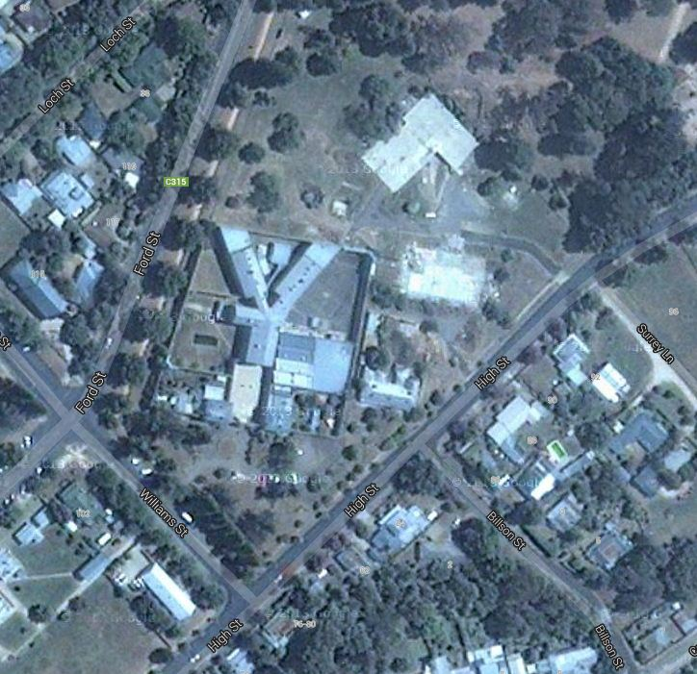
Aerial view

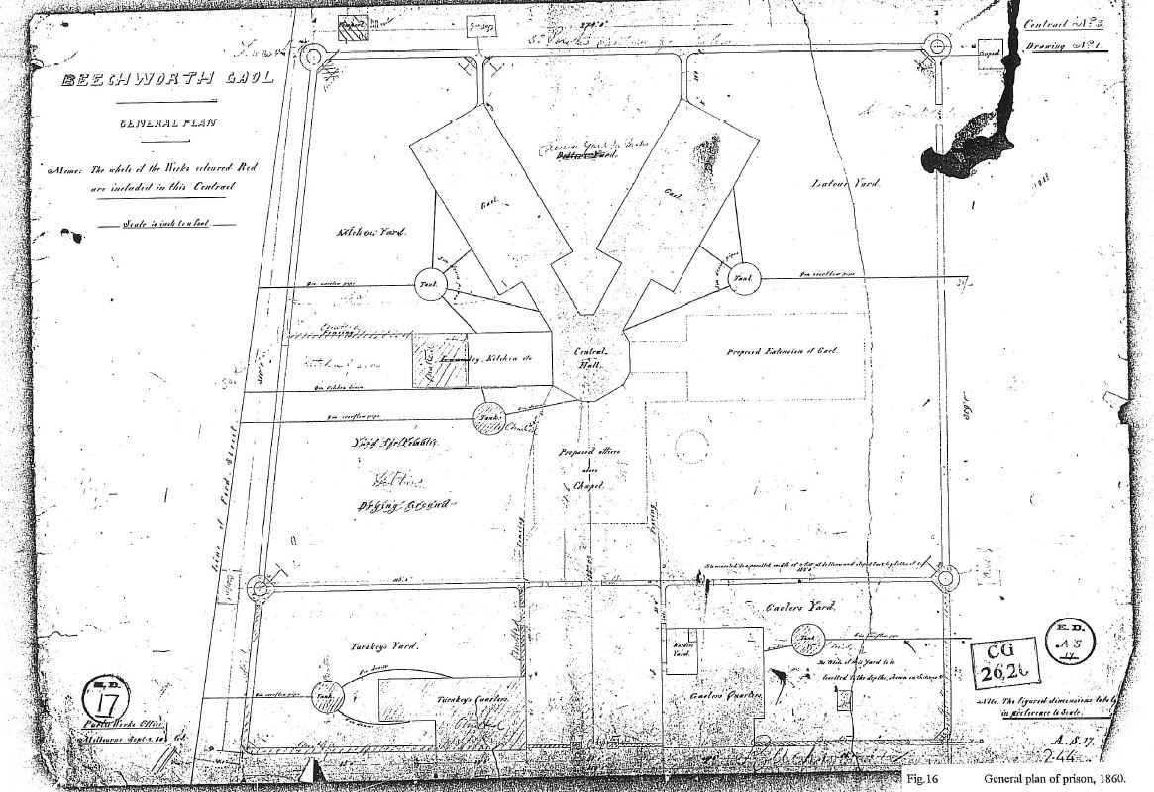
1860 plan, showing two wings of cells and the kitchen wing,
the perimeter and internal walls and the entrance buildings

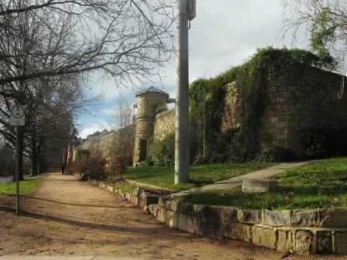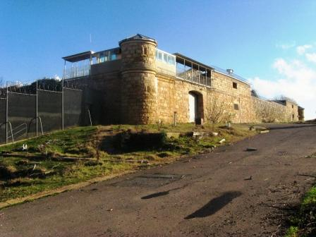
West wall and observation tower Rear wall

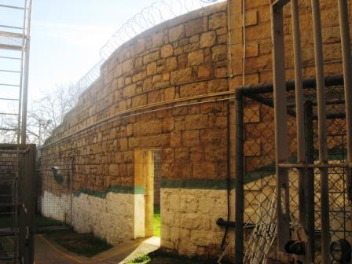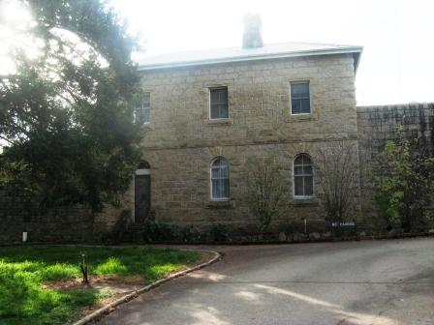
Interior wall dividing western yards Turnkeys’ Quarters adjoining main entrance

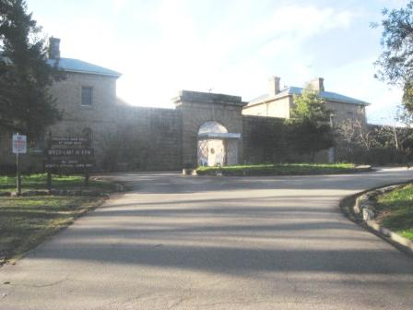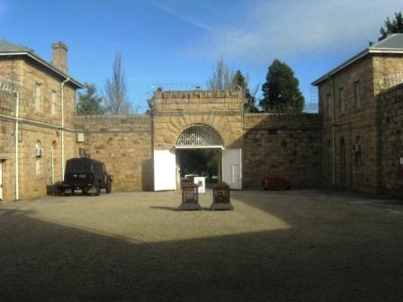
Main entrance Entry forecourt

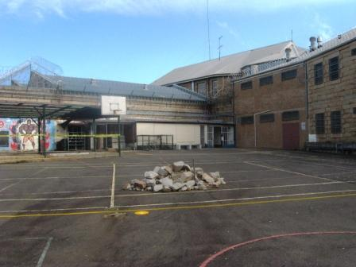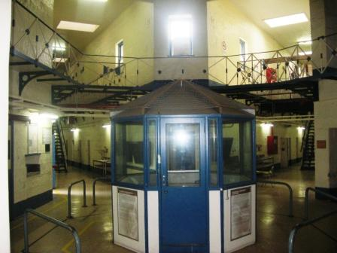
North-east yard, north-east wing (right) and Interior view showing central observation point
twentieth century workshop building (left) and ends of two cell wings

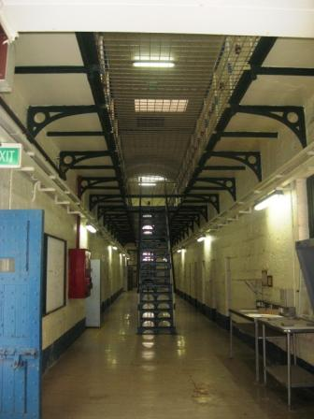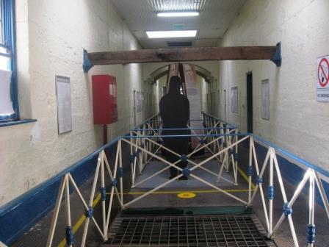
Central corridor of two-storey cell wing Gallows in centre of eastern cell wing

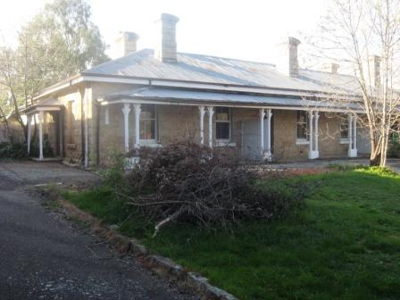
Governor’s and Warder’s House on eastern side of site, outside gaol walls

ATTACHMENT 1
Former registration details

FORMER EXTENT OF REGISTRATION
1. All of the buildings and features marked as follows on Diagram 1549 held by the Executive Director:
B1 Perimeter Walls and Watch Towers
B2 Interior division walls, including remnant service yard wall from Kitchen wing
B3 Cell Blocks, Central Hall, Kitchen Wing, Dining Hall and Office Wing
B4 Gaolers Quarters
B5 Turnkeys Quarters
B6 Warders Quarters
F1 Entry Gateway and Iron Gates
F2 Stone Quarry
F3 External granite retaining walls
All the following species of trees:
Sierra Redwood (Sequoiadendron giganteum)
2. All of the land (including any archaeological remains) marked L1 on Diagram 1549 held by the Executive Director.

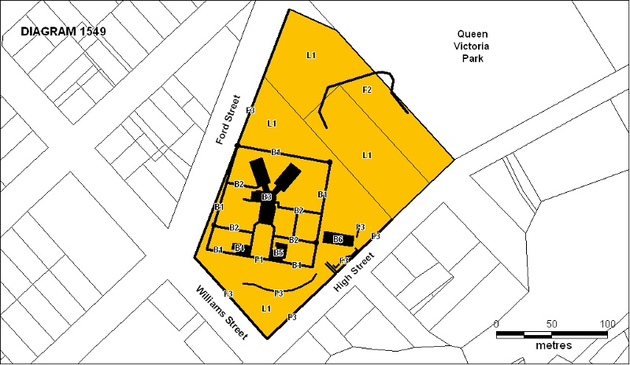

FORMER STATEMENT OF CULTURAL HERITAGE SIGNIFICANCE
What is significant?
Beechworth Prison was designed by Victoria's Public Works Department between 1857 and 1864. The major drawings of 1858, 1860 and 1864 were executed by Gustav Joachimi under the direction of William Wardell, and the 1861 drawings were jointly executed by Joachimi and H.A. Williams. The prison was built in stages between 1858 and 1864 using granite quarried on site. H. Dalrymple and George Simmie were the contractors. Beechworth is one of nine Victorian prisons designed on the radiating 'panopticon' principle which had proved an efficient, cost-effective design for easy surveillance of prisoners by allowing guards to watch over a large area from a central observation point. When opened in 1860, Beechworth provided single cells for 36 prisoners. Accommodation was doubled on the building's completion in 1864. The prison initially housed male and female prisoners, who were kept occupied with work of practical benefit to the town. Between 1918 and 1925 the prison closed from lack of numbers, then operated as a reformatory for habitual male offenders between 1925 and 1951. It became a training prison for straight-sentence prisoners after 1951 and continues as a prison today.
Despite numerous minor alterations since 1864, highly intact features include the cell blocks, observation hall, turnkey's quarters, gaoler's quarters, kitchen wing exterior, warder's quarters, watch towers, perimeter and division walls, the iron entrance gates, entrance court, and yards with the exception of the 1861 female yards which were built over in 1925. Original stairs, balustrades, architraves, skirtings, doors and windows also survive. Slate roofing has been replaced with corrugated iron and louvred ventilators have been removed from cell block roofs. The quarry is a significant feature in the grounds.
How is it significant?
Beechworth Prison is of historical and architectural significance to the State of Victoria.
Why is it significant?
Beechworth Prison is of historical significance as an intact example of the Public Works Department's most intensive prison building period which immediately followed the abolition of hulks and as an illustration of mid nineteenth century prison conditions. Many early Beechworth prisoners were Chinese, and the prison is important for its association with this significant ethnic minority on the north-eastern goldfields. The prison was the site of eight executions between 1865 and 1881.
The prison is of historical significance for its early association with John Castieau, Victoria's Inspector General of Prisons from 1880 to 1884, who was gaoler at Beechworth between 1856 and 1869.
The prison is of historical significance for its associations with the early development of Beechworth as the government administrative centre of north-eastern Victoria. It is part of a major precinct of public buildings, and has links to numerous other buildings in Beechworth which used granite quarried and broken at the prison by male inmates.
The prison is of historical significance for its associations with the bushranger Ned Kelly and the Kelly story. Kelly served six months in the prison in1870-71 for assault and was held there during his committal trial for murder in 1880. It was also in Beechworth Prison that Kelly's mother, Ellen and two associates of the Kelly family served sentences in the late 1870's for the attempted murder of Constable Alexander Fitzpatrick. It was this incident and the resulting convictions which are credited as being the catalyst for the so called Kelly Outbreak.
Beechworth Gaol is further associated with Kelly as the place where twenty suspected Kelly sympathisers were held in 1879 in an attempt to limit support to the Kelly gang. The iron gates were installed at this time as it was feared that there might be an attempt to break the sympathisers out of the prison. The bushranger Harry Power was also imprisoned here. It was with Power that Kelly became involved in bushranging as a teenager and it was information supplied by Kelly to the police that eventuated in Power's arrest.
Beechworth Prison is architecturally significant as an outstanding example of a panopticon prison, of which nine erected in Victoria, and as one of only two which continue to operate as prisons. Its architecture epitomises the severely simple Classical style of nineteenth century prisons commissioned by the Public Works Department.
The building is architecturally significant as a major architectural work of Gustav Joachimi, whose other designs include the entrance to Melbourne's Pentridge Prison (1858-9), Benalla Court House (1864), and A-Block and J-Block at Victoria Barracks (1860-7).
Beechworth Prison is architecturally significant as an intact example of the restrained ornamentation and high construction qualities characteristic of the Public Works Department under William Wardell.

FORMER PERMIT POLICY
Beechworth Gaol is significant in demonstrating the form and function of a 19th century prison. The place is of importance due to the layout of the specified buildings, walls and features, their forms and their relationship to each other and the outside world. The buildings built in the nineteenth century form the core of the prison and while later additions to the place demonstrate the evolution of prisons in Victoria in the twentieth century most are not considered to be of great significance and if not otherwise stated may be removed with approval from the Executive Director.
Although the current two storey dining hall wing was built in 1925 as a dining hall and chapel, it was built on the footprint of the original office wing. This wing demonstrates both the original layout of the prison and its evolution and as such it is important in the understanding of the place. While it may be possible to remove later post nineteenth century internal additions to this wing and possibly remodel areas of it internally, any works that may diminish its significance or adversely affects it fabric should be avoided.
A key feature of the grounds of the prison is the quarry that borders Queen Victoria Park. This quarry was a key feature in the life of many of the prisoners particularly those sentenced to hard labour. Its removal will dramatically diminish the full understanding of the prison and its surrounds. As such any proposals that would diminish this significance should be avoided.
The removal or alteration of the following buildings is possible subject to the Executive Director’s approval and to the full recording of the buildings to the satisfaction of the Executive Director. Replacement of or additions to these buildings will require a permit:
- 1957 cell block additions
- Ablutions extension to the to the East Cell Wing
- 1925 Boiler House extension to the Kitchen Wing
The Guard’s Control Room in the Central Hall may be removed of but not modified or added to subject to full recording to the satisfaction of the Executive Director.
The removal of the roofs over the Education wing, Prisoner Reception and the stores area that presently occupy the yards that were originally the female yards on the south side of the prison complex with approval from the Executive Director on the condition that no significant fabric is detrimentally affected in the process.
FORMER PERMIT EXEMPTIONS
General Conditions:
1. All exempted alterations are to be planned and carried out in a manner which prevents damage to the fabric of the registered place or object.
2. Should it become apparent during further inspection or the carrying out of works that original or previously hidden or inaccessible details of the place or object are revealed which relate to the significance of the place or object, then the exemption covering such works shall cease and the Executive Director shall be notified as soon as possible. Note: All archaeological places have the potential to contain significant sub-surface artefacts and other remains. In most cases it will be necessary to obtain approval from Heritage Victoria before the undertaking any works that have a significant sub-surface component.
3. If there is a conservation policy and plan approved by the Executive Director, all works shall be in accordance with it. Note: The existence of a Conservation Management Plan or a Heritage Action Plan endorsed by Heritage Victoria provides guidance for the management of the heritage values associated with the site. It may not be necessary to obtain a heritage permit for certain works specified in the management plan.
4. Nothing in this declaration prevents the Executive Director from amending or rescinding all or any of the permit exemptions.
5. Nothing in this declaration exempts owners or their agents from the responsibility to seek relevant planning or building permits from the responsible authorities where applicable.

Regular Site Maintenance :
The following site maintenance works are permit exempt under section 66 of the Heritage Act 1995,
a) regular site maintenance provided the works do not involve the removal or destruction of any significant above-ground features or sub-surface archaeological artefacts or deposits;
b) the maintenance of an item to retain its conditions or operation without the removal of or damage to the existing fabric or the introduction of new materials;
c) cleaning including the removal of surface deposits, organic growths, or graffiti by the use of low pressure water and natural detergents and mild brushing and scrubbing;
d) repairs, conservation and maintenance to plaques, memorials, roads and paths, fences and gates and drainage and irrigation.
e) the replacement of existing services such as cabling, plumbing, wiring and fire services that uses existing routes, conduits or voids, and does not involve damage to or the removal of significant fabric. Note: Surface patina which has developed on the fabric may be an important part of the item’s significance and if so needs to be preserved during maintenance and cleaning.
Note: Any new materials used for repair must not exacerbate the decay of existing fabric due to chemical incompatibility, obscure existing fabric or limit access to existing fabric for future maintenance. Repair must maximise protection and retention of fabric and include the conservation of existing details or elements.

Vermin Control:
The following vermin control activities are permit exempt under section 66 of the Heritage Act 1995,
- Vermin control activities provided the works do not involve the removal or destruction of any significant above-ground features or sub-surface archaeological artefacts or deposits;
Note: Particular care must be taken with vermin control works where such activities may have a detrimental
affect on the significant fabric of a place

Public Safety and Security:
The following public safety and security activities are permit exempt under section 66 of the Heritage Act 1995:
a) public safety and security activities provided the works do not involve the removal or destruction of any significant above-ground structures or sub-surface archaeological artefacts or deposits;
b) the erection of temporary security fencing, scaffolding, hoardings or surveillance systems to prevent unauthorised access or secure public safety which will not adversely affect significant fabric of the place including archaeological features;
c) development including emergency stabilisation necessary to secure safety where a site feature has been irreparably damaged or destabilised and represents a safety risk to its users or the public.
Note: Urgent or emergency site works are to be undertaken by an appropriately qualified specialist such as a structural engineer, or other heritage professional.
Signage and Site Interpretation:
The following Signage and Site Interpretation activities are permit exempt under section 66 of the Heritage Act 1995:
a) signage and site interpretation activities provided the works do not involve the removal or destruction of any significant above-ground structures or sub-surface archaeological artefacts or deposits;
b) the erection of non-illuminated signage for the purpose of ensuring public safety or to assist in the interpretation of the heritage significance of the place or object and which will not adversely affect significant fabric including landscape or archaeological features of the place or obstruct significant views of and from heritage values or items;
c) signage and site interpretation products must be located and be of a suitable size so as not to obscure or damage significant fabric of the place;
d) signage and site interpretation products must be able to be later removed without causing damage to the significant fabric of the place;
Note: The development of signage and site interpretation products must be consistent in the use of format, text, logos, themes and other display materials. Note: Where possible, the signage and interpretation material should be consistent with other schemes developed on similar or associated sites. It may be necessary to consult with land managers and other stakeholders concerning existing schemes and strategies for signage and site interpretation.
Minor Works:
Note: Any Minor Works that in the opinion of the Executive Director will not adversely affect the heritage significance of the place may be exempt from the permit requirements of the Heritage Act. A person proposing to undertake minor works may submit a proposal to the Executive Director. If the Executive Director is satisfied that the proposed works will not adversely affect the heritage values of the site, the applicant may be exempted from the requirement to obtain a heritage permit. If an applicant is uncertain whether a heritage permit is required, it is recommended that the permits co-ordinator be contacted.
Landscape:
*The process of gardening and maintenance, mowing, hedge clipping, bedding displays, removal of dead plants, disease and weed control, emergency and safety works to care for existing plants and planting themes.
*Removal of vegetation that is not significant to maintain fire safety and to conserve significant buildings and structures.
*The replanting of plant species to conserve the landscape character and plant collections and themes.
*Repairs, conservation and maintenance to hard landscape elements, buildings, structures, ornaments, roads and paths, drainage and irrigation system.
*Management of trees in accordance with Australian Standard; Pruning of amenity trees AS4373.
*Removal of plants listed as noxious weeds in the Catchment and Land Protection Act 1994.
*Installation, removal or replacement of garden watering and drainage systems.
*Non-structural works that occur at a distance greater than 5 metres from the canopy edge of a significant tree, plant or hedge, (structural works may require a permit if still on the registered land).
*Non-commercial signage, lighting, security fire safety and other safety requirements, provided no structural building occurs.
*Plant labelling and interpretative signage.
*Resurfacing of existing paths and driveways.
Other Works:
*Repainting all previously painted surfaces in the same colour scheme and paint type.
*Painting of previously painted walls and ceilings provided that preparation or painting does not remove evidence of any original paint or other decorative scheme.
*Repair and servicing of equipment and services including wiring, plumbing, heating, air-conditioning and fire services.
*Maintenance of power or pipelines or other public services located on the property where this involves no alteration to the fabric of the place.
*Cleaning out gutters, drainage systems and other water storage and drainage areas.
*Removal but replacement of post nineteenth century pipes, cabling, wiring and conduit but not roof plumbing, rainwater heads or downpipes.
*Removal of paint from originally unpainted or oiled joinery doors, architraves, skirtings and decorative strapping.
*Installation, removal or replacement of curtain track, rods, blinds, and other window dressings.
*Installation, removal or replacement of hooks, nails and other devices for hanging of mirrors, paintings and other wall mounted artworks.
*Alterations to toilets and kitchen to the extent of new fittings and surfaces which are required to meet health and safety regulations.
*Refurbishment of existing bathrooms, toilets and kitchens including removal, installation or replacement of sanitary fixtures and associated piping, mirrors, wall and floor coverings.
*Removal, replacement or installation of smoke detectors, insulation, electrical wiring provided that all new wiring is concealed and all original light switches or power outlets and timber conduits (if still existing) are retained in situ.
*Removal of extraneous items such as external lighting, air conditioners, pipe work, ducting, flues, wiring, antennae, aerials, fly screens, louvres etc, and making good.
*Installation or removal of external fixtures and fittings such as, hot water services and taps.
*Installation, removal or replacement of carpets and/or flexible floor coverings.
*Demolition or removal of non-original stud/partition walls, suspended ceilings or non-original wall linings (including plasterboard, laminate and Masonite), bathroom partitions and tiling, sanitary fixtures and fittings, kitchen wall tiling and equipment, lights, built-in cupboards, cubicle partitions, computer and office fitout and the like.
*Removal or replacement of non-original door and window furniture including, hinges, locks, knobsets and sash lifts.
*Removal of tiling or concrete slabs in wet areas provided there is no damage to or alteration of original structure or fabric.
*Installation, removal or replacement of ducted, hydronic or concealed radiant type heating provided that the installation does not damage existing skirtings and architraves and that the central plant is concealed.
*Installation, removal or replacement of electrical wiring.
*Installation, removal or replacement of electric clocks, public address systems, detectors, alarms, emergency lights, exit signs, luminaires and the like on plaster surfaces.
*Installation, removal or replacement of bulk insulation in the roof space.
*Installation of plant within the roof space.
*Installation of new fire hydrant services including sprinklers, fire doors and elements affixed to plaster surfaces.
*Removal of post nineteenth century internal additions to the current Education wing, Prisoner Reception and the stores area that presently occupy the yards that were originally the female yards on the south side of the prison complex on the condition that no significant fabric is detrimentally effected in the process.
*The removal and internal modification but not additions to the 1957 Office Building in the Entry Court.
*The removal and internal modification but not additions to all additional structures, except the weatherboard lean to addition, associated with the Gaolers Quarters.
*The removal and internal modification but not additions to all other buildings and structures not included in the extent of registration or otherwise stated.

