ASSESSMENT OF CULTURAL
HERITAGE SIGNIFICANCE AND
EXECUTIVE DIRECTOR
RECOMMENDATION TO THE
HERITAGE COUNCIL


NAME | the pines
LOCATION | 10 middle crescent, brighton
VHR NUMBER: | PROV VHR2364
CATEGORY: | HERITAGE PLACE
HERITAGE OVERLAY | CITY OF BAYSIDE HO240
FILE NUMBER: | FOL/16/19325
HERMES NUMBER: | 199563

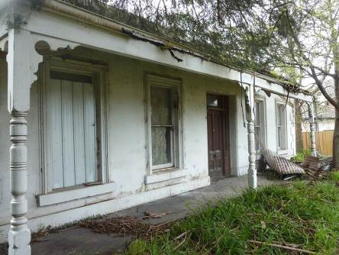
EXECUTIVE DIRECTOR RECOMMENDATION TO THE HERITAGE COUNCIL:
- That The Pines, Brighton be included as a Heritage Place in the Victorian Heritage Register under the Heritage Act 1995 [Section 32 (1)(a)].

TIM SMITH
Executive Director
Recommendation Date: 16 September 2016
This recommendation report has been issued by the Executive Director, Heritage Victoria under s.32 of the Heritage Act 1995. It has not been considered or endorsed by the Heritage Council of Victoria.

EXTENT OF REGISTRATION

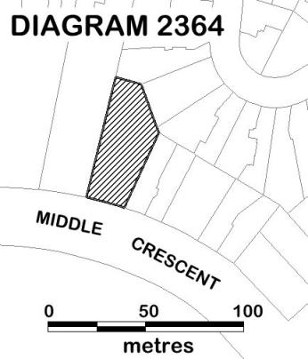

The extent of registration of The Pines, Brighton in the Victorian Heritage Register affects the whole place shown on Diagram 2364 including the land and all buildings (including the exteriors and interiors).

AERIAL PHOTO OF THE PLACE SHOWING EXTENT OF REGISTRATION

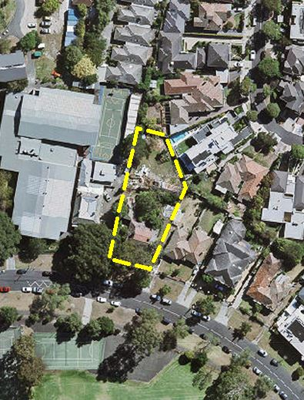

STATEMENT OF CULTURAL HERITAGE SIGNIFICANCE

What is significant?
The Pines, Brighton including a concrete house with rear brick and timber sections and two associated concrete outbuildings at the rear of the property.

History Summary
The Pines, Brighton was constructed in 1866 by local builder and dairyman William Durrant on land he owned in the Brighton Estate, between Middle and Outer Crescent. This estate, which was set out in crescent form by H B Foot c.1842 as part of the Dendy Special Survey village, was developed in the 1860s. By 1861 prolific local builder, William Durrant, had purchased 10 acres of land between Outer and Middle Crescent and built seven cottages. The Pines was the second in a sequence of larger concrete houses also built on this land by Durrant, and the first occupant was the squatter, Frank W Desailly. By 1872 The Pines was being used as a school known as Brighton College and it appears that a timber addition was constructed at the rear for this purpose. This school was initially conducted by John MacVean, then John Batten until 1881, and finally Arthur Backhouse until c.1883. Subsequently The Pines was used as a private residence until its acquisition in 2014 by Firbank Grammar School.

Description Summary
The Pines, Brighton is a concrete house with a hipped slate roof and brick and timber sections at the rear. It is a mid-Victorian Italianate villa with rendered walls which are lightly scribed to imitate ashlar construction. It has moulded chimney caps, quoined front corners, a central front door and tall paired double hung windows on either side. A concave roofed front verandah has been modified with a replacement frame, concrete floor and turned posts. The eaves have an unusual continuous rendered under-mould. The interior of the main house has a timber floor, plastered walls and ceilings, deep cornices and deep timber window reveals. At the rear of the main house are two sections, one of brick construction and a later addition to the west is of timber construction. To the rear of the property are two concrete outbuildings with corrugated iron roofs. It is recorded that the concrete used to form the walls of the house and outbuildings comprised of lime to bind sand and stones from the nearby foreshore. This was rammed in layers before a rendered finish was applied.
This site is part of the traditional land of the Boonwarrung people.

How is it significant?
The Pines, Brighton is of historical and scientific significance to the State of Victoria. It satisfies the following criteria for inclusion in the Victorian Heritage Register:

Criterion B
Possession of uncommon, rare or endangered aspects of Victoria’s cultural history.

Criterion F
Importance in demonstrating a high degree of creative or technical achievement at a particular period.

Why is it significant?
The Pines, Brighton is significant at the State level for the following reasons:
The Pines, Brighton is significant as a rare, early and intact example of the use of formed concrete construction. Very few buildings were constructed in Victoria as early as the 1860s using this building technique and there are even fewer that remain to illustrate the unusual and early use of formed concrete, using lime to bind sand and stones from the nearby foreshore, rammed in layers. The concrete house, with two concrete outbuildings, is an outstanding example of the early use of formed concrete in Victoria. [Criterion B & F]

The Pines, Brighton is also significant for the following reasons, but not at the State level:
The Pines, Brighton has a clear association with the development of the Dendy Special Survey village (the Brighton Estate). It is one of the earliest extant buildings in this estate which was laid out in crescent form by H B Foot c.1842 and developed in the 1860s.

RECOMMENDATION REASONS

REASONS FOR RECOMMENDING INCLUSION IN THE VICTORIAN HERITAGE REGISTER [s.34A(2)]
Following is the Executive Director's assessment of the place against the tests set out in The Victorian Heritage Register Criteria and Thresholds Guidelines (2014).

CRITERION B
Possession of uncommon, rare or endangered aspects of Victoria’s cultural history.

STEP 1: A BASIC TEST FOR SATISFYING CRITERION B
The place/object has a clear ASSOCIATION with an event, phase, period, process, function, movement, custom or way of life of importance in Victoria’s cultural history.
Plus
The association of the place/object to the event, phase, etc IS EVIDENT in the physical fabric of the place/object and/or in documentary resources or oral history.
Plus
The place/object is RARE OR UNCOMMON, being one of a small number of places/objects remaining that demonstrates the important event, phase etc.
OR
The place/object is RARE OR UNCOMMON, containing unusual features of note that were not widely replicated
OR
The existence of the class of place/object that demonstrates the important event, phase etc is ENDANGERED to the point of rarity due to threats and pressures on such places/objects.

Executive Director’s Response
The Pines, Brighton has a clear association with the early development of suburban Melbourne and this association is evident in the physical fabric of the place and in documentary sources.
The Pines, Brighton is a rare, early and intact example of formed concrete construction in Victoria. A concrete house and two concrete outbuildings remain on the site.
Criterion B is likely to be satisfied.

STEP 2: A BASIC TEST FOR DETERMINING STATE LEVEL SIGNIFICANCE FOR CRITERION B
The place/object is RARE, UNCOMMON OR ENDANGERED within Victoria.

Executive Director’s Response
The Pines is one of the earliest buildings remaining in Victoria to illustrate the use of formed concrete in construction. Very few buildings were constructed in Victoria as early as the 1860s using this building technique, and there are even fewer that remain to illustrate the unusual and early use of formed concrete. In addition, the retention of two concrete outbuildings is highly unusual.
The few remaining known early examples of concrete houses in Victoria are:
- Seagrove, 12 Middle Crescent, Brighton (adjacent to The Pines) which is a later, smaller and simpler house which has been substantially renovated.
- Meanyet, 27 Middle Crescent, Brighton which is an earlier example which only partially remains within an Edwardian envelope (associated stables were demolished in 2015).
- Laluma, 23 Woolley Street, Essendon, which is of unknown construction date and has been significantly modified.
- A house at Craiglee Winery, Sunbury (VHR H0677) which is a small extant example of concrete construction with substantial additions.
The Pines, Brighton clearly demonstrates this highly unusual building construction type in Victoria.
Criterion B is likely to be satisfied at the State level.

Criterion F
Importance in demonstrating a high degree of creative or technical achievement at a particular period.

STEP 1: A BASIC TEST FOR SATISFYING CRITERION F
The place/object contains PHYSICAL EVIDENCE that clearly demonstrates creative or technical ACHIEVEMENT for the time in which it was created.
Plus
The physical evidence demonstrates a HIGH DEGREE OF INTEGRITY.

Executive Director’s Response
The Pines, Brighton demonstrates a high degree of technical innovation as one of the earliest of a group of concrete constructions by William Durrant on his land at Brighton. Durrant’s method of construction in the Brighton Estate group was unusual in that he constructed the walls of his houses in formed concrete using lime to bind sand and stones from the nearby foreshore rammed in layers before applying a rendered finish.
The Pines, Brighton significantly predates and is of superior design quality to the other relatively intact example, Seagrove, 12 Middle Crescent (1874). The Pines includes corner quoining, rendered walls which are lightly scribed to imitate ashlar construction and a highly unusual continuous large rendered eaves under-mould, similar to a continuous cornice in masonry construction.
The Pines, Brighton demonstrates a greater level of integrity than Meanyet, Laluma and the concrete house at Craiglee Winery.
Criterion F is likely to be satisfied.

STEP 2: A BASIC TEST FOR DETERMINING STATE LEVEL SIGNIFICANCE FOR CRITERION F
The nature &/or scale of the achievement is OF A HIGH DEGREE or ‘beyond the ordinary’ for the period in which it was undertaken as evidenced by:
- critical acclaim of the place/object within the relevant creative or technological discipline as an outstanding example in Victoria; or
- wide acknowledgement of exceptional merit in Victoria in medium such as publications and print media; or
- recognition of the place/object as a breakthrough in terms of design, fabrication or construction techniques; or
- recognition of the place/object as a successful solution to a technical problem that extended the limits of existing technology; or
- recognition of the place/object as an outstanding example of the creative adaptation of available materials and technology of the period.

Executive Director’s Response
The use of formed concrete at The Pines, Brighton is highly unusual for the period in which it was undertaken. The place has been recognised as an outstanding example of the creative adaption of concrete and concrete technology in Victoria in the 1860s. Noted architectural historian Dr Miles Lewis recognises The Pines as an outstanding example of the adaption of concrete in construction. Lewis is an expert in building materials and their use and development, as recorded in such extensive work as ‘Australian Building: A Cultural Investigation’.
Criterion F is likely to be satisfied at the State level.

PERMIT POLICY

Preamble
The purpose of the Permit Policy is to assist when considering or making decisions regarding works to a registered place. It is recommended that any proposed works be discussed with an officer of Heritage Victoria prior to making a permit application. Discussing proposed works will assist in answering questions the owner may have and aid any decisions regarding works to the place.
The extent of registration of The Pines, Brighton in the Victorian Heritage Register affects the whole place shown on Diagram 2364 including the land, all buildings (exteriors and interiors). Under the Heritage Act 1995 a person must not remove or demolish, damage or despoil, develop or alter or excavate, relocate or disturb the position of any part of a registered place or object without approval. It is acknowledged, however, that alterations and other works may be required to keep places and objects in good repair and adapt them for use into the future.
If a person wishes to undertake works or activities in relation to a registered place or registered object, they must apply to the Executive Director, Heritage Victoria for a permit. The purpose of a permit is to enable appropriate change to a place and to effectively manage adverse impacts on the cultural heritage significance of a place as a consequence of change. If an owner is uncertain whether a heritage permit is required, it is recommended that Heritage Victoria be contacted.
Permits are required for anything which alters the place or object, unless a permit exemption is granted. Permit exemptions usually cover routine maintenance and upkeep issues faced by owners as well as minor works or works to the elements of the place or object that are not significant. They may include appropriate works that are specified in a conservation management plan. Permit exemptions can be granted at the time of registration (under s.42 of the Heritage Act) or after registration (under s.66 of the Heritage Act).
It should be noted that the addition of new buildings to the registered place, as well as alterations to the interior and exterior of existing buildings requires a permit, unless a specific permit exemption is granted.

Conservation management plans
It is recommended that a Conservation Management Plan is developed to manage the place in a manner which respects its cultural heritage significance.

Aboriginal cultural heritage
If any Aboriginal cultural heritage is discovered or exposed at any time it is necessary to immediately contact Aboriginal Victoria to ascertain requirements under the Aboriginal Heritage Act 2006.

Other approvals
Please be aware that approval from other authorities (such as local government) may be required to undertake works.

Archaeology
Ground disturbance may affect any archaeological deposits at this place and, subject to the exemptions stated in this document, requires a permit.

Cultural heritage significance

Overview of significance
The cultural heritage significance of The Pines, Brighton lies in the early and rare use of formed concrete construction. The intact form of the house and outbuildings demonstrates the use of this material.

PERMIT EXEMPTIONS (under section 42 of the Heritage Act)
It should be noted that Permit Exemptions can be granted at the time of registration (under s.42(4) of the Heritage Act). Permit Exemptions can also be applied for and granted after registration (under s.66 of the Heritage Act)

General Condition 1
All exempted alterations are to be planned and carried out in a manner which prevents damage to the fabric of the registered place or object.

General Condition 2
Should it become apparent during further inspection or the carrying out of works that original or previously hidden or inaccessible details of the place or object are revealed which relate to the significance of the place or object, then the exemption covering such works shall cease and Heritage Victoria shall be notified as soon as possible.

General Condition 3
All works should be informed by Conservation Management Plans prepared for the place. The Executive Director is not bound by any Conservation Management Plan, and permits still must be obtained for works suggested in any Conservation Management Plan.

General Condition 4
Nothing in this determination prevents the Heritage Council from amending or rescinding all or any of the permit exemptions.

General Condition 5
Nothing in this determination exempts owners or their agents from the responsibility to seek relevant planning or building permits from the relevant responsible authority, where applicable.

Specific Permit Exemptions
EXTERIOR
- Minor patching, repair and maintenance which replaces like with like.
- Removal of non-original items such as pipe work, ducting, wiring and making good in a manner not detrimental to the cultural heritage significance of the place.
- Installation or removal of non-original external fixtures and fittings such as hot water services and taps in a manner not detrimental to the cultural heritage significance of the place.
- Painting of previously painted surfaces provided that preparation or painting does not remove the original paint or other decorative scheme.

INTERIOR
- Painting of previously painted walls and ceilings provided that preparation or painting does not remove any original paint or other decorative scheme.
- Installation, removal or replacement of hooks, nails and other devices for the hanging of mirrors, paintings and other wall mounted art.
- Installation, removal or replacement of electric clocks, public address systems, detectors, alarms, emergency lights, exit signs, luminaires and the like on non-decorative plaster surfaces.
- Removal or installation of noticeboards.
- Installation, removal or replacement of electrical wiring provided that all new wiring is fully concealed and any light switches or power outlets are retained in situ.
- Installation of new fire hydrant services including sprinklers, fire doors and elements affixed to plaster surfaces.
- Installation of new built-in cupboards providing no alteration to the structure is required.

LANDSCAPE
- The process of gardening, including mowing, hedge clipping, bedding displays, pruning, removal of dead shrubs and replanting the same species or cultivar, disease and weed control, and maintenance to care for existing plants.
- Subsurface works involving the installation, removal or replacement of watering and drainage systems or services.
- Removal or lopping of trees and vegetation.

RELEVANT INFORMATION
Local Government Authority | City of Bayside
HERITAGE LISTING INFORMATION
- Heritage Overlay: | HO240
- Heritage Overlay Controls: | External Paint: No  Internal Alteration: No  Tree: No
- Victorian Aboriginal Heritage Register: | No

HISTORY
Early Development of Brighton

In 1840 the Colonial Office in England extended the system of ‘Special Survey’ to Port Phillip to encourage immigration. It enabled wealthy capitalists to purchase a block of 2,112 hectares (5,120 acres) from England before survey, for £1 an acre, or £5,120. Henry Dendy was the first to take up the offer and the only person to do so from England. After arriving in Melbourne in 1841 he eventually settled on land in the County of Bourke, Parish of Moorabbin, and this land was mapped in April that year. A competition, held for the design of this subdivision, was won by H B Foot who presented a design based on concentrically centred crescents and a town reserve. The Brighton Estate was advertised for sale at the end of May however early sales were slow and the estate only developed in the 1860s. Prolific local builder, William Durrant purchased 10 acres of land between Outer and Middle Crescent before 1861 and had built seven cottages on this land by this time.

History of The Pines

A house named The Pines was constructed in Middle Crescent Brighton in 1866 as the second in a sequence of large concrete houses built by William Durrant in the Brighton Estate. The first in this sequence was Meanyet to the north-west of The Pines (only partially remaining within an Edwardian envelope) and later in the sequence were Seagrove (smaller and simpler example) and Ardsallach (demolished), both located to the west of The Pines.

The Pines first appeared in Brighton Rate Books in 1867 and the first occupant was the squatter, Frank W Desailly. The following year The Pines was described as a ‘pisa house’ in the Rate Books. In 1871 it was described as a ‘pisa’ house of 5 rooms with stable. By 1872 The Pines was being used as a school known as Brighton College and it appears that a timber addition was constructed at the rear for this purpose. In 1874 the building was described in the Rate Books as as a ‘concrete [house]with wood schoolroom’. Brighton College was initially conducted by John MacVean, then John Batten until 1881 and finally Arthur Backhouse until c.1883. Subsequently The Pines was used as a private residence until its acquisition in 2014 by Firbank Grammar School.

History of Concrete House Construction in Australia
[Drawn from Miles Lewis, ‘Australian Building: A Cultural Investigation’
www.mileslewis.net/australian-building/]

There is scant extant information on the construction of concrete buildings in Australia prior to the 1850s. Up to this period complete concrete houses were occasionally built. The oldest surviving ones of the 1850s, indicate they would have been crude structures with thick walls, and the concrete more like a rubble bound in inferior lime, or a form of pisé, than anything we would recognise as concrete today. In 1851 architect Charles Mayes saw concrete houses at Norwood near Adelaide, and in 1860 believed them to be still standing. In 1852 settler Charles Pitt and his family built a concrete house in Adelaide, on the south bank of the Torrens near the site of the Felixstowe Bridge. It was made of river sand, gravel, rocks, and lime from Abbot's kiln, nearby at Payneham. The architect C McCarthy designed the first church at Campbelltown, South Australia, of concrete with brick quoins, as well as concrete walls for the cellar of the East Torrens Winemaking and Distillation Company, both in late 1858.

In Melbourne early concrete houses survive at 23 Woolley St, Essendon, and two at 10 and 12 Middle Crescent, Brighton. Another concrete building which survives is Craiglee at Sunbury in Victoria, built by J S Johnson in 1865. Chemical analysis of the latter, however, has suggested that the concrete was made with Roman or natural cement, rather than common lime.

In 1873 the Town and Country Journal gave detailed instructions on constructing concrete structures. A plank floor was to be prepared for mixing on, preferably with a roof over. Four barrels of broken stone, in pieces from the size of a walnut to that of an egg, were to be spread out to a depth of about 50 mm, then three barrels of sand or sharp grit were to be sprinkled between and over the stones; then half a barrel of lime; and finally half a barrel of ‘best cement’. The materials were to be raked together, then saturated with water long enough for the lime and cement ‘to slacken thoroughly’ – which betrays a misunderstanding of the properties of cement. The mixture was to be placed between planks and raised only a foot [300 mm], then allowed to stand a week before the next layer was placed – much as in cob construction. Window and door frames could be built in as the work proceeded. The wall could be made ‘hollow’ by suspending wooden blocks into it from the top of the formwork, leaving continuous tubes as the work rose.

During the later nineteenth century, concrete was a less favoured building material, but it was still used in remote areas. At Koonya, Tasmania, the architect Alexander North built in the 1880s a small 'rubble and concrete' house, predecessor of the reinforced concrete structures with which the architect would later experiment. In rural New South Wales Morris Simpson, who had been impressed by the concrete breakwater at Aberdeen, built a concrete house with 300 mm thick walls at the property Stonehenge, which he acquired in 1886. In 1888 the Townsville architects Tunbridge & Tunbridge reported that they had prepared plans and specifications for large concrete stores and offices in Darwin. These were for the Townsville-based merchants Aplin Brown & Co, but it is unclear whether they were actually built. In Townsville itself a concrete house was built in German Gardens (later renamed Belgian Gardens) in about 1903, following a cyclone, but the details of the construction are not known. At Broome, Western Australia, the customs house of 1889 appears to be of formed concrete (of unknown ingredients) and the old police lock-up of 1894 is of concrete and iron. During the gold boom in Western Australia the government experimented with a form of concrete made with the pindan or rich red soil of the north-west. It provided the fines in a mix with cement, gravel and coarse sand, and produced a durable building material of a rich earthy colour. This was used for shuttered concrete walls at Broome and for blocks at Roebourne and Cossack.

In the late 1800s, Portland cement concrete was a generally viable option, and was listed, along with lime concrete and 'coke concrete for arches' in Ernest Mayes’ The Australian builders and contractors' price book of 1883. Mass concrete was used also in increasingly major engineering works, culminating in the Beetaloo Dam in South Australia: when completed in 1888 this was the largest concrete dam in the southern hemisphere. The major use of cement, however, remained cosmetic rather than structural, for stucco rather than structure. Local limes began to be used to a considerable degree for mass concrete in engineering works, but the introduction of cement for such purposes had generally to wait upon local manufacture being initiated.

Construction details
Architect name: not known
Architectural style name: Victorian Italianate
Builder name: William Durrant
Construction started date: 1866
Construction ended date: 1867

VICTORIAN HISTORICAL THEMES
06 Building towns, cities and the garden state
6.3 Shaping the suburbs
6.7 Making homes for Victorians

PHYSICAL DESCRIPTION
The Pines, Brighton is a mid-Victorian hipped slate roof, double fronted villa of typical form. It is constructed of formed concrete, using lime to bind sand and stones from the nearby foreshore which was rammed in layers, and has a rendered external finish which is lightly scribed to imitate ashlar construction. It has chimneys with moulded caps, quoined front corners, a large centrally placed door and tall paired double windows either side. An unusual continuous rendered under-mould has been applied to the timber eaves. A concave roofed verandah across the front facade has been modified with a replacement frame, concrete floor and turned posts. The interior of the house has timber floor, plastered walls and ceilings, deep cornices and deep timber window reveals.
Brick walls at the rear of the main concrete house may be original and a slate roofed, timber addition has been made to the west side. A central hall at the rear of the house has a curved ceiling with glazed highlight. To the rear of the property are two concrete outbuildings with corrugated iron roofs.

OBJECTS AND INTERIORS
The interiors of The Pines, Brighton are in poor condition and little decoration remains. A number of fireplace surrounds and ruby glass door sidelight panels may date from the original construction.

LANDSCAPES, TREES & GARDENS
The house is surrounded by a garden which is in an unkempt state.

ARCHAEOLOGY
N/A

INTEGRITY/INTACTNESS
Intactness
The house retains much of its significant nineteenth century fabric and the outbuildings remain intact. Alterations have been made to the verandah, which has a concrete floor, a replacement frame and embellishment. The front fence has been replaced. (July 2016)
Integrity
The Pines, Brighton retains a high degree of integrity. There has been minimal change to the nineteenth century fabric and the characteristics of a typical Italianate house, including the plan form, remain clearly discernible. Some modifications have been made to the rear of the house, however the timber wing addition and two concrete outbuildings remain largely unchanged. (July 2016)

CONDITION
The Pines, Brighton is in very poor condition however it appears to be structurally sound. Damage extends to sections of the slate roof, internal floors and plaster finishes due to water penetration and deteriorated roof plumbing. The main external and internal walls of the house suffer from falling damp due to deteriorated roof gutters and roof damage, but remain structurally sound. The outbuildings are in a similar condition to the house. (July 2016)

COMPARISONS
The Pines is a typical mid-Victorian double fronted villa, however the early use of formed concrete construction is highly unusual. There are few extant examples of similar age in Victoria and none known elsewhere in Australia.
The few remaining known early examples of concrete houses in Victoria are:
- Seagrove, 12 Middle Crescent, Brighton (adjacent to The Pines); a later, smaller and simpler house which has been substantially renovated. Not in the VHR.
- Meanyet, 27 Middle Crescent, Brighton; an earlier example which only partially remains within an Edwardian envelope (associated stables were demolished in 2015 and house presently undergoing further works). Not in the VHR.
- Laluma, 23 Woolley Street, Essendon; originally a two roomed concrete house which is of unknown construction date and has been significantly modified. Not in the VHR.
- A house at Craiglee Winery, Sunbury (VHR H0677); a small extant example of concrete construction, possibly constructed in c.1865 (the date of the winery). This house has been altered, has substantial additions and is not included in the extent of registration of VHR H0677.

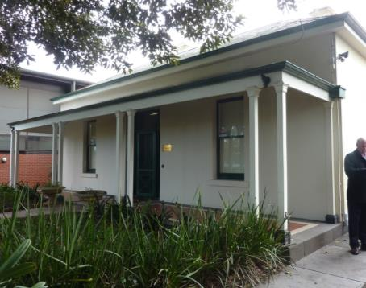
Seagrove, 12 Middle Crescent, Brighton. Not in the VHR.

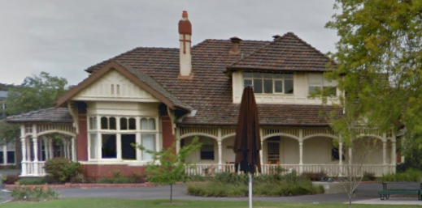
Meanyet, concrete portion remains within later building [2015 Google maps]. Not in the VHR.

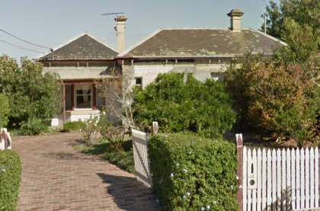
Laluma, 23 Woolley Street, Essendon [2015, Google maps]. Not in the VHR.
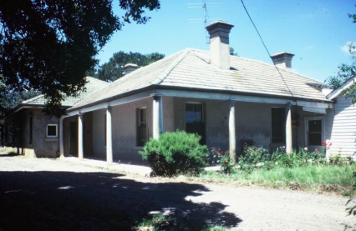
Concrete house at Craiglee Winery, Sunbury, VHR H0677.
Photo from Miles Lewis, ‘Australian Building: A Cultural Investigation’ [2015]

There are few extant or relatively intact examples of similar age in Victoria and none are known elsewhere in Australia. Of these examples, The Pines is the most intact and the most elaborate in detail.
There are later examples of concrete houses including 4 Ray Street, Beaumaris (1912) which was included in the Victorian Heritage Register in 1999 as VHR H1800 with permit exemption for demolition due to its poor condition. This house was subsequently demolished in 1999 and removed from the Victorian Heritage Register in 2014.

KEY REFERENCES USED TO PREPARE ASSESSMENT
Miles Lewis, ‘Australian Building: A Cultural Investigation’, 2015. [www.mileslewis.net/australian-building/]
Miles Lewis, 200 Years of Concrete in Australia, North Sydney, 1988.
Allom Lovell, ‘City of Bayside Heritage Review’, 1999.
Andrew Ward, ‘City of Brighton Heritage Study’, 1986.

ADDITIONAL IMAGEs

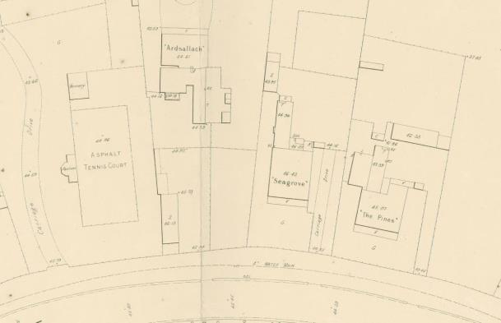
Detail of MMBW Detail Plan 2119, Town of Brighton, 1906, showing the location of three concrete houses: The Pines, Seagrove and Ardsallach (demolished)

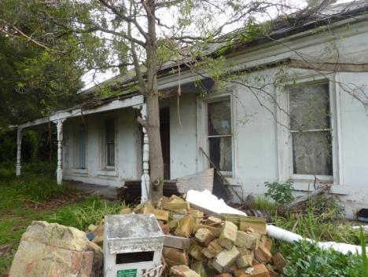
View of front facade from south-east

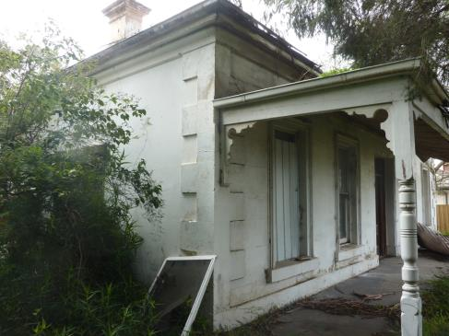
South-west corner of the house

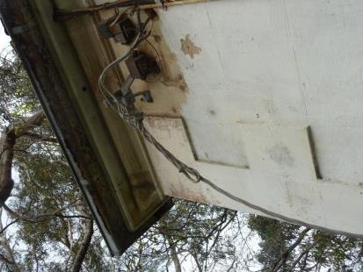
Detail of the continuous large rendered under-mould

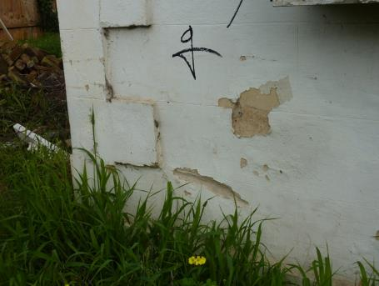
Scribed render wall finish

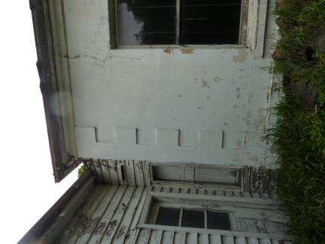
Junction between main house and timber schoolroom addition

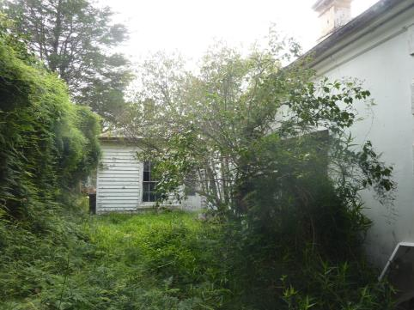
View of timber addition to the north-west of the house

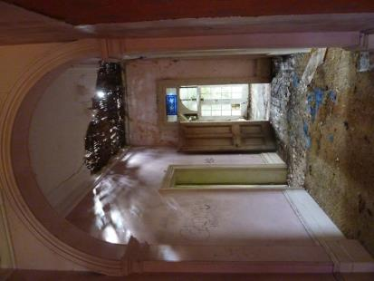
View of main hall from the entrance

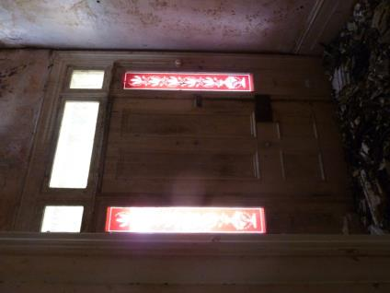
View of front door from hall

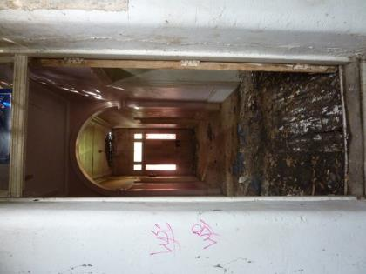
View towards front door from hall

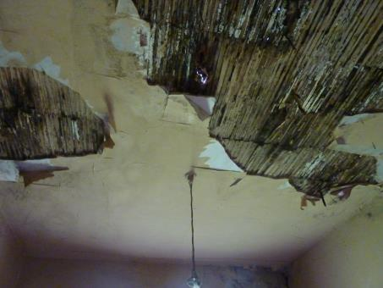
Ceiling damage in one of the main rooms

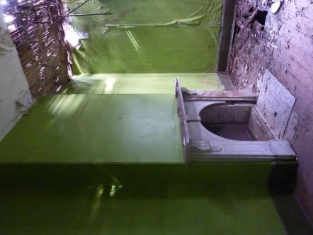
Fireplace in one of the main rooms

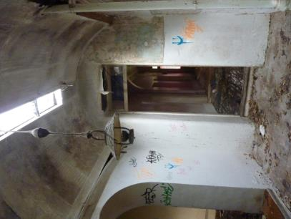
Rear hall with curved ceiling and highlight

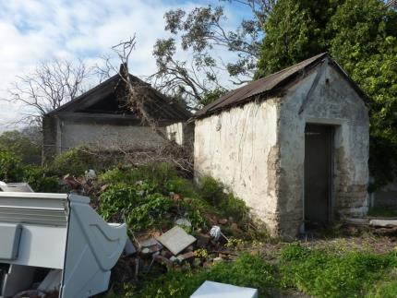
View of concrete outbuildings at the rear of the property

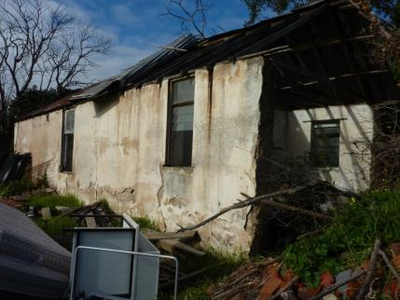
Detail of larger outbuilding

