

Former Hoyts Cinema Centre

134-144 Bourke Street, Melbourne

Heritage Council Registrations Committee

Members – Lindsay Merritt (Chair), Don Kerr, Mary Urquhart

# Decision of the Heritage Council

After considering the Executive Director’s recommendation and submissions received, pursuant to Section 42(1)(b) of the *Heritage Act 1995* the Heritage Council has determined that part of the place is of cultural heritage significance to the State of Victoria and should be included in the Heritage Register.

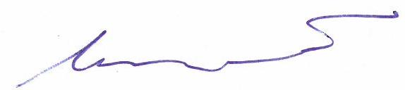 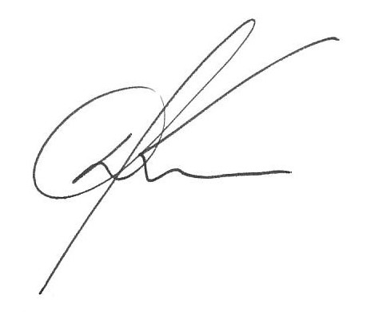 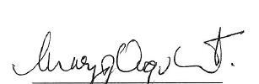

|  |  |  |  |  |
| --- | --- | --- | --- | --- |
| Lindsay Merritt (Chair) |  | Don Kerr |  | Mary Urquhart |

**Decision Date – 21 July 2014**

submissions

Written submissions were received from:

* Executive Director, Heritage Victoria
* Mr John Chow, on behalf of the owners of Lot 1C PS428191
* Mr Peter Lovell of Lovell Chen on behalf of the Owners Corporation of Properties within the Place (refer Attachment 4)
* Mr Paul Roser of the National Trust of Australia (Victoria)

**The Place**

1. The Former Hoyts Cinema Centre is comprised of the former entrance structure and office tower above and the former cinema auditoria.

## Nominations

1. A nomination from the National Trust of Australia (Victoria) (‘the National Trust’) for the Former Hoyts Cinema Centre was accepted by the Executive Director on 10 October 2013.

## Recommendation of the Executive Director

1. On 17 January 2014, the Executive Director recommended that the Former Hoyts Cinema Centre be included in the Victorian Heritage Register under the *Heritage Act* 1995 [Section 32 (1)(a)] (‘Original Recommendation’).

## Submissions

*s38 Submissions*

1. Two submissions were received pursuant to s38(1) of the *Heritage Act* 1995 (‘the Act’) in response to the Executive Director’s Original Recommendation.
2. One submission objected to the Original Recommendation and one objected to the extent of the recommended registration, wording of the Statement of Cultural Heritage Significance and the Proposed Permit Exemptions. In accordance with the Act a hearing was scheduled to be held on 16 May 2014.

*Initial Submissions*

1. On 16 April 2014 the Heritage Council Registrations Committee (‘the Committee’) received correspondence from the Executive Director. The Committee was informed that the Executive Director had been in contact with the two objecting parties, Mr John Chow on behalf of the owners of Lot 1C PS428191 (‘Lot 1C’) and Mr Peter Lovell on behalf of the Owners Corporation of properties within the Place (refer Attachment 4), and negotiated a foreshadowed amended recommendation (‘Amended Recommendation’). The foreshadowed Amended Recommendation was supported by Mr Chow and Mr Lovell and the Executive Director noted that both parties were ‘prepared to withdraw their objections if the Heritage Council is minded to support [the foreshadowed Amended Recommendation]’. This was further confirmed in a letter from Mr Lovell received on 18 April 2014.
2. An initial submission from the National Trust was received on 22 April 2014 advising that they supported the Executive Director’s Original Recommendation but agreed with the other parties’ submissions to reduce the extent of registration by excluding the ‘former store’ and ‘addition’, both within Lot 1C.
3. On 3 May 2014 the Chair of the Registrations Committee wrote to Mr Chow and Mr Lovell advising them that in its deliberations the Heritage Council takes into account all relevant submissions and may make any decision it deems appropriate. The letter advised that any person wishing to withdraw their request for a hearing must do so unconditionally and that conditional withdrawals which request a hearing to still take place if the Heritage Council does not support a proposed outcome will not be accepted. They, and all other parties, were advised that at this time the hearing was still scheduled to take place and that the initial submission period had been extended from 22 April 2014 to 16 May 2014 to enable them to make any further written submissions.
4. Following the Committee’s letter of 3 May 2014 the parties stated below withdrew any request to be heard in relation to the matter:
   * Mr John Chow on behalf of the owners of Lot 1C via email dated 8 May 2014
   * Mr Lovell on behalf of the Owners Corporation via letter dated 20 May 2014
   * Mr Paul Roser of the National Trust via email dated 22 May 2014
5. The Registrations Committee determined that a hearing was no longer required and proceeded to a Registration Meeting to consider the Amended Recommendation and all written submissions received.

**Site Inspection**

1. On 11 June 2014, the Committee made a site inspection of the Place accompanied by the Hearings Manager.

**Summary of Issues**

1. This section is not intended to be a complete record of submissions that were made. It is a summary of what the Committee considers to be the key issues relating to cultural heritage significance, followed by an explanation of the position the Committee takes on each issue.
2. Any reference to Criteria refers to the ‘Heritage Council Criteria for Assessment of Places of Cultural Heritage Significance’ (refer Attachment 1).

*Issues*

1. In his Original Recommendation the Executive Director submitted that the former Hoyts Cinema Centre is of architectural and historical significance to the State of Victoria, with the extent of the building being ‘the former entrance structure and office tower above, and the former cinema auditoria and bulk store to the rear’. The Executive Director stated that the Place is significant under Criterion A as the ‘first multi-cinema complex in Victoria’ and for its association with the revitalisation of the cinema industry in Victoria. The Executive Director was of the view that the Place is significant as an example of the first major post World War II cinema construction and the first to ‘make full economic use of its valuable city site by incorporating a rentable office tower’.
2. The Executive Director stated that the Place is of architectural significance as a unique and ‘innovative and individualistic building with a distinctive tower’. He submitted that the form of the building ‘draws clear inspiration from Asia’ and ‘displays early characteristics of the emerging Brutalist style’. It is his view that the Place satisfies Criterion D for inclusion in the Victorian Heritage Register.
3. In his written submission Mr Chow, on behalf of the owners of Lot 1C, objected to the inclusion of Lot 1C, being the former store and addition, within the recommended registration. Mr Chow submitted that the bulk store was demolished and the building currently on the site was constructed in 1986. He is of the view that Lot 1C is of no cultural heritage significance to the State and should not be included within the registration of the Former Hoyts Cinema Centre.
4. Mr Lovell, on behalf of the Owners Corporation of the Place (refer Attachment 4), objected to some aspects of the Executive Director’s Original Recommendation. Mr Lovell supported Mr Chow’s argument that the ‘former store’ and the ‘addition’ were of no significance to the Place and also questioned the inclusion of the ‘former cinema box’. Further, it was requested that some additional refinement of the wording of the Proposed Permit Policy and Proposed Permit Exemptions and Statement of Cultural Heritage Significance be undertaken.
5. The National Trust supported the Executive Director’s Original Recommendation but in response to the submissions by the two objecting parties, agreed that Lot 1C should be removed from the extent of registration.
6. On 16 April 2014 the Executive Director submitted the Amended Recommendation which addressed the concerns raised by Mr Chow, Mr Lovell and the National Trust. The Amended Recommendation contains revisions to the Original Recommendation in relation to the following issues:
   * Removal of Lot 1C (the former bulk store and Little Bourke Street addition) from the proposed registration
   * Revision of certain claims for State level significance under Criterion A
   * Clarification of Proposed Permit Policy and Proposed Permit Exemptions
7. In his Amended Recommendation the Executive Director accepted that the ‘former store’ building on Lot 1C had been demolished, with a new building then being erected, and that as it no longer retained a link to the rest of the site, it should not be included in the Amended Recommendation. Further, the Executive Director removed the following claims from his Original Recommendation due to the veracity of the statements being questioned:
   * The Place was ‘the first cinema at the time to make full economic use of its valuable city site by incorporating a rentable office tower’; and
   * The Place was ‘the first multi-cinema complex to be designed with three cinemas in the southern hemisphere and the third of its type in the world (with others constructed in Toronto and New York)’.
8. The Executive Director’s Amended Recommendation also provided clarity around the wording of the Proposed Permit Policy and Proposed Permit Exemptions as requested by Mr Lovell, on behalf of the Owners Corporation of properties within the Place (refer Attachment 4). The Executive Director distinguished between the areas of primary and contributory significance by including a clause which states that ‘it is acknowledged that there is scope for some modification of [the exterior of former auditoria of the cinemas], subject to the permit process’. He also clarified that permit exemptions for works to the interior of the Place do not include works to the internal support structure required to support the building.
9. Amendments to the Executive Director’s Original Recommendation are shown in Attachments 2, 3 and 4.

**Conclusion**

1. The Committee supports the Executive Director’s Amended Recommendation and is of the view that the Former Hoyts Cinema Centre is of cultural heritage significance to the State of Victoria and should be included in the Victorian Heritage Register.
2. The Committee finds that Criterion A is satisfied and concurs with the Executive Director’s submission that the Former Hoyts Cinema Centre is of historical significance to the State of Victoria for its role in the development of the cinema industry post World War II and as the first multi-cinema complex in Victoria.
3. The Committee finds that Criterion D is satisfied and concurs with the Executive Director’s submission that the Former Hoyts Cinema Centre is of architectural significance to the State of Victoria as a unique and innovative building which demonstrates characteristics of the Brutalist style.



**ATTACHMENT 1**

**HERITAGE COUNCIL CRITERIA FOR ASSESSMENT OF PLACES OF CULTURAL HERITAGE SIGIFICANCE**

|  |  |
| --- | --- |
|  |  |
| CRITERION A | Importance to the course, or pattern, of Victoria’s cultural history. |
| CRITERION B | Possession of uncommon, rare or endangered aspects of Victoria’s cultural history. |
| CRITERION C | Potential to yield information that will contribute to an understanding of Victoria’s cultural history. |
| CRITERION D | Importance in demonstrating the principal characteristics of a class of cultural places or objects. |
| CRITERION E | Importance in exhibiting particular aesthetic characteristics. |
| CRITERION F | Importance in demonstrating a high degree of creative or technical achievement at a particular period. |
| CRITERION G | Strong or special association with a particular community or cultural group for social, cultural or spiritual reasons. This includes the significance of a place to Indigenous peoples as part of their continuing and developing cultural traditions. |
| CRITERION H | Special association with the life or works of a person, or group of persons, of importance in Victoria’s history. |

**These were adopted by the Heritage Council at its meeting on 7 August 2008, and replace the previous criteria adopted by the Heritage Council on 6 March 1997.**



ATTACHMENT 2

***What is significant?***

The Former Hoyts Cinema Centre, comprising the former entrance structure and office tower above, and the former cinema auditoria.

*History Summary*

The Former Hoyts Cinema Centre was constructed from 1966-69 in the well established entertainment precinct at the east end of Bourke Street. Designed by Sydney architect Peter Muller, it was the first multi-cinema complex in Victoria and The advent of television in Melbourne a decade earlier had seen the demise of the large city theatre and the provision of a facility with three smaller cinemas running simultaneously, a restaurant and associated office tower with rentable space, presented the Hoyts Company with an economically viable option. Established in 1908 as Hoyts Pictures Pty Ltd, this company played a large role in the development of the cinema industry in Victoria, particularly after the introduction of talking films in the late 1920s. Many large, grand theatres were built and well known architects were employed by Hoyts to design their buildings. In reaction to the introduction of television, Hoyts began an expansion, modernisation and replacement programme in the mid-1960s and the largest project was the construction of the $4.5m 13 storey cinema and office tower complex. The genesis for the design by Peter Muller can be seen in a similar project, which remained unbuilt, for Hoyts in Newcastle, NSW in 1960. The originality of the concept and the design ensured that the Cinema Centre received much attention during and after construction, and ultimately led to the closure of the Hoyts -owned Regent Theatre in Collins Street in 1970. Two floors of the office tower were allocated to the Victorian branch of Twentieth Century Fox Film Corporation (Aust) Pty Ltd and the registered offices of Hoyts Theatres Ltd and the remaining ten floors were made available for rent. In 1982 one of the cinemas was divided into two separate cinemas and in 2005 the Cinema Centre was closed after thirty-five years of operation. In 2009 the lower levels of the complex were converted into a health club resulting in extensive remodelling of the cinemas and their associated foyer spaces. The tower has continued to provide rentable office space.

*Description Summary*

The Former Hoyts Cinema Centre is a carefully detailed building comprising a two-level podium that originally housed the cinemas and associated foyers on split levels, a basement that housed plant, car parking and store rooms, and an office tower that rises above the podium. The cinema auditoria were located at the rear of the site, structurally separate from the remainder of the building. Principally an off-form concrete building, it is highly distinctive, innovative and individualistic in design and clearly draws inspiration from Asia. The symmetrical tower block resembles an inverted pagoda with each rising floor level increasing in size. The overhang which resulted provided shading, reduced energy needs and allowed the unusual use of timber window frames in a city office building. Muller’s design was based on a structural system which was inspired by oriental post and bracket construction to achieve the stepped form of the tower and this resulted in a distinctive multi-storey building profile in contrast to the commonly used curtain wall or precast panel facades of the 1960s. The tower dominates the exterior form and comprises massive off-form concrete side buttresses, both vertical and tapered in form, which contrast with horizontal concrete balustrading of the front and rear facades. A dramatic fleche, with five encircling rings at its base, crowns the tower. The concrete throughout the building is treated in a highly Brutalist manner with the rough marks of the construction boards remaining clearly evident. Interiors of the public areas were well detailed but little of this remains, with the exception of dentilated concrete beams of the original entrance plaza and lobbies. Muller’s early work, including the Cinema Centre, displayed characteristics similar to the work of Frank Lloyd Wright and many architectural critics, both contemporary and more recent, have regarded Muller as amongst the best exponents of Wright’s philosophies in Australia.

This site is part of the traditional land of the Kulin Nation.

***How is it significant?***

The Former Hoyts Cinema Centre is of architectural and historical significance to the State of Victoria. It satisfies the following criterion for inclusion in the Victorian Heritage Register:

Criterion A Importance to the course, or pattern, of Victoria’s cultural history

Criterion D Importance in demonstrating the principal characteristics of a class of cultural places and objects

***Why is it significant?***

The Former Hoyts Cinema Centre is significant at the State level for the following reasons:

The Former Hoyts Cinema Centre introduced the first multi-cinema complex to Victoria and consequently has an important association with the development of the cinema industry in the State. The building represents a revitalisation of the cinema industry which had not been seen since the advent of talking movies in the late 1920s. It was the first major excursion into cinema construction in Australia after World War II [Criterion A]

The Former Hoyts Cinema Centre is of architectural significance as a highly innovative and individualistic building with a distinctive tower which dominates the overall design. It is unique in Victoria. Unusually the overall form of the tower draws clear inspiration from Asia and departs from the conventional modernist curtain wall or precast panelled facade which was prevalent in 1960s multi-storey office design. The building displays early characteristics of the emerging Brutalist style in the use of massive expanses of exposed off-form concrete and the obvious imprint of construction boards. [Criterion D]

The Former Hoyts Cinema Centre is also significant for the following reasons, but not at the State level:

The Former Hoyts Cinema Centre is significant for its associations with well known Australian architect, Peter Muller, who achieved early recognition as a Sydney house designer and whose work embodied organic architecture, in a similar manner to Frank Lloyd Wright. Muller was one of the first Australian architects to embody Japanese ideals, and this oriental influence is evident in his largest commission, the Former Hoyts Cinema Centre.



ATTACHMENT 3

**PERMIT POLICY**

**Preamble**

The purpose of the Permit Policy is to assist when considering or making decisions regarding works to a registered place. It is recommended that any proposed works be discussed with an officer of Heritage Victoria prior to making a permit application. Discussing proposed works will assist in answering questions the owner may have and aid any decisions regarding works to the place.

**The extent of registration of the Former Hoyts Cinema Centre on the Victorian Heritage Register affects the whole place shown on Diagram 2335 including the land and the building.** Note that the interiors are exempt from the permit requirements of the *Heritage Act 1995* (see “Permit Exemptions”).

Under the Heritage Act 1995 (‘the Act’)a person must not remove or demolish, damage or despoil, develop or alter or excavate, relocate or disturb the position of any part of a registered place or object without approval. It is acknowledged, however, that alterations and other works may be required to keep places in good repair and adapt them for use into the future.

If a person wishes to undertake works or activities in relation to a registered place or registered object, they must apply to the Executive Director, Heritage Victoria for a **permit**. The purpose of a permit is to enable appropriate change to a place and to effectively manage adverse impacts on the cultural heritage significance of a place as a consequence of change. If an owner is uncertain whether a heritage permit is required, it is recommended that Heritage Victoria be contacted.

Permits are required for anything which alters the place or object, unless a **permit exemption** is granted. Permit exemptions usually cover routine maintenance and upkeep issues faced by owners as well as minor works. They may include appropriate works that are specified in a conservation management plan. Permit exemptions can be granted at the time of registration (under s.42 of the Act) or after registration (under s.66 of the Act).

It should be noted that the addition of new features or structures to the registered place, as well as alterations to the exterior of the existing building requires a permit, unless a specific permit exemption is granted. Interior works to the existing building are permit exempt. The retention of the remaining unpainted dentilated concrete beams in the original entrance plaza and lobbies of the building is encouraged.

**Conservation management plans**

It is recommended that a Conservation Management Plan is developed to manage the place in a manner which respects its cultural heritage significance.

**Cultural heritage significance**

Overview of significance

The cultural heritage significance of the Former Hoyts Cinema Centre lies in its highly distinctive and individualistic architectural character which exhibits both oriental and Brutalist qualities. The building also has important associations with the development of the cinema industry due to its introduction of the multi-cinema complex to Victoria and the incorporation of a rentable office tower to maximise the use of valuable space.

1. The elements of the building listed here are of **primary cultural heritage significance** in the context of the place. This is shown in red on the diagram. A permit is required for works or alterations.

* Exteriors of the entrance structure of the building and the tower, including the mezzanine level and awning.

1. The elements of the building listed here are deemed to have **contributory cultural heritage significance** to the place. They are shown in blue on the diagram. A permit is required for works or alterations. It is acknowledged that there is scope for some modification of this element, subject to the permit process.

* Exterior of former auditoria of the cinemas to the rear of the entrance structure

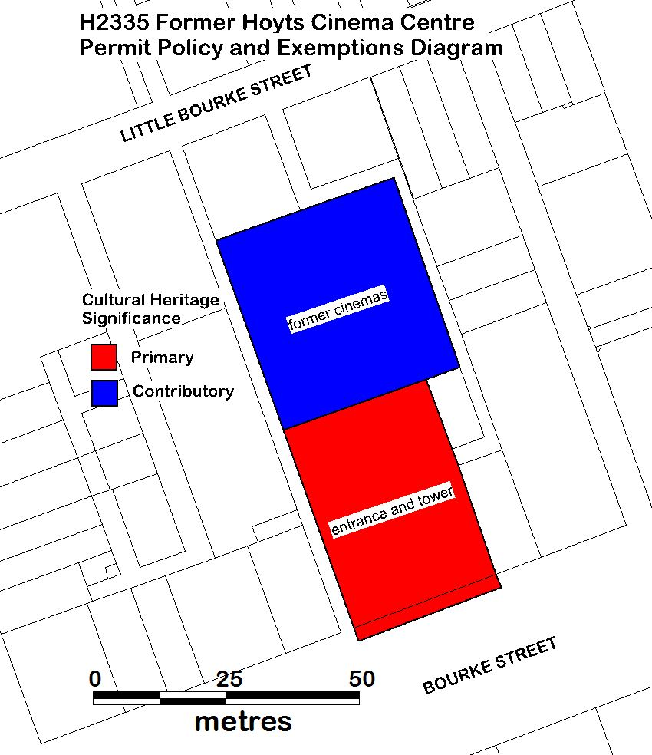

**PERMIT EXEMPTIONS (under section 42 of the Act)**

It should be noted that Permit Exemptions can be granted at the time of registration (under s.42(4) of the Act). Permit Exemptions can also be applied for and granted after registration (under s.66 of the Act)

**General Condition: 1.**   
All exempted alterations are to be planned and carried out in a manner which prevents damage to the fabric of the registered place or object.

**General Condition: 2.**   
Should it become apparent during further inspection or the carrying out of works that original or previously hidden or inaccessible details of the place or object are revealed which relate to the significance of the place or object, then the exemption covering such works shall cease and Heritage Victoria shall be notified as soon as possible.

**General Condition: 3.**   
All works should be informed by a Conservation Management Plan prepared for the place.

**General Conditions: 4.**   
Nothing in this determination prevents the Executive Director from amending or rescinding all or any of the permit exemptions.

**General Condition: 5.**   
Nothing in this determination exempts owners or their agents from the responsibility to seek relevant planning or building permits from the relevant responsible authority, where applicable.

**Specific Exemptions:**

**Interior**

* Internal works to all parts of the registered place known as the Former Hoyts Cinema Centre, excluding the internal structure required to support the building.

**Exterior**

* Minor repairs and maintenance which replace like with like.
* Removal of non-original items such as air conditioners, pipe work, ducting, wiring, antennae, aerials etc, and making good in a manner which does not affect the cultural heritage significance of the place.
* Installation or removal of non-original external fixtures and fittings such as, hot water services and taps.
* Installation and repairing of damp proofing by either injection method or grouted pocket method in a manner which does not affect the cultural heritage significance of the place.



ATTACHMENT 4

# EXTENT OF REGISTRATION

All of the place shown hatched on Diagram 2335 encompassing Lots 1, 1A, 1B, 2, 2A-2H, 2J, 3-41, 201-204, 301, 302, 401-404, 501, 502, 601, 602, 701, 801-804, 901, 1001, 1101, 1102, CM1-CM9 on Plan of Subdivision 428191 and the awning/balcony to Bourke Street.

