Sustainability and Heritage
Improving the energy efficiency of existing and heritage houses
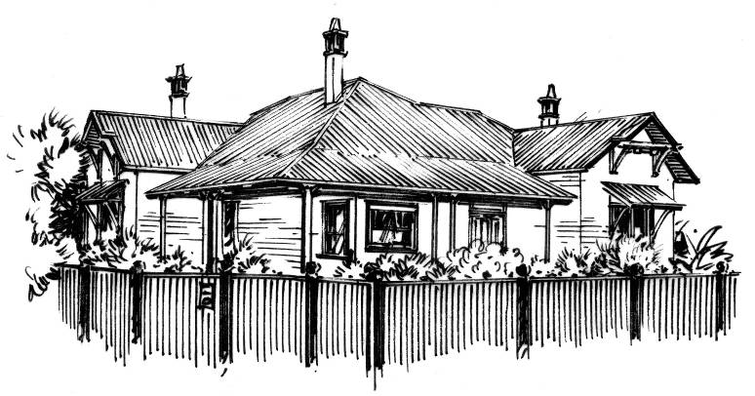
Edwardian
guidance sheet
IN SUMMARY
Heating and cooling needs reduced by up to 57%
Potential cost saving of up to $2900 per annum for $13,000 investment
5 GJ/m² of primary energy is embodied in the building itself
94 GJ/m² of primary energy is used for heating and cooling over the building’s lifecycle

The Case Study
This case study is one of a series which examines the use of energy for heating and cooling in typical existing and heritage homes. It also identifies upgrades to the building fabric which can be incorporated to reduce energy use. The study takes a life cycle approach which includes heating and cooling as well as energy used to create the fabric of the buildings. For more information on the methodology of analysis that formed these case studies, refer to the Guidance Sheet Introduction in this series.
Period: 1901-1918
This example, representative of many Edwardian style dwellings, has weatherboard walls, metal roof and a floor area of 220 m². Edwardian period dwellings often include elaborate plaster ornaments and stained glass front windows, featuring geometric and curvilinear shapes and sometimes native plants or birds. Many feature red brick walls with flush joints with cream painted render to base and gable ends.
Life Cycle Energy Use
Over the life cycle of any building, primary energy, largely derived from fossil fuels, is used to manufacture materials, construct the building, heat and cool the building, maintain the building, and to dispose of the building at the end of its life. Using life cycle assessment (LCA) it was determined that the house will use 100 GJ per square metre of primary energy over its life, of which 94 GJ is associated with heating and cooling, 5 GJ with materials and construction and 1 GJ with the other life cycle stages mentioned above (over a 100 year lifetime). Results exclude all appliances other than heating and cooling appliances.
Reducing Life Cycle Energy Use
The life cycle energy study tells us that the primary energy used to heat and cool the building is far greater than the energy used in other life cycle stages and should be the focus of attention when seeking to reduce energy use. It also tells us that 5 GJ per square metre of primary energy is associated with the manufacture of materials and the construction of the building itself. If the house is retained, the primary energy associated with the construction and materials of a new, replacement house can be avoided (a contemporary 5 star house analysed in the study required 4 GJ per square metre of primary energy for construction and materials manufacture).
To help place these figures into context, 100 kilograms of brown coal contains approximately 1 gigajoule (GJ) of primary energy.
Interventions to Reduce Heating and Cooling Energy Use
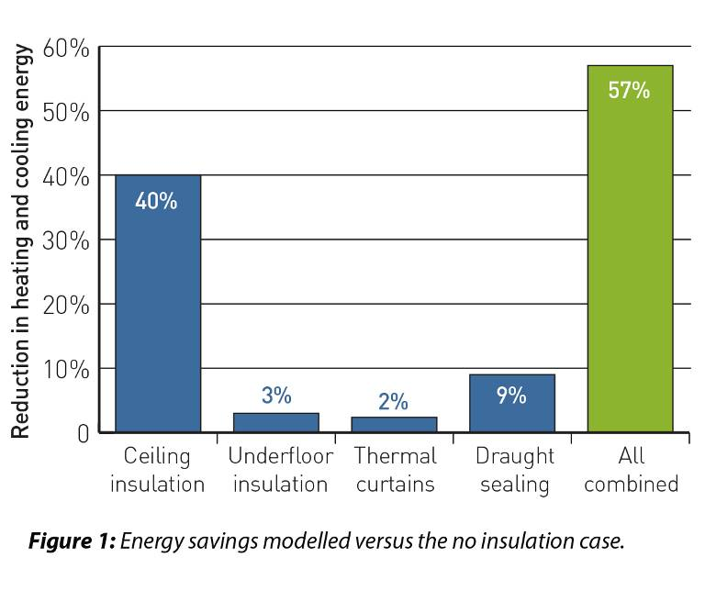
The study also identified building fabric related interventions to reduce heating and cooling energy use. To determine how these interventions might perform, each was modelled independently and compared to a theoretical baseline comprising the same house with no insulation. Although based entirely on modelled results (no actual interventions were undertaken), the results show that significant energy efficiency improvements could be achieved. In addition, the primary energy associated with the materials and installation of the interventions was small relative to the house as a whole.
The modelled reduction in heating and cooling requirements for each intervention, versus the same house with no insulation, are shown in Figure 1.
Table 1 summarises estimated investment costs for each intervention and the energy bill savings that could result*.
The Nationwide House Energy Rating Scheme (NatHERS) star rating of the house after simulated installation of each intervention is also shown in Table 1. Note that due to the non-linear-nature of the NatHERS rating scale and interactions between the interventions, energy savings do not necessarily add when applied in combination.

Table 1: Intervention costs and savings*
Ceiling Underfloor Thermal Draught All
insulation insulation curtains sealing combined
Approximate investment $3500 $3300 $4400 $1800 $13,000
Potential yearly cost saving versus no insulation case $1100-2000 $110-190 $67-120 $250-450 $1600-2900
Potential Star Rating Improvement after intervention 1.4 0 0 0 2.3

Additional Energy Savings
The study undertaken focussed primarily on the fabric of heritage buildings and how this relates to heating and cooling energy use. Although it did not consider the upgrade of heaters, coolers and other appliances to improve efficiencies, these items also represent good opportunities for energy savings. Good sources of additional information relating to home energy efficiency are www.yourhome.gov.au, www.livinggreener.gov.au and www.resourcesmart.vic.gov.au.

*Limitations:
These results are based on desktop analysis and therefore represent a guide only. Results are specific to a particular house considered, and do not reflect general outcomes.
Upgrade costs shown are based on a range of assumptions and are approximate only.
Energy cost savings shown assume gas central heating and refrigerative cooling. Ranges of savings reflect alternative appliance efficiencies and alternative householder behaviours.
The heating and cooling energy requirements shown were based on thermal modelling undertaken using Accurate™ software.

